Last lesson we talked about when to bid even though the opponents have opened bidding.
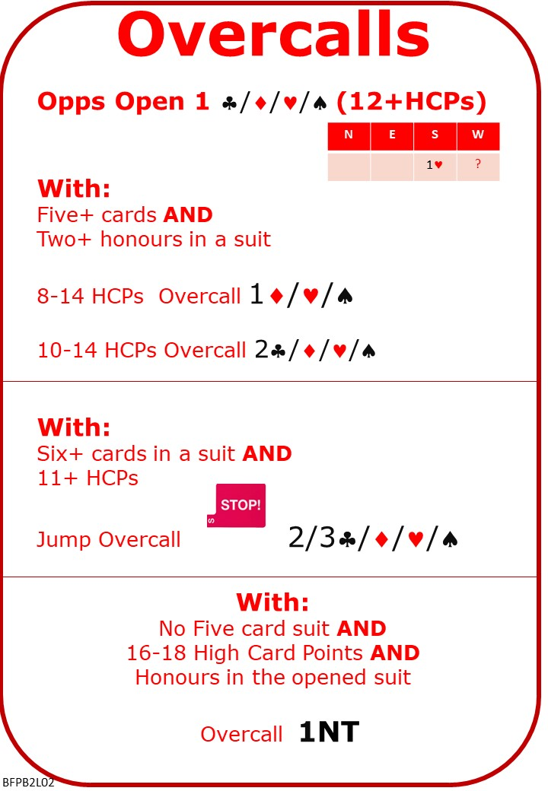

Attached Documents:
- L01 Playing Suit Contracts QUIZ with ANSWERS
- L02 Simple Overcalls NOTES
- L02 Simple Overcalls QUIZ

No Fear Bridge
On No Fear Bridge Bidding
- On the Home Page, From the vertical menu on the left, select "Topic Index"
- “Bidding Topics Alphabetically”
- Overcalls
- From the list select "Making a suit overcall" and “1NT Overcall and responses”
- Check out the “Tips”

Invite to Next Lesson
If online send link/joining instructions
If face to face remind venue, day and start time.

