Dear All
An opening bid of one of a suit is much less informative than 1NT.
We looked at showing partner a balanced hand with 15-19 HCPs.
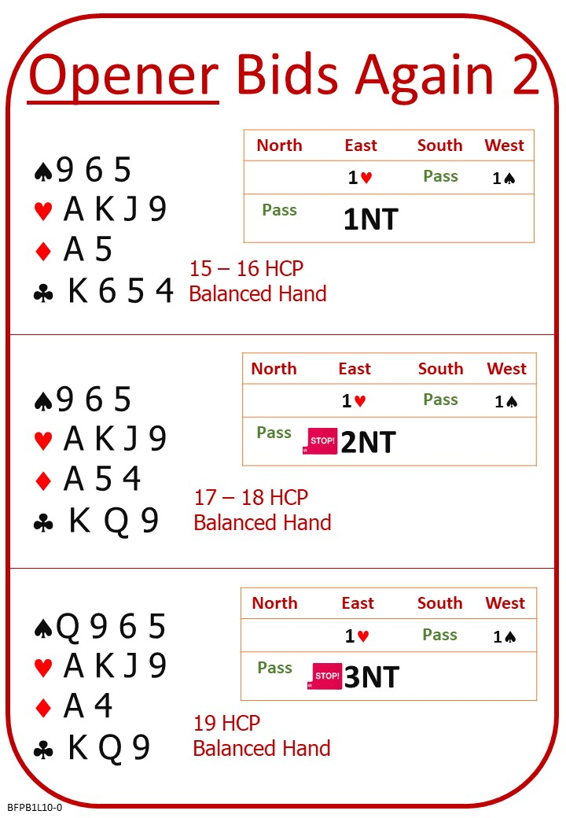
The second bid by opener tells the full story.
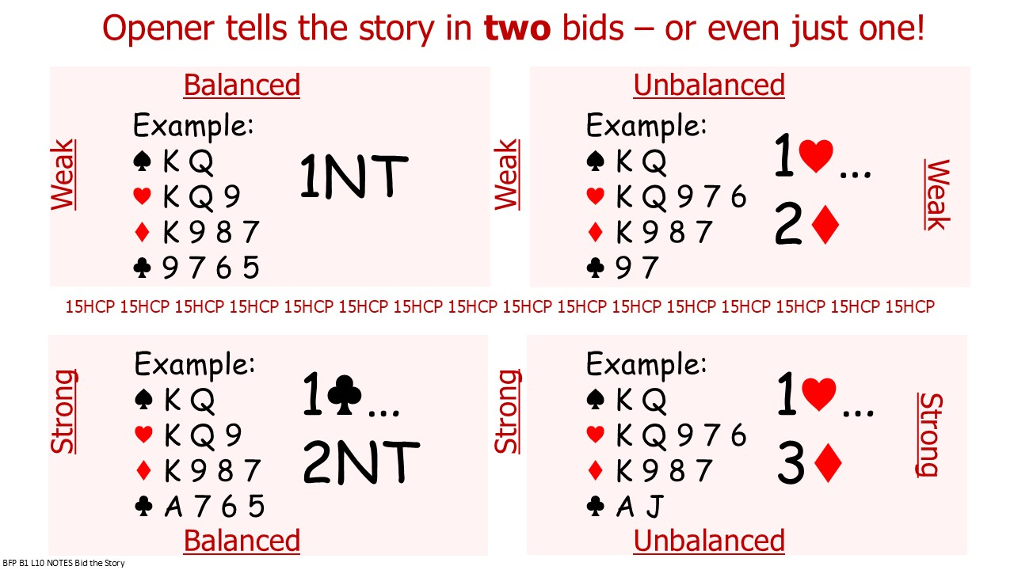

Please find attached:
- B1 L09 QUIZ ANSWERS Openers Rebid Unbalanced
- B1 L10 NOTES Openers Rebid Balanced
- B1 L10 QUIZ Openers Rebid Balanced
- B1 L10 QUIZ ANSWERS Openers Rebid Balanced

No Fear Bridge:
Homepage Top Centre: Practice Hands and Quizzes
Bidding Quizzes
Level 1 – Beginners Easy
Opener’s Rebids with Balanced Hands
And/Or
Homepage Top Centre: Practice Hands and Quizzes
Millionaire Quiz
Level 1 – Beginners
Opener’s Rebids with Balanced Hands

We have come to the end of the beginners first ten lessons.
Please find two more files attached:

- B1 L10 NOTES Openers Rebid Unbalanced
Summary of ACOL opening bid, responding bid, and opener’s second bid or rebids.

- B1 System Summary
The system summary gives an overview of everything we have covered on the course.
If a more experienced player offers to partner you, show them what you learnt so far.
Ask them to help you practice what you know.

Nest Lesson

