Dear All
An opening bid of one of a suit much less informative than 1NT.
Opener’s second bid, known as opener’s rebid, tells the full story.
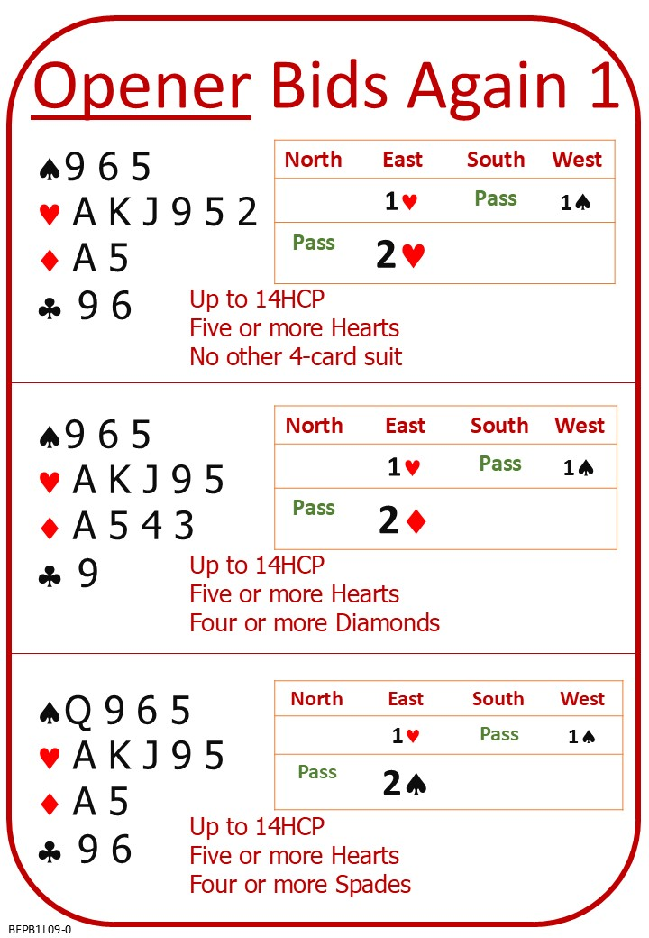
After opener’s second bid, the responder has enough information about the two hands to determine what the best contract is.
Please find attached:
Lesson 8 Other Replies Quiz with Answers
Lesson 9 Opener’s Rebid 1 Notes
Lesson 9 Opener’s Rebid 1 Quiz
Please practice on No Fear Bridge:
Guided Learning; Courses; Bridge in 30 Lessons; Lesson 8
Covering Honours (document to read)
Covering or not Covering Honours Level 1 (Hands to practice)

Opener’s Rebids Instant Feedback Quiz EASY

