We looked at replying to partners 1 of a suit opening when you do not have four cards in a partner's suit.
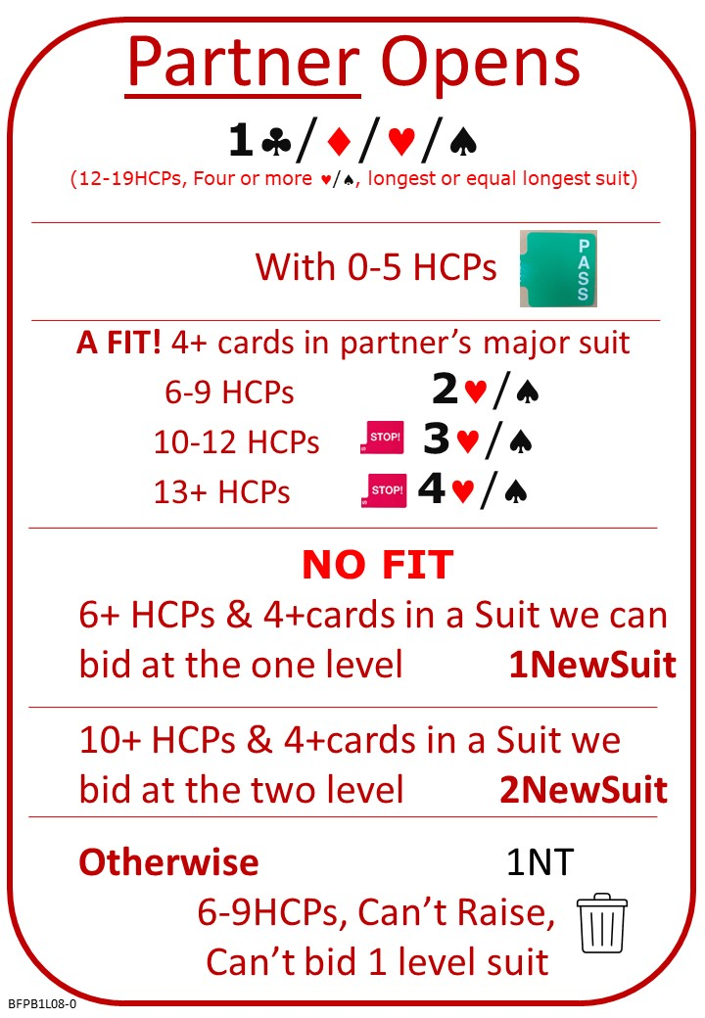
Please find attached:
Lesson 7 Quiz with answers
Lesson 8 Notes
Lesson 8 Quiz

No Fear Bridge
Horizontal Menu: Click ​V​ideo Courses, and again from the drop down
Then: Level 1 Bridge in 30 lessons (Part 1 of 3):
Then: Lesson 8 Responding at the One Level etc
- Presentation "Change of Suit Responses to A Suit Opening" (There is quite a lot of extra detail, so you may just like to read the attached notes.)
- Covering Honours (Document to read)
- Covering or not Covering Honours Level 1 (Hands to practice)
- Here's a link to a new video course on No Fear Bridge on the topic. Do try it and let me know what you think.

https://www.nofearbridge.co.uk/members/app_courses.php?C=822

Next Lesson:

