Auctions that start with a bid of 1 of a suit
When partner opens the bidding with a bid of 1 of a suit, we know relatively little about their hand. We do know that they have at least four cards in that suit, and somewhere from 12 to 19 HCPs. Also, they didn’t open 1NT.

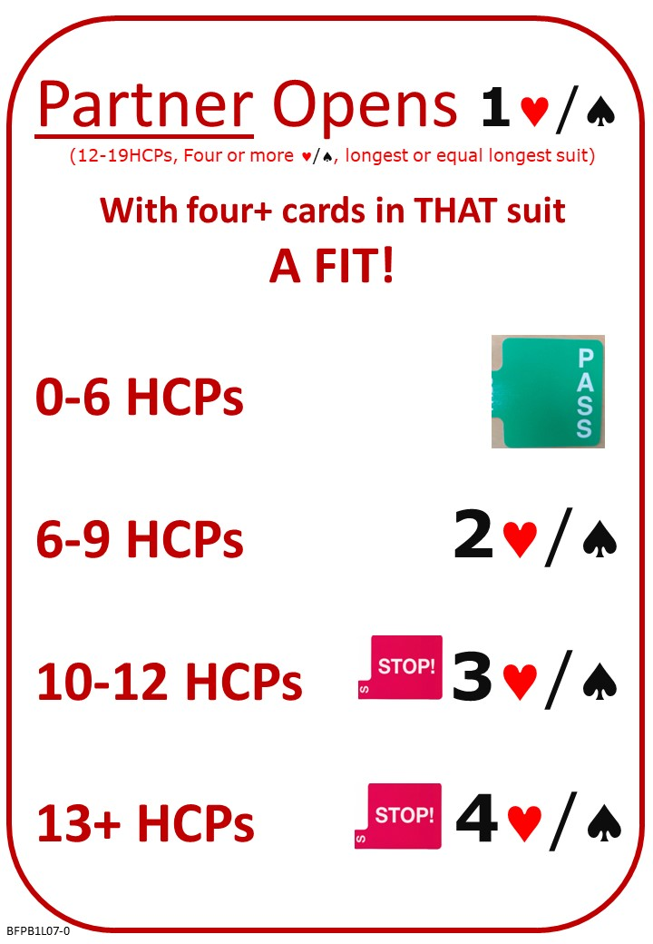

Please find attached:
Lesson 6 Reply to 1 No Trump with Unbalanced Hand: Quiz with Answers
Lesson 7 Raising Partners Suit: Notes
Lesson 7 Raising Partners Suit: Quiz

No Fear Bridge:
Click on the centre button: “Practice Hands and Quizzes” at the top of the Home Page…
Click “Bidding Quizzes”
Click Responding to 1H or 1S with a fit

AND/OR

Click on the left button: “Video Courses” at the top of the Home Page and then on “Video Courses” again…
Under “Other Courses”
Level 1 – Beginners “Bridge in 30 Lessons (Part 1 of 3)”
Lesson 7 – Opening 1 of a suit and Raising….
Any/All of the activities.

Next Lesson:

