In our last lesson
When partner opens the bidding with a bid of 1NT, we know a lot about their hand.
If we also have a balanced hand, the contract will be No Trumps.
The question is: do we have 25HCPs between us, and therefore can bid 3NT, make nine tricks, and collect a game bonus?
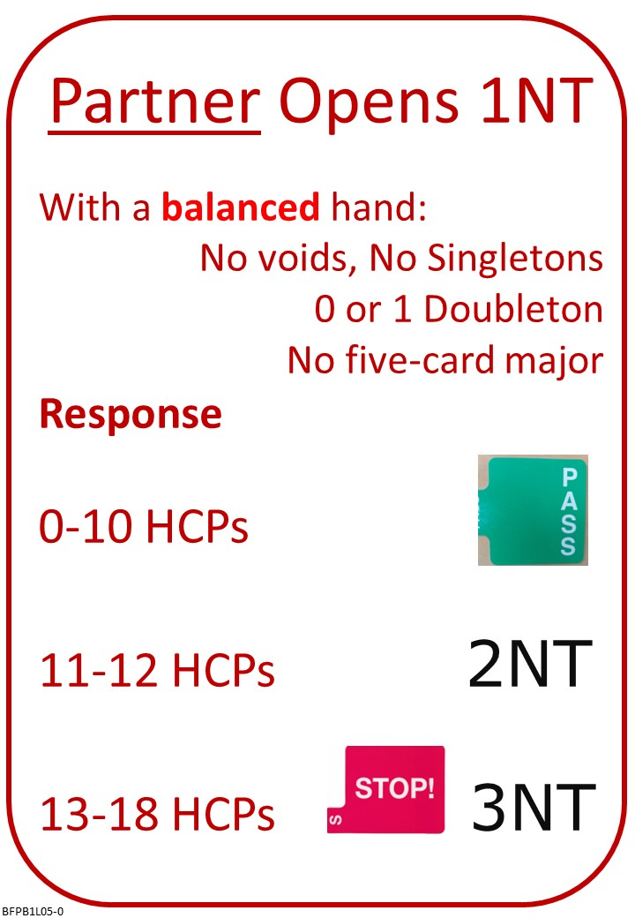
Please find attached:
- BFP B1 L04 QUIZ ANSWERS Opening 1 No Trump
- BFP B1 L05 POSTER Reply to 1NT with balanced Hand
- BFP B1 L05 NOTES Reply to 1NT with balanced Hand
- BFP B1 L05 QUIZ Reply to 1NT with balanced Hand

No Fear Bridge:
- Click on the centre button: “Practice Hands and Quizzes” at the top of the Home Page…
  - Click “Bidding Quizzes”
    - Under “Opening 1NT and Responses – No Stayman”
      - Responding to 1NT with balanced hands Instant Feedback Quiz

- Click on the left button: “Video Courses” at the top of the Home Page…
  - Select “Video Courses”
    - Level 1 – Beginners “Bridge in 30 Lessons (Part 1 of 3)”
    - Lesson 5
      - Document to Read: Third Hand High
      - Hands to Play: Setting up a Long Suit in No Trumps Level 2 (7 hands)
Invite to Next Lesson
If online send link(s) / joining instructions
If face to face remind venue, day and start time.

