We discussed how to evaluate (judge) our hand.
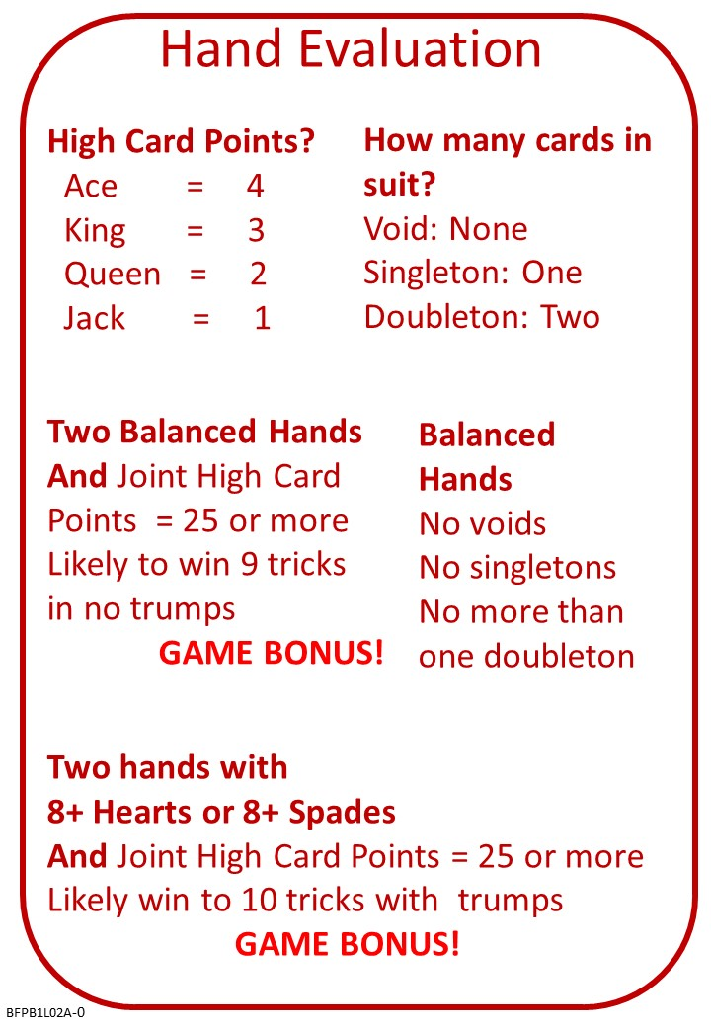
When we decide what our hand is good for, we also need to understand a bit about the scoring.

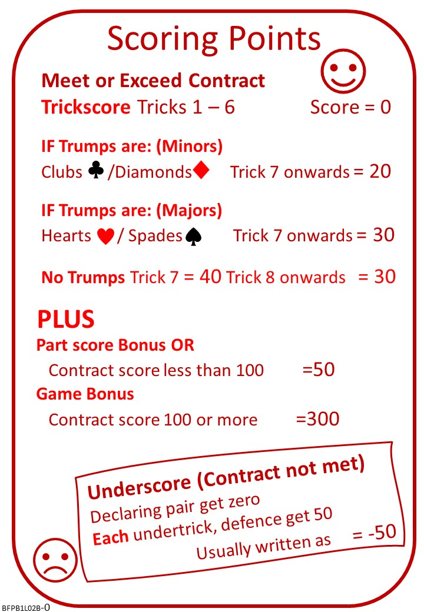

Attached Documents
We went through a quiz about playing the cards. Please find attached Lesson 1 QUIZ with ANSWERS.
Please find attached Lesson 2 NOTES from the lesson.
Also, a Lesson 2 Quiz. We will look at this quiz at the beginning of next week.

No Fear Bridge
I do hope you have signed up for No Fear Bridge.
If you have already used this site, you will know how good it is.
If it is new to you, then please use the link below to get a free THREE MONTH trial. This will be long enough to see you through the course and beyond.
Please note that the free trial link on the No Fear Bridge home page is for TWO WEEKS. Don't use that, use this:
www.nofearbridge.co.uk/free

Here is a suggestion to try on No Fear Bridge.

Logon, Click “Guided Learning”, “Courses”, “MiniBridge”
Part 1 – Learning to Play

The next lesson

Payment

