**League of Eight & League of Four**

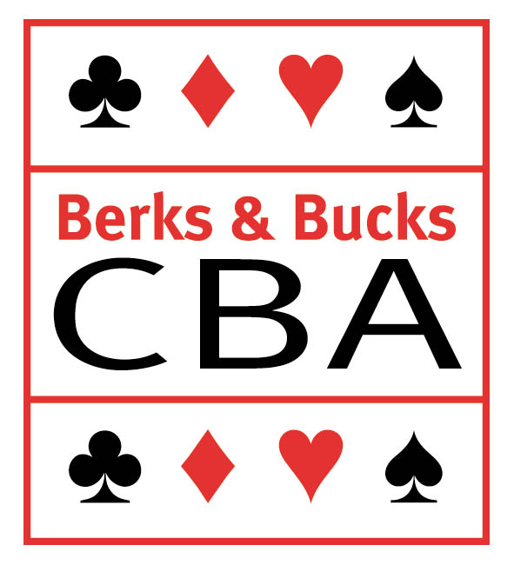

#### Request for Ruling or Notification of Appeal

|  |  |  |
| --- | --- | --- |
| **Competition/Division:** | | |
| **Match Date:** | | |
| **Home Team:** | | |
| **Away Team:** | | |
| **The Appeals Secretary**  The Appeals Secretary is purely an administrator and takes no part in making decisions about rulings or appeals. The services of this Secretary are available to assist in the framing of a request for a ruling or appeal. Please communicate with the Appeals Secretary with urgency if this service is required.  In any event this form should be forwarded to the Appeals Secretary *without delay*. This form should be accompanied by result(s) from the other table(s). | | | The Appeals Secretary is:  David Barnes  Decoy Cottage, Aldermaston, READING, Berks, RG7 4PP  07702 214 801 ( mobile)  0118 970 0376 ( home)  email: decoycottage@btinternet.com |
| **Players’ Names**  The names of the players in the deal described overleaf:  North: East:  South: West: | | | |
| **Captain N/S**  Name and email of the captain of the players sitting N/S at the table described overleaf: | **Captain E/W**  Name and email of the captain of the players sitting N/S at the table described overleaf: | | |
| **Who is appealing?**  Which side is asking for a ruling or making an appeal against a ruling?  Is it the captain of the N/S pair or the captain of the E/W pair at the table described overleaf? | | | |
| *This form accommodates completion on a computer but can also be printed and filled in on paper, in which case signatures of players and captains should be entered below.* | | | |
| **Signatures of the four players at the table described overleaf:**  All four players should sign below after completion of the page over.  North: East:  South: West: | | | |
| **Signatures of Captains**  After signature by the captains, this form should not be amended in any way whatsoever.  Captain of N/S pair at table described overleaf:  Captain of E/W pair at table described overleaf: | | | |
| When this form is used for an **appeal** against a referee's decision of first instance, then it should be accompanied by a **deposit of £20** which will be retained by Berks & Bucks Contract Bridge Association if the Appeals Committee deems the appeal ‘frivolous’. | | | |
| Deal      ◻   ▪     N  W E  S    ◻◻  ▪▪       ◻   ▪   Board Number:  Dealer: Vulnerability:  Opening Lead: Result:  Relevant details of auction, opening lead, play and result(s) at other table(s): | | Auction Mark alerts and announcements given with a number and quote explanation given (if any) against numbers below.   |  |  |  |  |  |  |  | | --- | --- | --- | --- | --- | --- | --- | | **N** |  | **E** |  | **S** |  | **W** | |  |  |  |  |  |  |  | |  |  |  |  |  |  |  | |  |  |  |  |  |  |  | |  |  |  |  |  |  |  | |  |  |  |  |  |  |  | |  |  |  |  |  |  |  | |  |  |  |  |  |  |  | |  |  |  |  |  |  |  | |  |  |  |  |  |  |  | |  |  |  |  |  |  |  | |  |  |  |  |  |  |  | |  |  |  |  |  |  |  |   1  2  3  4  5  Relevant information appearing on the convention card of:  N/S  E/W | |
| *The boxes below are for statements (as needed) by the four players and the two captains. If you are entering on a computer and do not need all the space in a box, you can delete lines. If you need more space, just keep on typing and the box will enlarge to accommodate more text. If you are submitting a paper form and need more space, write your additional material on a separate sheet of paper.* | | | |
| Statements of Players. Please indicate the polarity (not the name) of the player making each statement. | | | |
| Statements of Captains. Please indicate if you are captain of the N/S or the E/W pair above but do not give your name here. | | | |
| Ruling by Tournament Director/Referee including thoughts, ruling, relevant laws and precedents. | | | |