How to Ride a Moose?
Once a year, if we are lucky, we are dealt a hand with so many high card points that we refer to it as a Moose. The following hand occurred recently and all I can now say is, “When there is a Moose on the road, be careful how you drive!”
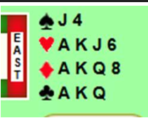
As opening bidder, you hold 27 points, so you start by opening 2 clubs. With opponents silent throughout, I’m relieved that my partner first responds 2 diamonds – this shows either a king or ace. Either or both of these card(s) have to be in spades as I have the Kings & Aces in all the other suits! If responder held a bust hand, our agreement is that he would respond 2 hearts – denying either an ace or king and less than 5 points.
As opener my next rebid was 2NT. Did you expect me, holding the Moose, to rebid 3NT instead? Since our bidding has us in a game force, I want to give my partner a chance to further describe his hand at a comfortable level. I have left him bidding room to either transfer in a major (holding 5+M) or bidding Stayman if he held a 4-card major, below the game level.
My partner then bids 3NT, denying major suit interest. His bidding helps me understand what his hand shape is like. I now know 100% that he has at least 1 four card minor suit as he has denied a 4-card major suit by failing to either transfer or invoke Stayman. Since I also know that he has 6+ high card points based on his 2 Diamond positive response (of which either 3 or 4 HCPs are in spades), it makes us 33+ HCPs combined).
Holding the Moose I must have a fair shot at 12 tricks (I can count 7 in the minors and 4 in the Major tricks, and there must be a good chance for a 12th trick). I am now in position to place the best final contract which is 6NT. This is the complete hand:
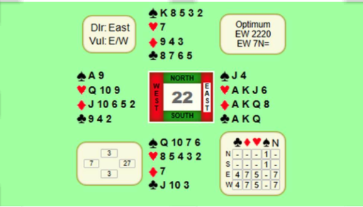

Author: John Jarman

