
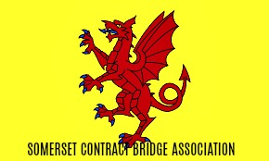
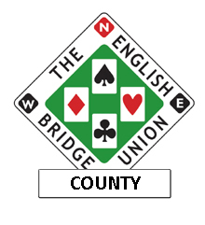
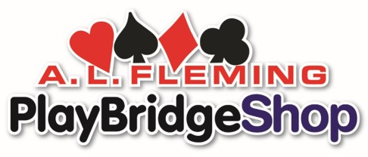


NEWSLETTER June 2019

The AGM 2019

A splendid day out for all. Over 70 people attended the AGM to find out whether the committee had been doing its job for the last year.

Minutes can be found here on the SCBA website:

http://www.bridgewebs.com/cgi-bin/bwx/bw.cgi?club=somerset&pid=display_home&sessid=369449789283698

Highlights worth mentioning were the award of the Terry Girdlestone cup to Roy Rowe. As ever there were several worthy contenders for this award, any one of whom could he heartily commended for their efforts on behalf of the game of bridge in Somerset. Roy has been outstanding in his endeavours and this is small reward for all his work and achievements.
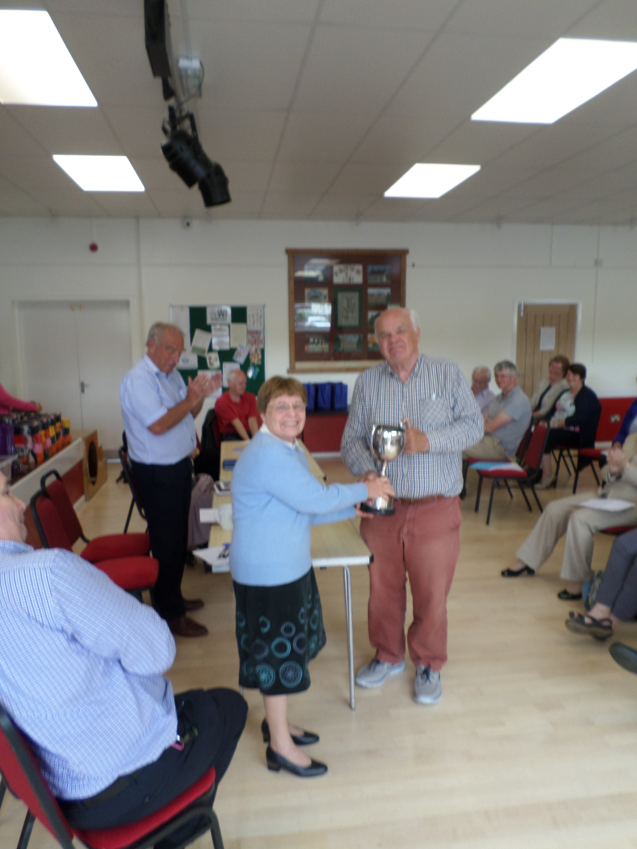

The treasurer's report showed that we are in a healthy financial state with a new County development officer in place, grant monies in the bank to continue promotion of the game and sufficient working capital to ensure that the next couple of years are secure and our events in this time underwritten.

Sheila Coda took a well deserved round of applause as she stepped down from the committee after many years labouring for us all.

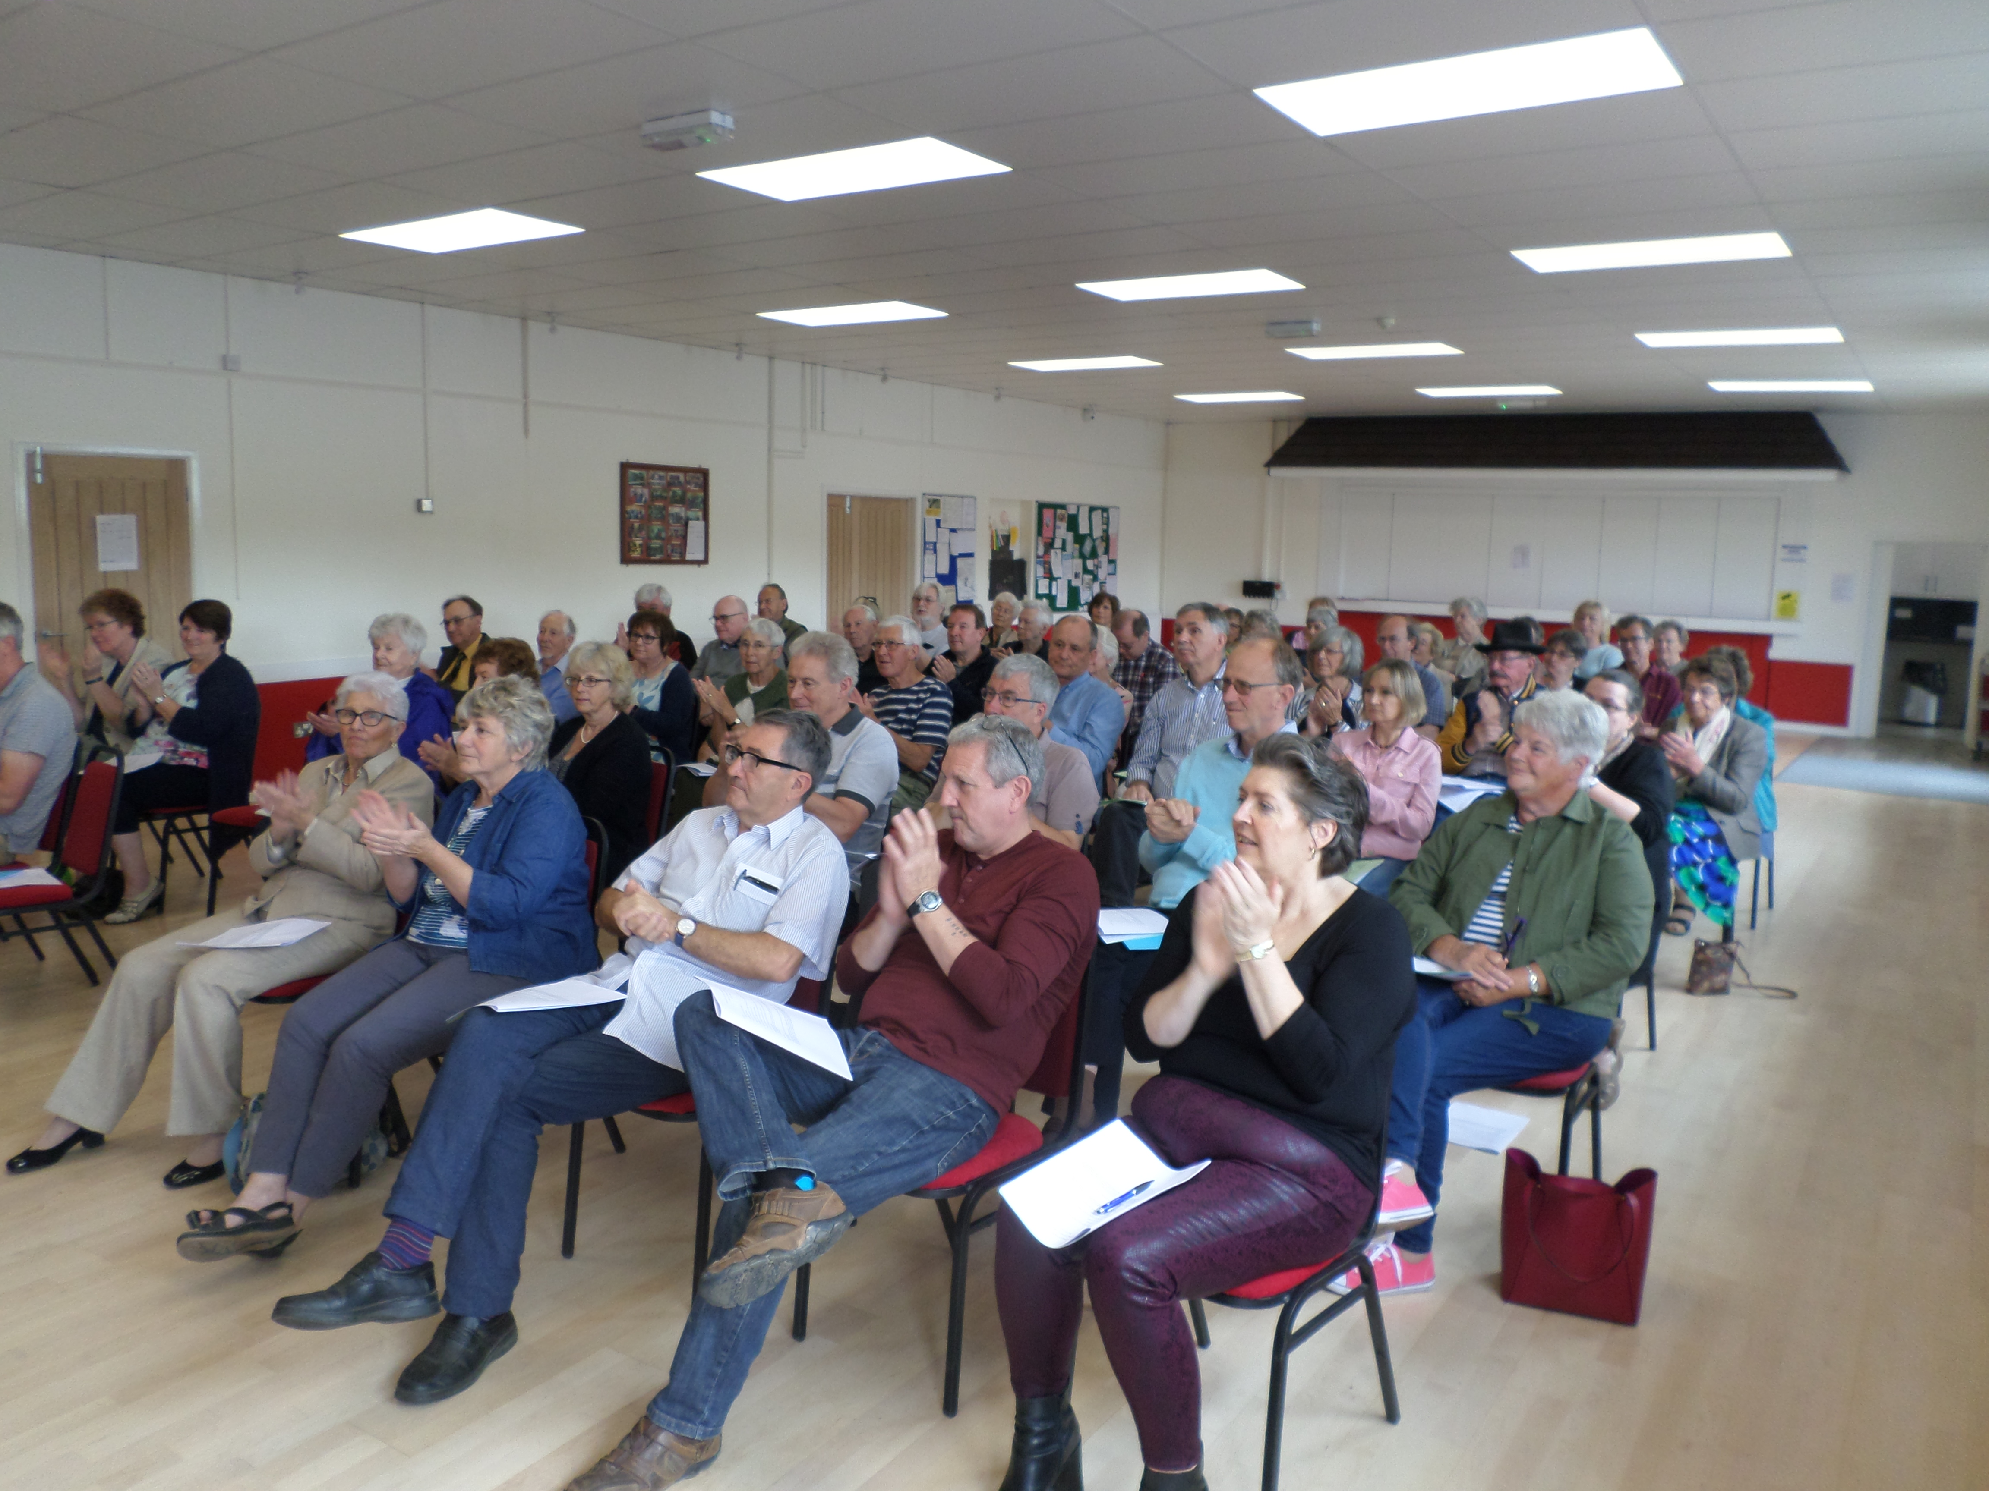

Questions were raised about the format of the Championship Teams and Championship Pairs competitions and those with any ideas as to possible changes are encouraged to get in touch with Tony Russ as follows: scbachair@icloud.com.

The Chairman's AGM report covering the year's events and the current issues in more detail is available here:

http://www.bridgewebs.com/somerset/Chairman.pdf

After the meeting the Swiss teams event was won by Gina and David Howard and Ray Nicholson and Hazel Wotton – congratulations to them all. They won all five matches on the day accruing 85 VPs.

Full results can be found here:

http://www.bridgewebs.com/cgi-bin/bwx/bw.cgi?pid=display_rank&event=20190526_1&club=somerset

The tea as ever was superb and tasted even better for being paid for from county funds. Our member's health always close to the committee's hearts....

Upcoming events for your diary:

- The Barometer Pairs - 28th July at Woolavington At this event the same boards are played simultaneously at all tables enabling a running score to show the fortunes of all competitors as their scores rise and fall. Fair weather for some.... stormy for others is my prediction.
- The Paul Jones - 25th August at Woolavington. Also known as the Pivot teams event – in this competition all players will partner each other member of their team.

Entries for the above are now open and you can register on the SCBA website here: http://www.bridgewebs.com/cgi-bin/bwx/bw.cgi?pid=display_page31&sessid=547087427184089&wd=1&club=somerset

and here:

http://www.bridgewebs.com//cgi-bin/bwx/bw.cgi?club=somerset&pid=display_page6

In addition we have entries building for the West of England Congress taking place at the Winter Gardens in Weston-Super-Mare from 4th - 6th October. More details can be found here:

http://www.bridgewebs.com/cgi-bin/bwx/bw.cgi?club=somerset&pid=display_page51&sessid=369449789283698

Andrew Robson returns to Somerset for three seminars at Street. Friday October 18th is the date for you to reserve – 10am start at the Victoria Club with all the details here:

http://www.bridgewebs.com//somerset/ANDREW%20ROBSON%20at%20STREET.pdf

Still looking for contributions to bulk out the newsletters in the future so have a think about what might interest your fellow players and let me know on paul.burgess738@gmail.com.

Famous names – there have been a few celebrity players over the years. The most famous is probably Omar Sherif and we have two players that I know of in Somerset who have partnered him. Both said that he was a perfect gentleman – one a little wistfully.... Others who have dipped their hand in the bidding box include Errol Brown from Hot Chocolate who was rumoured to burst into a few bars of You Win Again when making a particularly daring contract, Stereophonics who played back stage while waiting to perform and Louis Sachar the author of Holes and the Card Turner which is an excellent book for teaching early teenagers about the game.

If anyone has any anecdotes about well known personalities from the wider world or within the bridge community we would love to hear them. Suitable ones will be referred to our legal team and may be included in future missives.....

