Recommended Bridge Books

Hugh Kelsey [Declaring]  Logical Bridge Play | 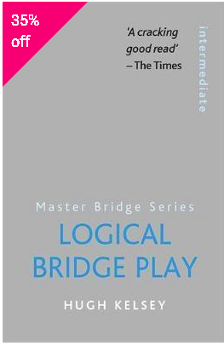
Hugh Kelsey [Defence]  Killing Defence at Bridge | 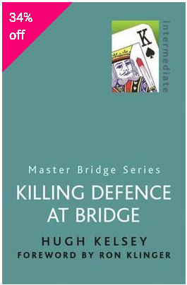
Victor Mollo [Declaring/Defence]  Card Play Technique  *** Must read brilliant | 
Mike Lawrence [Card Play]  How to Read Your Opponents’ Cards | 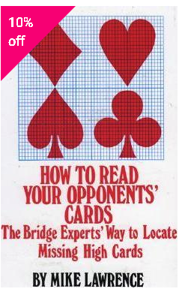

Mike Lawrence [Bidding]  The Complete Book on Overcalls | 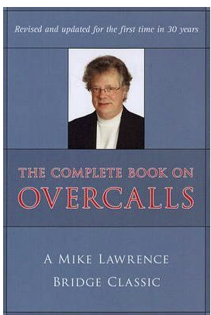
Ron Klinger [Bidding]  The Modern Losing Trick Count  *** a must-know concept | 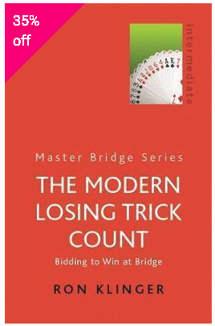
Mike Lawrence [Bidding]  The Complete Guide to Passed Hand Bidding | 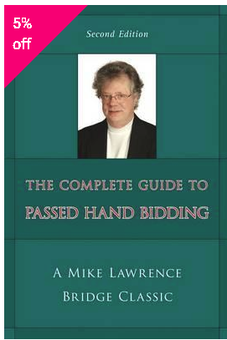
Mike Lawrence [Bidding]  The Complete Book on Takeout Doubles | 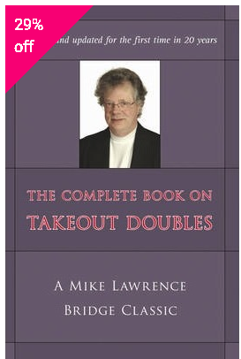

Mike Lawrence [Bidding]  The Complete Book on Balancing | 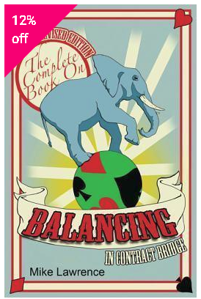
Mike Lawerence [Declaring]  How to Play Card Combinations | 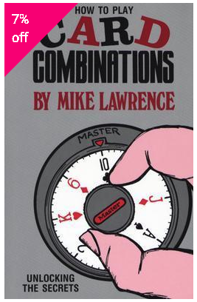
Mike Lawrence [Bidding]  Judgement at Bridge | 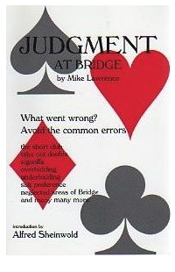
Mike Lawrence [Defence]  Dynamic Defence | 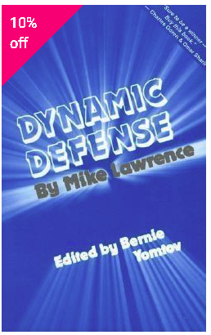

Hugh Kelsey [Defence]  More Killing Defence at Bridge | 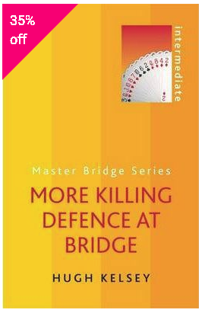
Hugh Kelsey [Declaring]  Kelsey on Squeeze Play | 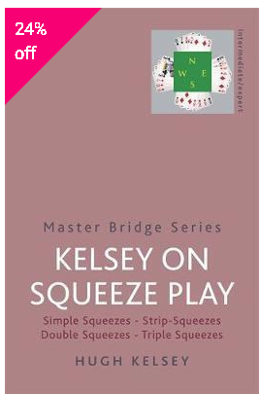
Hugh Kelsey [Card Play]  Bridge Odds for Practical Players | 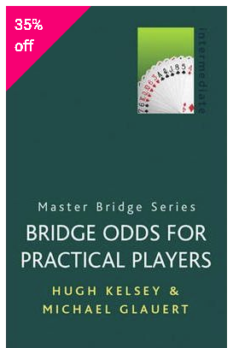
Hugh Kelsey [Card Play]  Test your Timing | 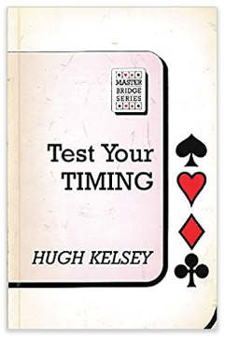

Hugh Kelsey [Card Play]  Test your Pairs Play | 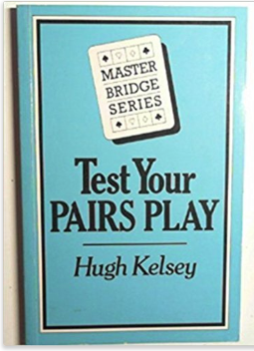
Hugh Kelsey [Defense]  Test your Defensive Play | 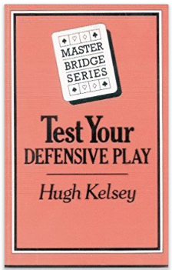
Hugh Kelsey [Card Play]  Test your Elimination Play | 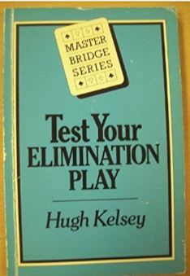
Hugh Kelsey [Card Play]  Test your Trump Control | 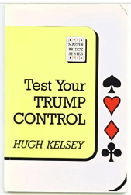

Hugh Kelsey [Card Play]  Test your Communications | 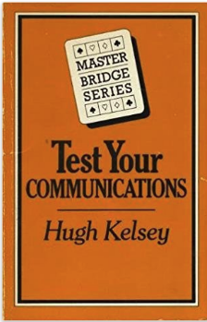
Hugh Kelsey [Declaring]  Test your Finessing | 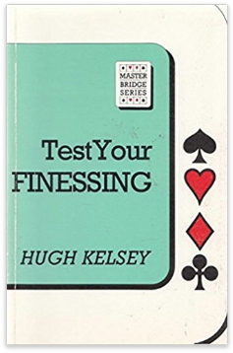
Hugh Kelsey [Card Play]  Test your Card play | 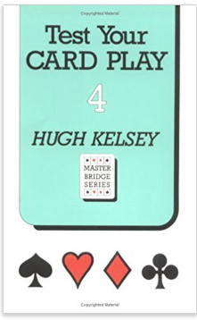
Victor Mollo [Classic]  Bridge in the Menagerie | 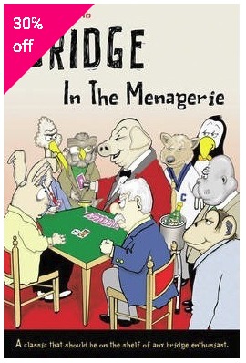

Marty Bergen [Bidding]  Points Schmoints | 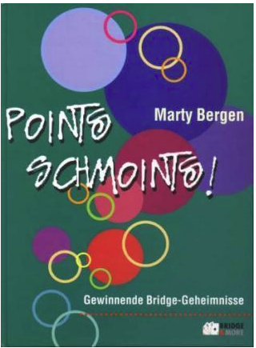
Larry Cohen [Bidding]  To Bid or Not to Bid | 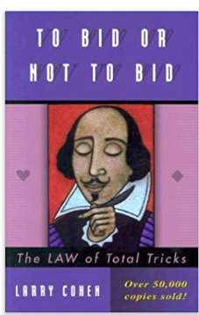
SJ Simon [Classic]  ***Why you Lose at Bridge | 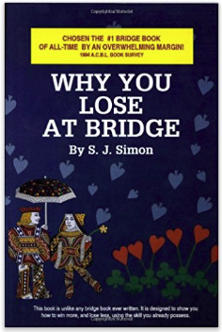
Marty Bergen [Bidding]  More Points Schmoints | 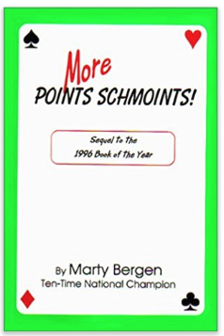

Robert B Ewen [Defence]  Opening Leads | 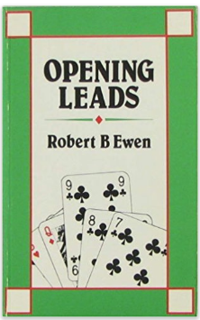

Book depository

Amazon

The bridge world

