RIPLEY BRIDGE CLUB

FED UP WITH THE TV? RECENTLY RETIRED? WANT A NEW INTEREST?
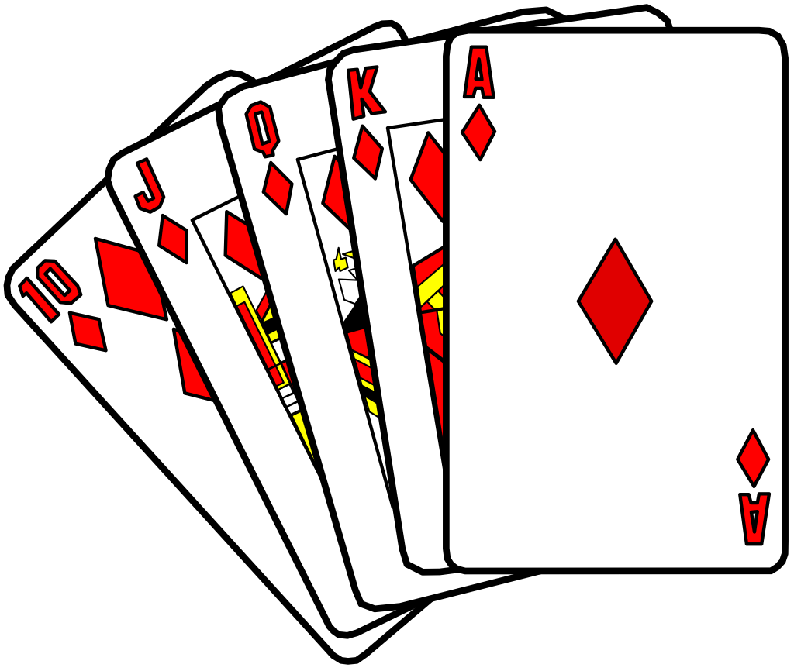
THEN LEARN TO PLAY BRIDGE!

A New 30 Week

BEGINNERS' COURSE

Is to be held in

PENTRICH VILLAGE HALL

WEDNESDAYS - 10:15am to 12:30pm

COMMENCING

17th September 2014

NEVER PLAYED CARDS? NOT SURE IT’S FOR YOU?

JUST COME ALONG and CHECK IT OUT!

FIRST SESSION FREE! NO OBLIGATION!

FOR FURTHER DETAILS CONTACT

PHIL UPTON

07519 610138, 01773 541829, or email : philip.upton@gmail.com

