To import scores from Bridgemates.
Example if originally scores on Score Bridge.

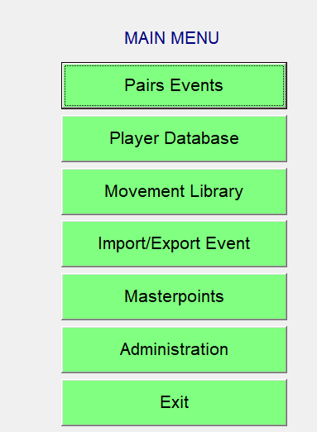

Import/Export Event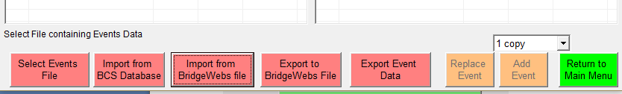
Import from BCS Database
Navigate to required file
OS (C:)\Bridgedata\”club name”\Bridgemates\
Example of file name: 2018May10!! Extension “bws”

