Swiss Teams

** Check Player database before start!
Player Database – Player Management. Copy EBU Database to Scorer Database.

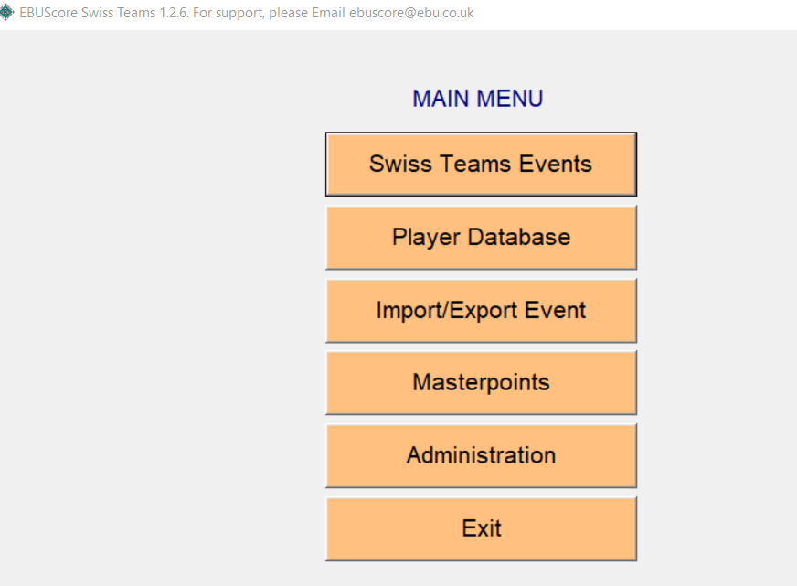

Swiss Team Events
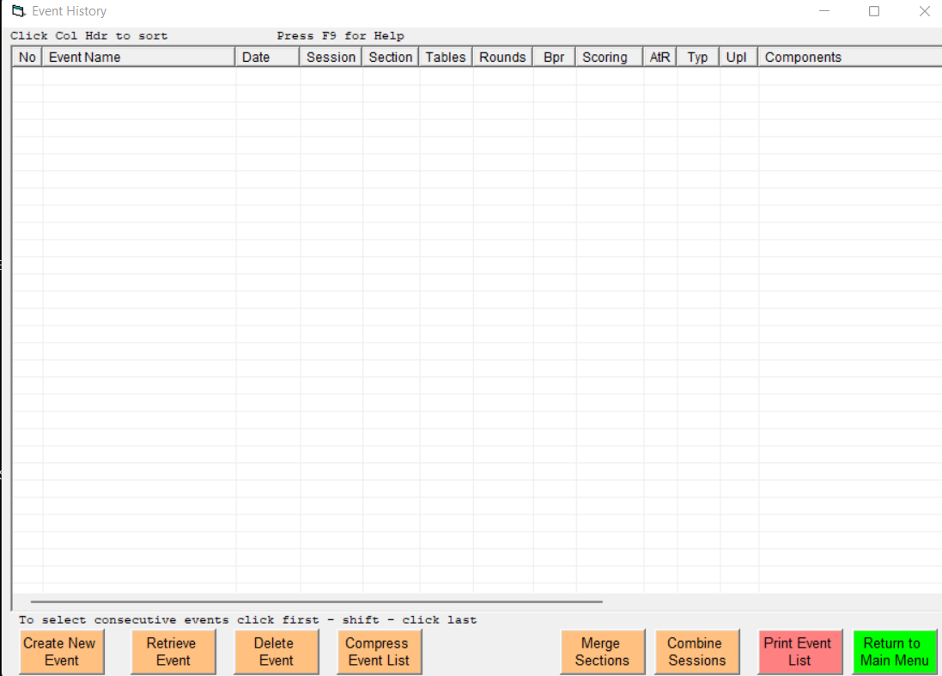

Create New Event. Enter details as required.
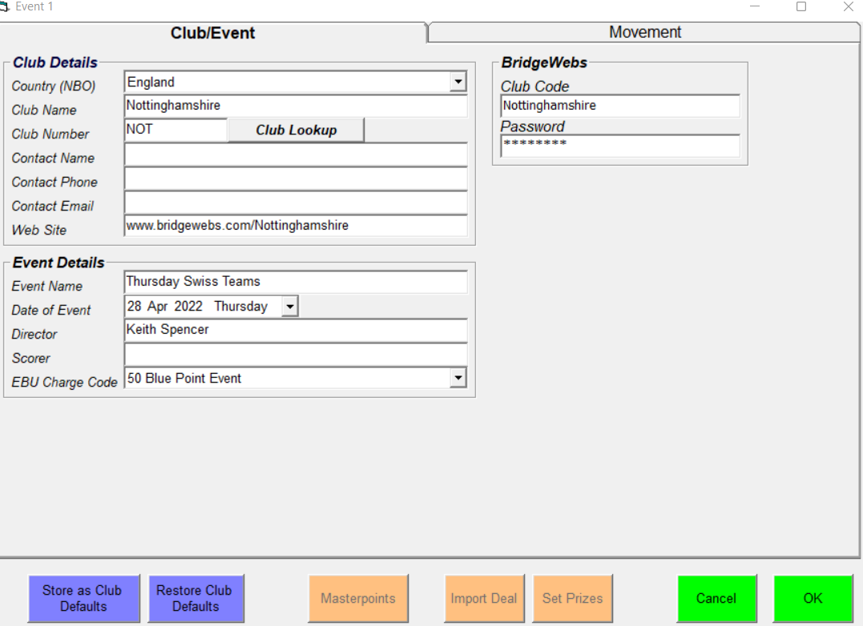

Club Name
Director
EBU Charge Code
Bridgewebs details

You can also import the Deal File from this page.
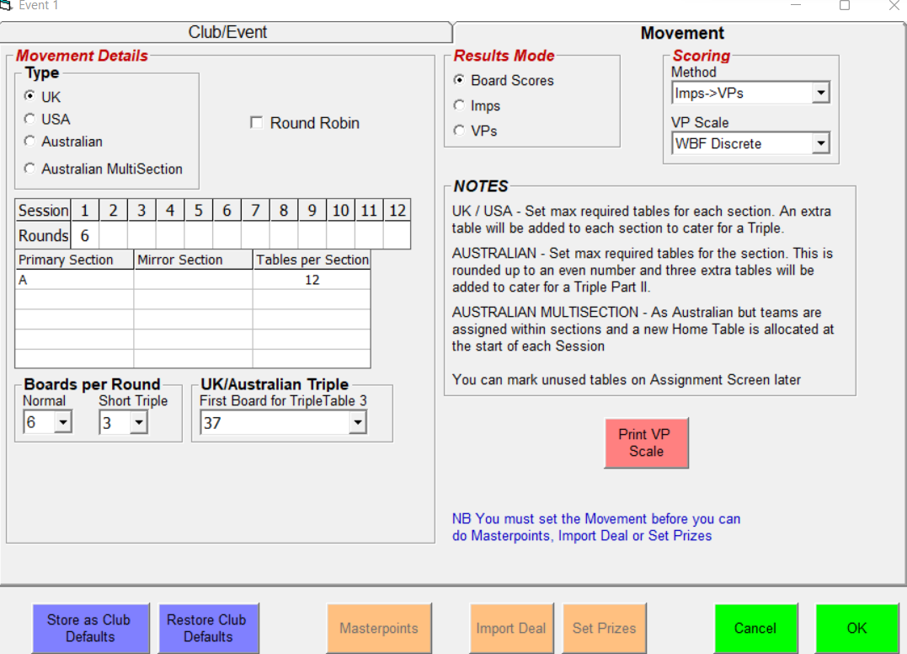

Not sure about Triple?

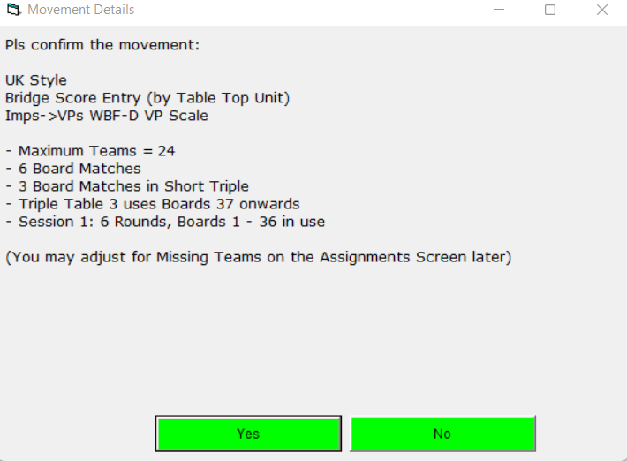

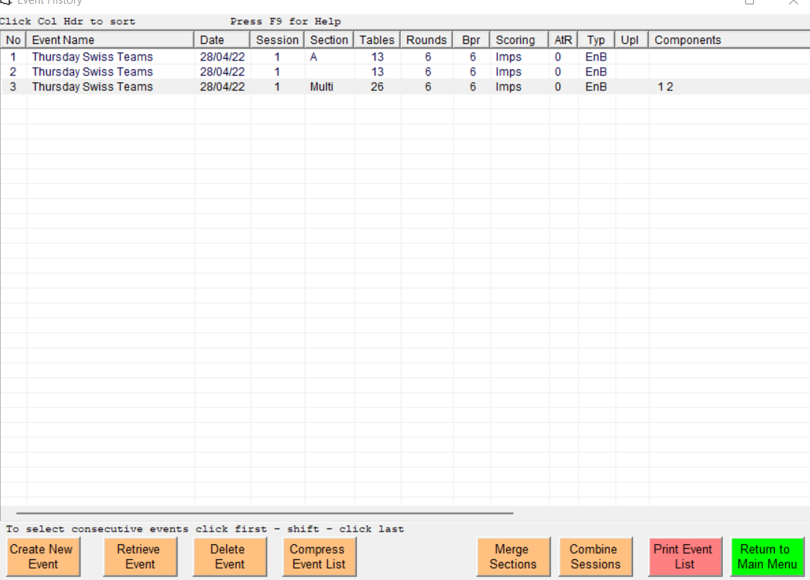
Retrieve Event (Multi)
