Notes for TD on how to use BRIAN
Enter Event ID and Password
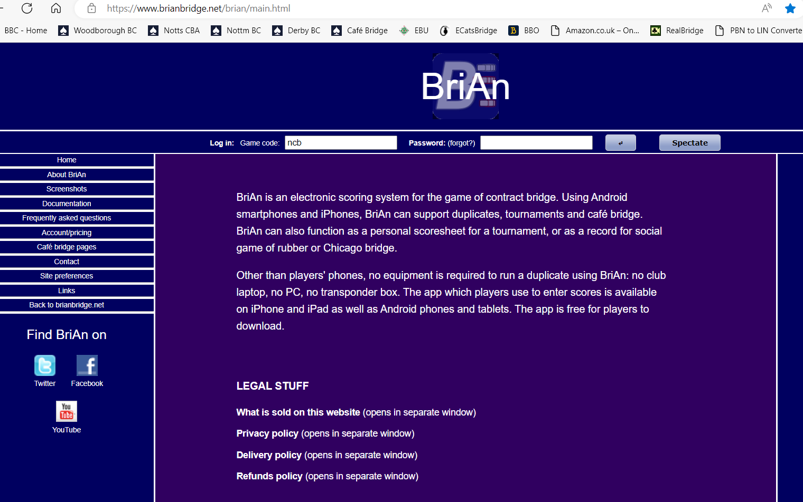
Select “Settings”
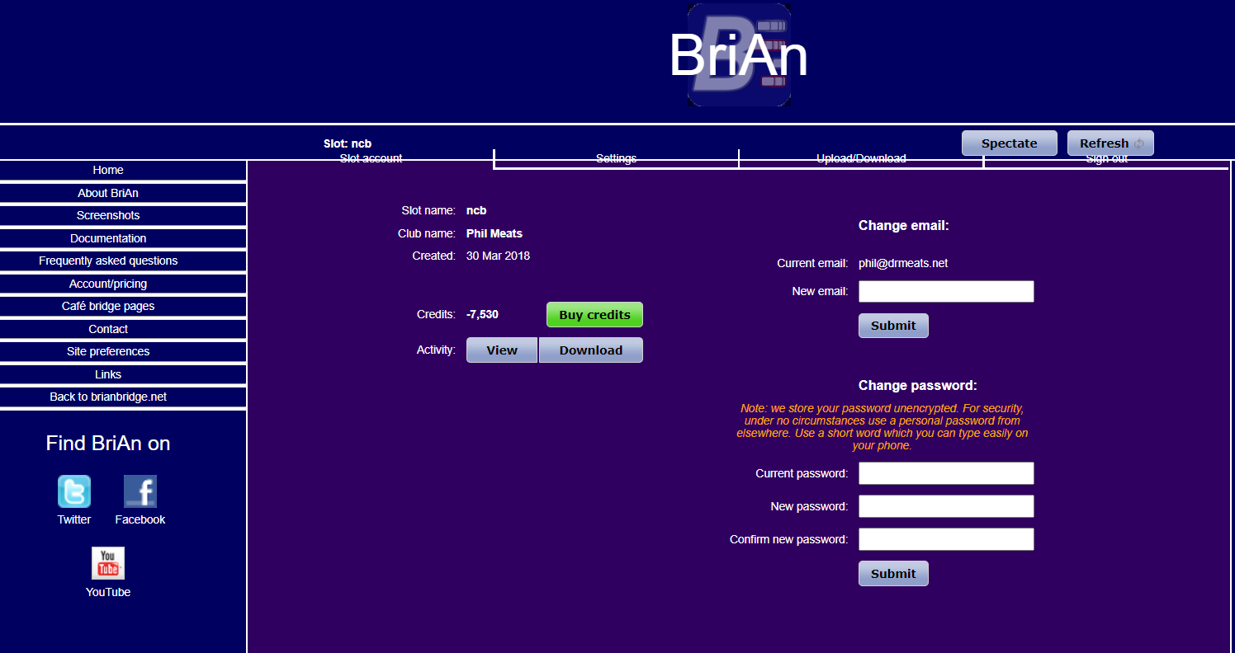

Select “Database”
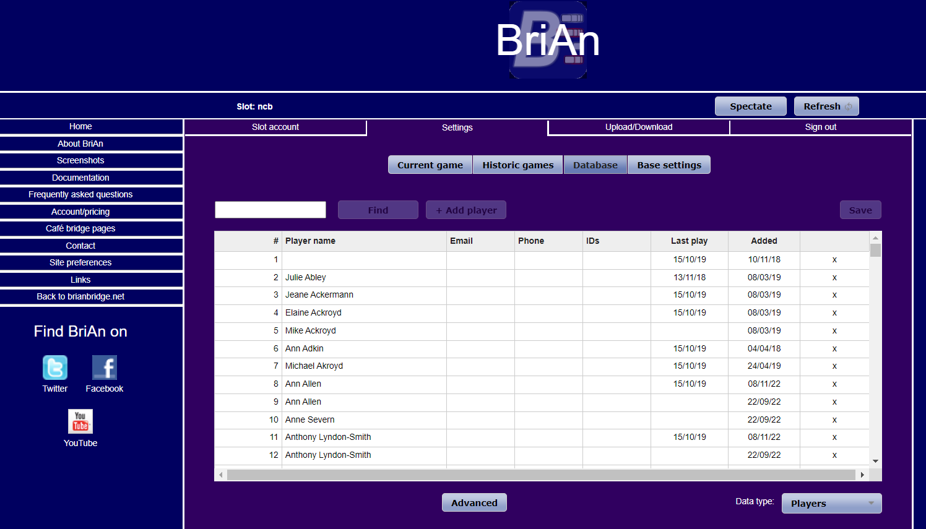
Enter Players names.
SAVE

Best to do this in advance!!

Select “Upload/Download”
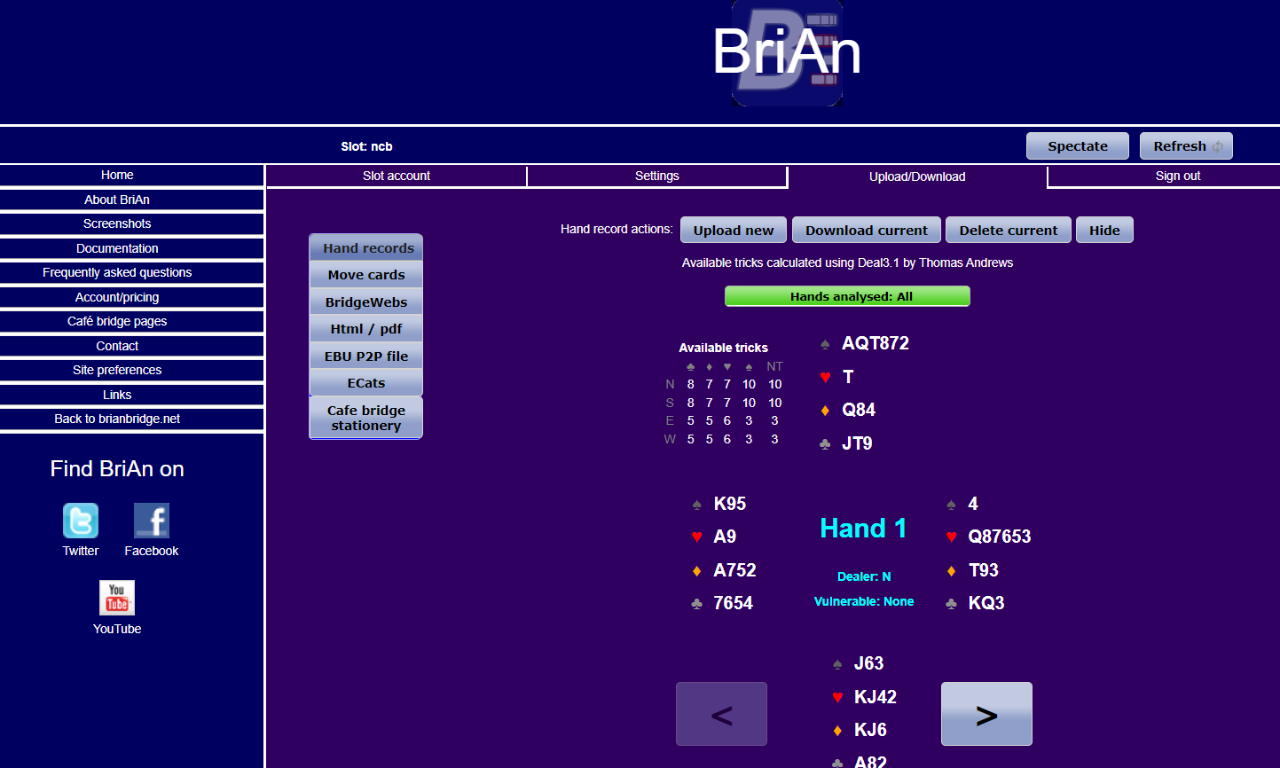

This is where you upload Deal Files

Select “Settings”
Select “Current Game”
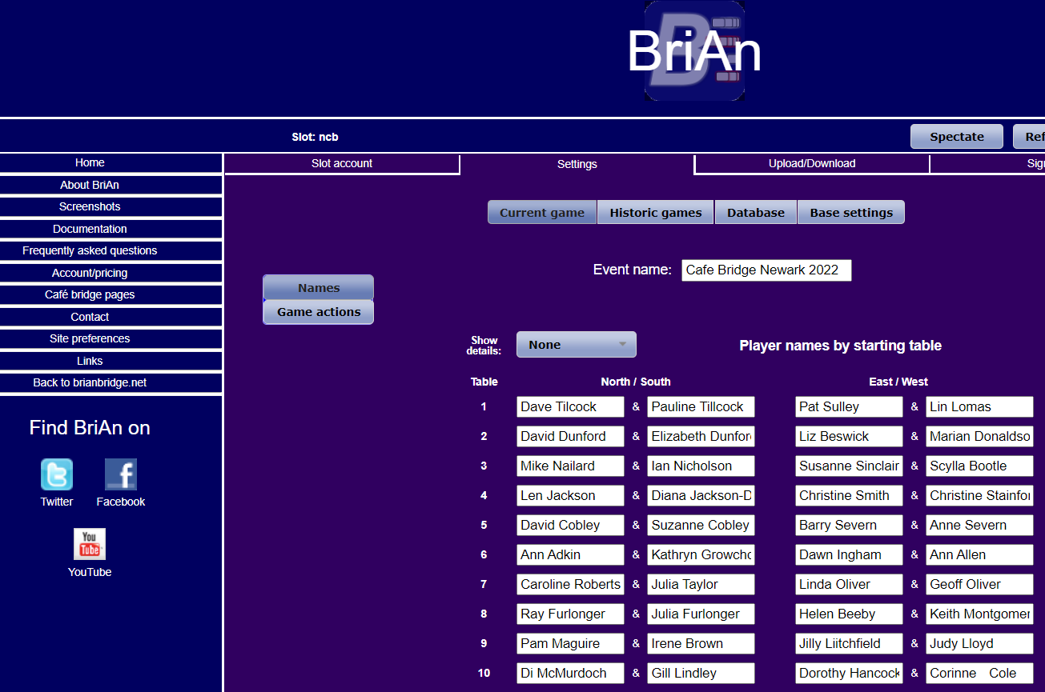

Enter Player names for current Event
** Note you need to look at the Movement!! **
Make note of Pair numbers at each Table!!

Once Event starts you need to use the APP, not the web page.

