District 23 Bridge week 2018
July 2 – 8, 2018
Wednesday, July4

Welcome to Long Beach!

We have a full line-up of games and speakers for you this week – as usual. Before we get down to brass tacks, though, here are a few Important Announcements:

Parking
To get the reduced rate for daily parking you must get your parking ticket validated. Check at the hospitality desk (or the hotel front desk) for information. $6 for self-park.

Session / Section Winners
If you finish atop your section (pairs) or win any event, drop by the Hospitality desk (according to the posted schedule) and (1) pick up your award, (2) find Dave White, our photographer. We’d all like see your smiling face in tomorrow’s Daily Bulletin.

Fourth-of-July Trivia
OK, how much do you know about Your Country? Try this one on for size: our National Anthem, the Star-Spangled Banner, is unique in one peculiar way. No, it’s not the fact that the melody is an old English drinking song (although that’s probably unique among anthems, too). What else is peculiar about our anthem? (Answer on page 5)

Promotions?
If you earn enough points this week to get that Gold Card at our tournament – or any other promotion, for that matter – let Penny (Hospitality Desk) or the Dave White know so we can suitably congratulate you.

Today’s Schedule
10:30 AM
AM Side Game – session 2 of 5
299-er Pairs – single session
Bernie Mateer Stratiflighted
Pairs – session 1 of 2
Lois MillerGold Rush
Pairs – session 1 of 2
Betsy Ross KO – session 3 of 4
Firecracker KO – session 1 of 4

2:15PM
Guest Lecture –Leo Bell, “How to Irritate Partner”

3:00 PM
Afternoon Side Game – session 3 of 6
Betsy Ross KO – session 4 of 4
Firecracker KO – session 2 of 4
Bernie Mateer Stratiflighted
Pairs – session 2 of 2
Lois MillerGold Rush
Pairs – session 2 of 2
Stratified Swiss Teams – single session

7:30 PM
Blackbird Turbo Swiss – session 1 of 2
PM Side Game – session 2 of 5

“If you want to come forth on the 5th, don’t drink a fifth on the 4th.”

Tournament Directing Staff
Ken Horwedel – Director-in-Charge
Scott Campbell
Arleen Harvey
Patty Holmes
Peter Knee
Brandon Sheumaker
Gary Zeiger

Tournament Committee
Mike Marcucci– District 23 President
Kevin Lane – District Director
Stan Holzberg – Tournament Chair
Peter Benjamin – Tournament Manager
Kim Wang – Caddy Master
Penny Barbieri – Hospitality &Newcomers
Diane Sachs – Partnerships
Gerri Carlson – Publicity &299-er Education
Margie Michelin – Pro Speakers
Jeff Grotenhuis – Novices&
Intermediate/Newcomers
Tom Lill – Daily Bulletin
Dave White – Photography

299-er Quiz
Today we have another easy one for you. Although this situation doesn’t come up too often, when it does, the solution is very useful.
Playing either Standard or 2/1 (it doesn’t matter in this case), you find yourself looking at
♠Q108 ♥A1052 ♦K96 ♣J54
Partner deals and opens 1♠. With the opponents silent throughout, you judge your flat hand (not to mention the unsupported ♣J) not worth more than a raise to 2♠. Partner makes a game try of 3♥, and you ... ? (Answer on page 3).

SPECIAL ANNOUNCEMENT
Contrary to what the tournament flyer says, there WILL be a Gold Rush Pairs event on Thursday: 10:30 a.m. and 3:00 p.m.

The Chronicles of Steve

In the San Diego Regional Team Games

with Linda and Jay Tipton

by Mike Savage

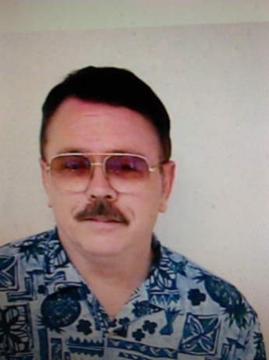
Can 4♠ make? Should we be in 4♠? South only made 3♠ while our E/W was down 2 in 3♦.
Scoring: IMPs
Dealer: East
Vulnerability: North-South
North
♠ K J 7 x
♥ x
♦ J x x x
♣ A x x x
West East
♠ 10 9 8 x ♠ x
♥ Q ♥ A 10 x x x x
♦ K 10 x x ♦ A Q 9x
♣ J 9 x x ♣ Q x
South
♠ A Q x x
♥ K J 9 x x
♦ x
♣ K 10 x

The bidding at our table:
N E S W
1♥ 1♠ pass
2♥ pass 2NT pass
3♠ all pass

Lead: ♥Q followed by a spade shift

The bidding at the other table:
N E S W
1♥ 1♠ dbl
2♠ 3♦ all pass

After the opening lead and dummy hit, South thought North might have bid 4♠ after he had shown more than a minimum overcall, but try as he might, with the 4-1 trump break, declarer was only able to take nine tricks for plus 140.Can you find a way that ten tricks could have been made? At the other table, after West’s negative double for the minors, East rebid 3♦ over 2♠, and was allowed to play it there as North didn’t bid 3♠. But after a 4-1 trump break,3♦ went down 2 (-100), a 1 IMP gain for us.

Today’s Honorees
Lois Miller
Today’s Gold Rush Pairs event is in memory of Lois Miller, Unit 559, who loved her Family, friends and bridge.
Bernie Mateer
Bernie Mateer, affectionately called “Bernie” or “Burnsy” by her many friends, was a classy lady. She was a wonderful human being, generous to a fault, always ready to help out and volunteer. She started playing bridge in the 1980s after raising three children, mentored by her husband Bob. She achieved the rank of Silver Life Master and was a longstanding member of the Pasadena / San Gabriel Unit (559) Board. She volunteered at the summer Nationals held in Pasadena in the 1990s and was in charge of arranging sight seeing trips for visiting dignitaries.
Her contributions were recognized by being awarded the ACBL Friendship Pin.
Bernie was active at the Theodore Payne Foundation, interested in native plants. For many years her native plant garden was on the Foundation’s annual visiting list. Bernie was a fabulous hostess and her patio parties were famous in the local bridge circles.
She contracted lung cancer and passed away on Mother’s Day, 2016. We shall cherish her memory.

Thursday’s Schedule
10:30 AM
AM Side Game – session 3 of 5
299-er Pairs – single session
*Miriam Collup Stratified
Pairs – session 1 of 2
Firecracker KO – session 3 of 4
Red & White Stratified Swiss
Teams – session 1 of 2
2:15PM
Guest Lecture –Marjorie Michelin, “Match Point Play

3:00 PM
Afternoon Side Game – session 4 of 6
Firecracker KO – session 4 of 4
Miriam Collup Stratified
Pairs – session 2 of 2
Red & White Stratified Swiss
Teams – session 2 of 2
Stratified Swiss Teams – single session

7:30 PM
Blackbird Turbo Swiss – session 2 of 2
PM Side Game – session 3 of 5

Get Your Results
Would you like to have your session results delivered to you right after each session? It can be done! Simply go to www.acbl.org, click on the LIVE button at the top of the home page, and follow the instructions. You will get an email after each session you play, with a link to your results – contract, result, matchpoints for each deal – and your masterpoints if any. (For team games, of course you don’t get the contracts and results, since these are shuffle-deal-and-play events.)

Schedule of Speakers
We have another winning line-up of speakers for you, to help you improve your game. (Not that your game needs improvement, but there’s always partner!)

Wednesday
2:15: Leo Bell, “How to Irritate Partner”
Thursday
2:15: Marjorie Michelin, “Match Point Play”
Friday
2:15: Master Solvers Panel – Mitch Dunitz, Moderator, with an all-star panel:
Ellen Anten
Ifti Baqai
Leo Bell
Mark Itabashi
John Jones

Answer to 299-er Quiz
Obviously, with a maximum and help in hearts, you are going to accept the game try. But, why bid 4♠ right away? Bid 4♥, instead. If partner has four hearts, maybe that’s where you want to be. Remember, a 4-4 fit often plays better than a 5-3 fit, because you are likely to get two discards on the five card suit. Also, with your flat hand, partner isn’t ruffing anything in dummy, while she must have a short suit of her own. (With five spades, she has to have a doubleton at least!) Better to be able to take the taps using hearts rather than spades – remember, a 4-1 trump break is better than a 28% chance. And if partner doesn’t have four hearts, no problem, she just bids 4♠.

Remember
When an irregularity occurs at the table, calmly summon a Director. Do not attempt to “fix” things by yourself. You are most likely to worsen the situation (for your side!) if you try to rectify the error without the Director’s help.

Today’s Speaker
Leo Bell,
“How to Irritate Partner”

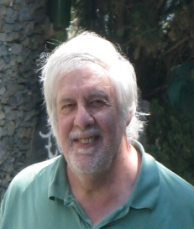

ACBL Grand Life Master and world Champion (2004 World Team Olympiad – Senior) winner of numerous regional events.
Teacher and director for over 30 years. Retired as a financial manager, now travels as a touring bridge professional, Coached the United States juniors for international competition. Member of the ACBL National Goodwill Committee.

Fourth of July Trivia Answer
The Star-Spangled Banner is the only national anthem that both begins and ends with a question! (Just the first stanza, that is. There are three more stanzas ... one of which is officially frowned upon nowadays, because it says some very not-so-nice things about the British.)

Bridge Quote-for-the-Day
It is not enough to win the tricks that belong to you. Try also for some that belong to the opponents. – Alfred Sheinwold
Bridge Odds-‘n-Ends
Did you know ...
… from page 348 of the Bridge Encyclopedia: There are 3756 possible perfect hands, defined as a hand that will produce 13 tricks in notrump irrespective of the opening lead or the composition of the other three hands. One example: AKQJxxxxx AK A A. As there are 635,013,559,600 possible hands a player can hold, the odds against holding a perfect hand are 169,066,442 to 1.
☺
CONGRATULATIONS TO THE WINNERS!
Tuesday Gold Rush
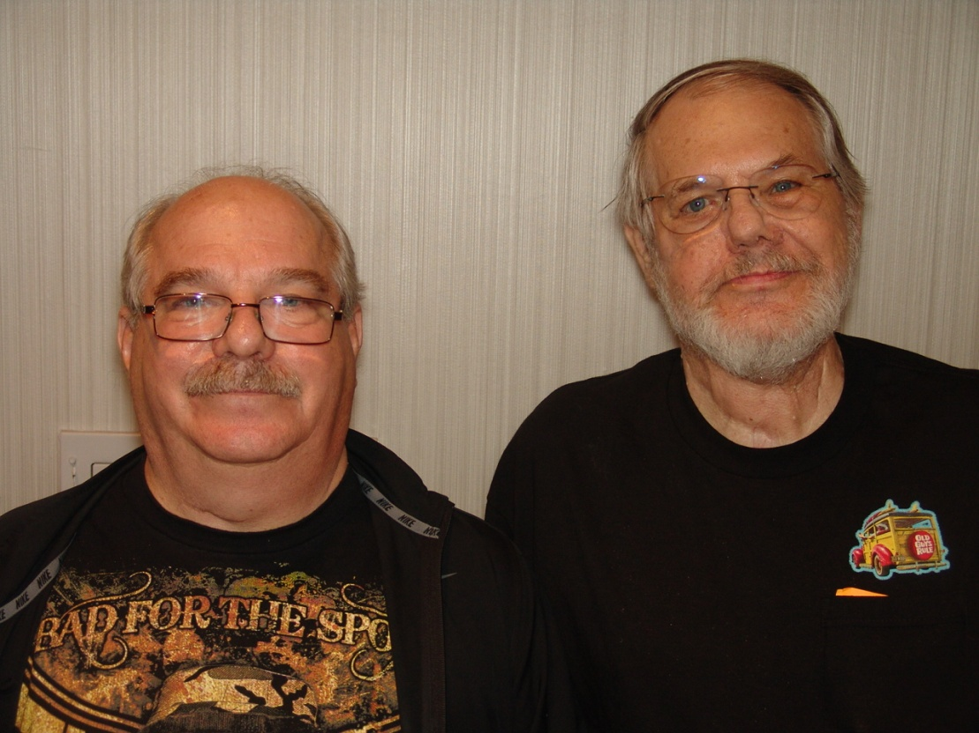

Richard and John Bakovic

Tuesday Strati-Flighted Pairs
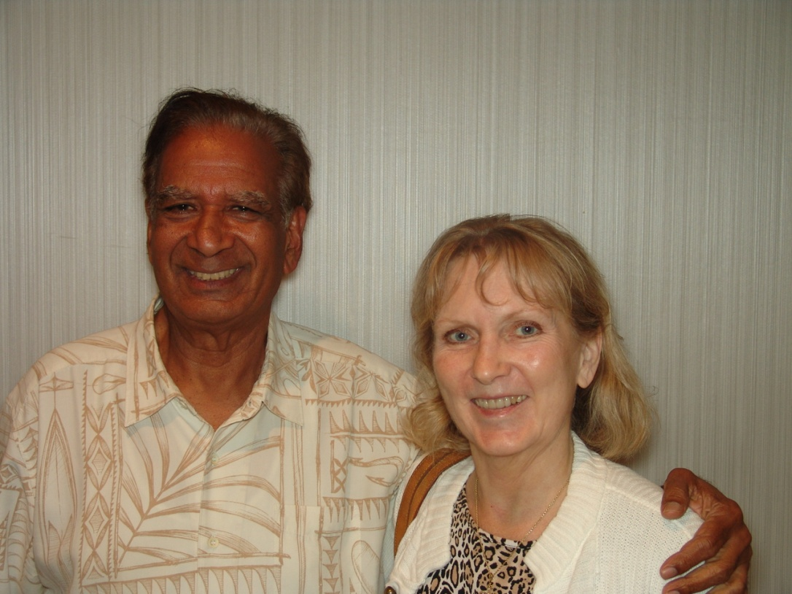

Gale Senter and Subba Ravipudi

BELATED MONDAY RESULTS

PRO-AM PAIRS MON AFT SESSION

NORTH-SOUTH SECTION K EAST-WEST
A B C A B C
1 Leo Bell, Carlsbad CA; 1 1 1 J Ross Bengel, Playa
Levi Katriel, Del Mar CA 59.67% Del Rey CA; Myrna
2 1 1 Melanie Smith, Long Kupperman, Laguna Woods CA 55.83%
Beach CA; Joyce Field, 2 John Jones, Santa Fe
Torrance CA 58.15% Spgs CA; Judith Cook,
3 2 Milton Kalikman, Azusa Seal Beach CA 55.80%
CA; Linda Tessier, 3 Steve Mager, Hermosa
Pomona CA 56.07% Beach CA; Howard
4 3 2 Steve Ramos Jr, Seal Schecter, Hawthorne CA 55.71%
Beach CA; Barbara 4 2 2 Morris Jones, Monrovia
Fuller, El Segundo CA 55.24% CA; Pat Marlowe,
5 4 Booth Tarkington - Torrance CA 55.12%
Harold Avent, Rancho 5 3 Frances Israel, Palos
Palo Vds CA 54.17% Verdes Pn CA; Sue
Reese, Lomita CA 53.21%
4 3 Genise Hasan, Santa
Monica CA; Glen
Musicer, Torrance CA 53.04%
4 James Gardner,
Northridge CA; Judy
Strauss, Long Beach CA 49.82%

NORTH-SOUTH SECTION L EAST-WEST
A B C A B C
1 Ellen Anten, Encino CA; 1 Walter Schafer Jr,
Carol Schamp, Rancho Fountain Valley CA;
Palos Vs CA 55.42% Lillian Slater, Long 60.60%
2 Calvin Waller, Rancho 2 Carol Frank, Burbank
Palo Vds CA; Raeann CA; Nancy Guenther,
Koerner, Ventura CA 52.44% Palos Verdes Es CA 60.36%
3 Mark Tang, Seal Beach 3 Chiye Horiguchi,
CA; Marla Horn, Redondo Gardena CA; Katharine
Beach CA 50.89% Seibert, Long Beach CA 57.50%
4 Bruce Horiguchi, 4 Jenny Ernest, Long
Gardena CA; Carolyn Beach CA; Clinton Lew,
Byrnes, Long Beach CA 50.36% Claremont CA 56.13%
5 Patricia Schenasi, 5 Sumit Daftuar, Arcadia
Redondo Beach CA; CA; Peggy Shoup, Laguna
Joanne Hadley, 50.24% Niguel CA 54.23%
1 1 Barry Potter, Long
Beach CA; Beverly
Narahara, Rancho Palo 48.27%

NORTH-SOUTH SECTION M EAST-WEST
A B C A B C
1 Brian Glubok, New York 1 Laura Gastelum,
NY; Brenda Perry, Napa CA 62.29% Torrance CA; Bruce
2 Betsey Amador, Rancho Schelden, Playa Del Rey CA 61.49%
Palo Vds CA; Craig 2 Murdoch Heideman,
Wilson, Burnaby BC 61.82% Irvine CA; Matthew
3 Stephen Goldstein, Mallory, Laguna Woods CA 59.70%
Anaheim CA; Stephen 3 Michael Marcucci, San
Perry, Napa CA 58.84% Gabriel CA; Brigitte
4 Stanley Greengard, Prince, Hermosa Beach CA 55.30%
Torrance CA; Ana Winn, 4 Alex Fowlie, San Marcos
Long Beach CA 58.07% CA; Ted Dowe, Long Beach CA 55.09%
5 Michael Mikyska, Los 5 Deeann Huddleston, Long
Angeles CA; Steven Beach CA; Stephen
Nesseler, Kaneohe HI 51.46% Sturm, Fullerton CA 53.13%

MON AFT SIDE GAME 1ST OF 6 SESSION

NORTH-SOUTH SECTION N EAST-WEST
A B C A B C
1 Kevin Dwyer, Melbourne 1 Iftikhar Baqai, Irvine
FL; Cookie Potter, Boca CA; Mitch Dunitz,
Grande FL 61.62% Sherman Oaks CA 62.46%
2 Brian Gilbert, Irvine 2 Lisa Evans, Danville
CA; Allan Deserpa, Tempe AZ 59.60% CA; Cheryl Haines, Half
3 Sherman Gao - Weidong Moon Bay CA 60.94%
Pei, Brea CA 59.09% 3 Paul Darin, San Diego
4 David Abelow, La Jolla CA; Mary Loehr, El Cajon CA 59.26%
CA; Phyllis Yates, San 4 1 Linda Young, Butte MT;
Diego CA 58.92% Russell Buker, Lancaster CA 58.25%
5 Valentin Kovachev, Las 5 2 1 Robert Barrett - Lori
Vegas NV; Carole Liss, Barrett, Santa Ana CA 55.89%
San Rafael CA 57.74% 3 2 Linda Stuart, San Dimas
1 Harry Wessels, Rancho CA; Thomas Stephenson,
Palo Vds CA; Elaine Arcadia CA 51.85%
Godin, Manhattan Beach CA 48.65% 3 Timothy Cole - Bonny
2 1 Michael Black, Walsh, Long Beach CA 49.49%
Huntington Bch CA;
Mariann Satin, Long 48.15%
3 2 Frederick Solomon,
Irvine CA; Dale
Rensing, Fountain Valley CA 44.78%

PRO-AM PAIRS
38.0 Tables
A B C
11.20 1 Brian Glubok, New York NY; Brenda
Perry, Napa CA 62.29%
8.40 2 Betsey Amador, Rancho Palo Vds CA;
Craig Wilson, Burnaby BC 61.82%
6.30 3 Laura Gastelum, Torrance CA; Bruce
Schelden, Playa Del Rey CA 61.49%
4.73 4 Walter Schafer Jr, Fountain Valley
CA; Lillian Slater, Long Beach CA 60.60%
3.54 5 Carol Frank, Burbank CA; Nancy
Guenther, Palos Verdes Es CA 60.36%
2.66 6 Murdoch Heideman, Irvine CA;
Matthew Mallory, Laguna Woods CA 59.70%
2.68 7 Leo Bell, Carlsbad CA; Levi
Katriel, Del Mar CA 59.67%
1.50 8 Stephen Goldstein, Anaheim CA;
Stephen Perry, Napa CA 58.84%
4.03 9 1 1 Melanie Smith, Long Beach CA; Joyce
Field, Torrance CA 58.15%
1.12 10 Stanley Greengard, Torrance CA; Ana
Winn, Long Beach CA 58.07%
1.29 11 Chiye Horiguchi, Gardena CA;
Katharine Seibert, Long Beach CA 57.50%
3.02 2 Milton Kalikman, Azusa CA; Linda
Tessier, Pomona CA 56.07%
2.68 3 2 J Ross Bengel, Playa Del Rey CA;
Myrna Kupperman, Laguna Woods CA 55.83%
1.70 4 3 Steve Ramos Jr, Seal Beach CA;
Barbara Fuller, El Segundo CA 55.24%
1.28 5 4 Morris Jones, Monrovia CA; Pat
Marlowe, Torrance CA 55.12%
0.96 6 5 Booth Tarkington - Harold Avent,
Rancho Palo Vds CA 54.17%
0.67 6 Genise Hasan, Santa Monica CA; Glen
Musicer, Torrance CA 53.04%

MON AFT SIDE GAME
12.0 Tables
A B C
4.17 1 Iftikhar Baqai, Irvine CA; Mitch
Dunitz, Sherman Oaks CA 62.46%
3.13 2 Kevin Dwyer, Melbourne FL; Cookie
Potter, Boca Grande FL 61.62%
2.35 3 Lisa Evans, Danville CA; Cheryl
Haines, Half Moon Bay CA 60.94%
1.80 4 Brian Gilbert, Irvine CA; Allan
Deserpa, Tempe AZ 59.60%
1.32 5 Paul Darin, San Diego CA; Mary
Loehr, El Cajon CA 59.26%
1.29 6 Sherman Gao - Weidong Pei, Brea CA 59.09%
3.41 1 Linda Young, Butte MT; Russell
Buker, Lancaster CA 58.25%
2.98 2 1 Robert Barrett - Lori Barrett,
Santa Ana CA 55.89%
2.24 3 2 Linda Stuart, San Dimas CA; Thomas
Stephenson, Arcadia CA 51.85%
1.68 4 3 Timothy Cole - Bonny Walsh, Long
Beach CA 49.49%
1.86 5 Harry Wessels, Rancho Palo Vds CA;
Elaine Godin, Manhattan Beach CA 48.65%
1.40 4 Michael Black, Huntington Bch CA;
Mariann Satin, Long Beach CA 48.15%
0.98 5 Frederick Solomon, Irvine CA; Dale
Rensing, Fountain Valley CA 44.78%

TUESDAY’S RESULTS

TUE OPEN PAIRS FIRST SESSION

NORTH-SOUTH SECTION G EAST-WEST
A B C A B C
1 1 1 Jeremy Maurer, 1 Gale Senter, San
Orangevale CA; Steve Clemente CA; Subba
Maurer, Fair Oaks CA 57.19% Ravipudi, Downey CA 62.38%
2 Valentin Kovachev, Las 2 Mark Itabashi, Murrieta
Vegas NV; Carole Liss, CA; Peter Gelfand,
San Rafael CA 53.27% Corralitos CA 59.48%
3 2 2 Wayne Otsuki, Rancho 3 Stephen Goldstein,
Palo Vds CA; C. Valerie Anaheim CA; Michael
Gamio, Palos Verdes Pn CA 51.72% Shaw, Los Angeles CA 58.04%
4 Sudhakar Divakaruni, 4 1 1 Wayne Gorski, Mission
Scottsdale AZ; John Viejo CA; Bob Cuccias,
Mohan, Las Vegas NV 50.97% Laguna Woods CA 56.82%
5 3 Sherman Gao, Brea CA; 5 2 Robert Carroll - Sandra
Robert Micone, Tustin CA 47.78% Carroll, Los Angeles CA 56.15%
4 3 Abby Triback, Altadena 3 2 Robert Rubin, Whittier
CA; Sadika Elewy, CA; Harry Sacks,
Pasadena CA 46.97% Hacienda Hgts CA 55.23%

NORTH-SOUTH SECTION H EAST-WEST
A B C A B C
1 Bob Etter, Elk Grove 1 Crispin Barrere,
CA; Jack Waller, Dana Berkeley CA; Rick
Point CA 62.69% Roeder, La Mesa CA 59.62%
2 Marjorie Michelin, 2 John Schnell - Della
Laguna Woods CA; Marcus Schnell, Paradise Valley AZ 53.42%
Evans, Orange CA 59.78% 3 1 1 Ted Gibbs, Rancho Palo
3 Brian Gilbert, Irvine Vds CA; Mike Welsh,
CA; Allan Deserpa, Tempe AZ 55.92% Manhattan Beach CA 51.99%
4 1 Matthew Mallory, Laguna 4 2 Lisa Evans, Danville
Woods CA; Stanford CA; Cheryl Haines, Half
Holzberg, Sherman Oaks CA 55.32% Moon Bay CA 50.54%
5/6 2/3 1/2 Phil Feldman, Los 5 Walter Schafer Jr,
Angeles CA; James Fountain Valley CA;
Nicola, Whittier CA 55.19% Wenjia Yan, Cerritos CA 48.79%
5/6 2/3 1/2 Dalia Hernandez - 3 2 Michael Mezin, San
Robert Preece, Long Diego CA; Elaine Chan,
Beach CA 55.19% La Jolla CA 47.28%

TUE GOLD RUSH PAIRS FIRST SESSION

NORTH-SOUTH SECTION I EAST-WEST
7 3 1 7 3 1
1 Judy Brennan, Laguna 1 1 1 Glen Musicer - Caryn
Beach CA; Margaret Musicer, Torrance CA 56.43%
Briskie, Coto De Caza CA 54.71% 2 2 Anand Mhaskar,
2 1 John Galligher, Succasunna NJ; Madhav
Huntington Bch CA; Gokhale, Bengaluru 52.90%
Ardis Laine, Long Beach CA 53.71% 3 Barbara Wallace, Long
3 2 Carol Hanson, Redondo Beach CA; Mark Singer,
Beach CA; Diane Maye, Huntington Bch CA 52.08%
Palos Verdes Es CA 51.90% 4 Susan Skara, Orange CA;
4 Donna Abersman, Dana Peggy Shoup, Laguna
Point CA; Panna Niguel CA 51.54%
Chaudhari, Laguna Niguel CA 51.54%

NORTH-SOUTH SECTION J EAST-WEST
7 3 1 7 3 1
1 1 Erica Walker, Dallas 1 Jeffrey Hartmann,
TX; Vicky Renzulli, Northridge CA; Tony
Dana Point CA 56.88% Mirchandani, Studio City CA 57.07%
2 Rae Yan, Manhattan 2 Richard Buhl - Joan
Beach CA; Craig Wilson, Buhl, Long Beach CA 55.71%
Burnaby BC 56.70% 3 Thomas Lill, Chino CA;
3 Lou Zucker - Judy Linda Tessier, Pomona CA 54.71%
Zucker, Santa Monica CA 53.99% 4 1 Jack Stewart, Torrance
4 Delene Hoff, Trabuco CA; Sandy Rathbun,
Canyon CA; Raquel Manhattan Beach CA 53.35%
Unger, Laguna Woods CA 52.90% 2 Bonnie Simon - Louise
Lee, Newport Beach CA 52.08%

NORTH-SOUTH SECTION K EAST-WEST
7 3 1 7 3 1
1 John Bakovic, 1 1 Richard Schaeffer, Long
Springfield VA; Richard Beach CA; Glen Drogin,
Bakovic, San Pedro CA 67.93% Altadena CA 56.34%
2 1 1 Mark Rappaport - Larisa 2 Cheeky Carlson, La
Rappaport, Beverly Hills CA 57.43% Quinta CA; Hugh Meeks,
3 2 Gulie Hamir, Ran Msn Rancho Mirage CA 54.89%
Viejo CA; Bonnie 3 Margaret Bissell,
O'Donnell, Corona Del 54.53% Westlake Vlg CA; Sin
4 Larry Shannon, Yorba Orensztein, North 54.71%
Linda CA; Chuck Lohr, 4 Douglas Carlson -
Eastvale CA 51.27% Howard Schecter,
Hawthorne CA 52.99%

TUE AM 299ER PAIRS ONLY SESSION

NORTH-SOUTH SECTION L EAST-WEST
A B C A B C
1 Thomas Fisher - Charles 1 Tay Cherry - Robert
Strathman, Manhattan Cherry, Fresno CA 60.93%
Beach CA 63.96% 2 1 1 Stephen Perry - Brenda
2 Deborah Downs - Rami Perry, Napa CA 56.37%
Razouk, Manhattan Beach CA 53.20% 3 2 Lillian Slater - Jenny
3 1 1 Ramani Ravikandan - Ernest, Long Beach CA 55.83%
Brenda McKinnon, 4 Brigitte Prince,
Rolling Hills E CA 50.74% Hermosa Beach CA; Petra
4 2 Les Nakasaki, Green, Rancho Palo Vds CA 53.75%
Montebello CA; Don 2 David Scholler, Rolling
Nakasaki, Chino CA 50.00% Hills E CA; Joanna
Jones-Reed, Lomita CA 44.56%

TUE OPEN PAIRS SECOND SESSION

NORTH-SOUTH SECTION G EAST-WEST
A B C A B C
1 Gale Senter, San 1 Fred Hamilton, Las
Clemente CA; Subba Vegas NV; Joe Lentz,
Ravipudi, Downey CA 64.95% Madison WI 56.93%
2 Valentin Kovachev, Las 2 John Schnell - Della
Vegas NV; Carole Liss, Schnell, Paradise Valley AZ 54.06%
San Rafael CA 63.12% 3 1 1 Henry Crowder - Bob
3 1 1 Wayne Gorski, Mission Bacharach, Rancho Palo
Viejo CA; Bob Cuccias, Vds CA 54.03%
Laguna Woods CA 56.29% 4 2 Matthew Mallory, Laguna
4 2 Sherman Gao, Brea CA; Woods CA; Stanford
Robert Micone, Tustin CA 55.13% Holzberg, Sherman Oaks CA 53.55%
5 3 Robert Carroll - Sandra 5 3 2 Eva Mroz - Penny
Carroll, Los Angeles CA 50.92% Wentworth, Villa Park CA 52.66%
2 Michael Marcucci, San 4 3 Betti Harris,
Gabriel CA; Midori Huntington Bch CA;
Saito, Indio CA 48.77% Barbara Gilcrest, Irvine CA 51.89%

NORTH-SOUTH SECTION H EAST-WEST
A B C A B C
1 1 1 Michael Mezin, San 1 David Abelow, La Jolla
Diego CA; Elaine Chan, CA; Phyllis Yates, San
La Jolla CA 55.12% Diego CA 64.98%
2 Walter Schafer Jr, 2 Mark Itabashi, Murrieta
Fountain Valley CA; CA; Peter Gelfand,
Wenjia Yan, Cerritos CA 54.75% Corralitos CA 56.77%
3 Mary Dougherty, Santa 3 John Grantham,
Fe NM; Cameron Doner, Bentonville AR; Mac
Surrey BC 53.71% Busby, San Diego CA 56.64%
4 Crispin Barrere, 4 1 1 James Jensen, Rancho
Berkeley CA; Rick Palo Vds CA; Hank
Roeder, La Mesa CA 53.33% Sheehan, Torrance CA 55.41%
5 2 2 Verna Burns, Long Beach 5 Sudhakar Divakaruni,
CA; Sue Fardette, Scottsdale AZ; John
Cypress CA 50.33% Mohan, Las Vegas NV 55.01%
3 Ted Gibbs, Rancho Palo 2 2 Abdol Samiian, Laguna
Vds CA; Mike Welsh, Hills CA; Shiu-Ming
Manhattan Beach CA 49.57% Huang, San Marino CA 51.31%
3 3 Sherry Troeger, Seal
Beach CA; Gayle Grubb,
Newport Beach CA 50.34%

TUE AM SIDE GAME 1ST OF 5 SESSIONS

NORTH-SOUTH SECTION M EAST-WEST
A B C A B C
1 1 Joyce Nakasaki - Joseph 1 1 Calvin Waller - Jo-Anne
Thomas, Redondo Beach CA 57.50% Waller, Rancho Palo Vds CA 60.83%
2/3 2/3 Lise Cote, Palos Verdes 2/3 2 Janet Wickersham,
Es CA; Elaine Godin, Sierra Madre CA;
Manhattan Beach CA 55.00% Richard Halverstadt, La 53.75%
2/3 2/3 1 Patricia Taylor - 2/3 Samuel Jordan - Yoko
Patricia Berg, Rancho Jordan, Cardiff CA 53.75%
Palo Vds CA 55.00% 1 Stephen Massman,
Beverly Hills CA;
Russell Van Cleve, 51.67%

TUE GOLD RUSH PAIRS SECOND SESSION

NORTH-SOUTH SECTION I EAST-WEST
7 3 1 7 3 1
1 1 1 Barbara Wallace, Long 1 John Bakovic,
Beach CA; Mark Singer, Springfield VA; Richard
Huntington Bch CA 59.31% Bakovic, San Pedro CA 64.40%
2 Bennett Kerns, Santa 2 Margaret Bennett,
Monica CA; Phyllis Orange CA; Cynthia
Selig-Kerns, Los Angeles CA 55.30% Gallaway, San Juan 64.04%
3 Beverly McLeod, 3 Linda Stuart, San Dimas
Northridge CA; Anne CA; Thomas Stephenson,
Hurwitz, Woodland Hills CA 50.52% Arcadia CA 57.90%
4 2 Anna Kreucher - Joyce 4 Mark Hartzell, San
Potter, Mission Viejo CA 49.46% Diego CA; Jonathan
Harvey, Riverside CA 56.81%
1 Gulie Hamir, Ran Msn
Viejo CA; Bonnie
O'Donnell, Corona Del 45.40%

NORTH-SOUTH SECTION J EAST-WEST
7 3 1 7 3 1
1 Alexander Wiles, Los 1 John Horn, Glendora CA;
Angeles CA; Jim Brunet, Henry David, Los Angeles CA 63.47%
Santa Monica CA 58.09% 2 Judy Brennan, Laguna
2 1 Jack Stewart, Torrance Beach CA; Margaret
CA; Sandy Rathbun, Briskie, Coto De Caza CA 61.70%
Manhattan Beach CA 56.32% 3 1 John Galligher,
3 Richard Buhl - Joan Huntington Bch CA;
Buhl, Long Beach CA 54.06% Ardis Laine, Long Beach CA 56.66%
4 Jeffrey Hartmann, 4 Leon Kraus, Newport
Northridge CA; Tony Beach CA; Robert
Mirchandani, Studio City CA 52.95% Carlson, Costa Mesa CA 54.82%
2 Marsha Vandiver - 2 Dee Clary - Porter
Kenneth Vandiver, Clary, Long Beach CA 51.26%
Camarillo CA 52.22%

NORTH-SOUTH SECTION K EAST-WEST
7 3 1 7 3 1
1 Bonny Walsh, Long Beach 1 Lou Zucker - Judy
CA; Julie Osborne, Zucker, Santa Monica CA 60.10%
Fullerton CA 67.66% 2 Larry Graves - Vicki
2 1 Gregg Alsdorf, Glendale Graves, La Quinta CA 56.61%
CA; Margaret Shifley, 3 Lynne Finley, Long
San Gabriel CA 62.48% Beach CA; Kay Hyland,
3 Raeann Koerner, Ventura La Palma CA 48.75%
CA; Sunila Kulkarni, 4 Dianne Sax, Venice CA;
Ladera Ranch CA 57.93% Toni Gold, Los Angeles CA 46.94%
4 2 Richard Schaeffer, Long 1 Rosalie Storc,
Beach CA; Glen Drogin, Huntington Bch CA;
Altadena CA 55.41% Jerry Reid, Long Beach CA 45.94%

TUE AFT SIDE GAME 2ND OF 6 SESSIONS

NORTH-SOUTH SECTION L EAST-WEST
A B C A B C
1 1 Scott Nelson - Carol 1 Vandana Jhawar -
Nelson, Carlsbad CA 61.85% Pradeep Jhawar, Layton UT 61.48%
2 2 Lise Cote, Palos Verdes 2 1 Arlene Greengard -
Es CA; Elaine Godin, Stanley Greengard,
Manhattan Beach CA 59.81% Torrance CA 61.11%
3 3 Jack Chao, Jurupa 3 2 1 Timothy Cole, Long
Valley CA; Tien Zee, Beach CA; Moises Ganc
Long Beach CA 53.89% Kolodner, Mexico Mexico 57.04%
4 Donald Cline - Anne 4 3 2 Jim Liu, Saratoga CA;
Cline, Ventura CA 51.48% Stuart Hemple, Los
4 Laura Gastelum - Angeles CA 56.67%
Raymond Mack, Torrance CA 51.30% 4 3 Ruth Watkins - Arthur
1 Penny O'Toole, Watkins, Laguna Woods CA 53.89%
Westminster CA; Sandra
Schlosser, Long Beach CA 47.78%
2 Genise Hasan, Santa
Monica CA; Kiran Kumar,
Walnut CA 46.85%

TUE EVE SIDE GAME 1ST OF 5 SESSIONS

NORTH-SOUTH SECTION G EAST-WEST
A B C A B C
1 1 Teri Smoot, Placerville 1 Pradeep Jhawar -
CA; Nancy Alvarado, Vandana Jhawar, Layton UT 63.99%
Yucaipa CA 60.42% 2 1 Michael Klemens,
2 2 Sherman Gao, Brea CA; Tarzana CA; James
Jim Liu, Saratoga CA 60.12% Gardner, Northridge CA 55.06%
3 3 1 Morris Jones, Monrovia 3 Carole Liss, San Rafael
CA; Jeff Grotenhuis, CA; Valentin Kovachev,
Redondo Beach CA 58.04% Las Vegas NV 54.17%
2 Thomas Lill, Chino CA; 2 Mary Ose, Sacramento
Linda Tessier, Pomona CA 50.89% CA; Ginny Curtis,
Citrus Heights CA 53.27%
1 Ralph Moskowitz -
Andrea French, Laguna
Woods CA 49.11%

TUE AM 299ER PAIRS
8.5 Tables
A B C
2.49 1 Thomas Fisher - Charles Strathman,
Manhattan Beach CA 63.96%
1.87 2 Tay Cherry - Robert Cherry, Fresno CA 60.93%
1.98 3 1 1 Stephen Perry - Brenda Perry, Napa CA 56.37%
1.49 4 2 Lillian Slater - Jenny Ernest, Long
Beach CA 55.83%
1.11 5 3 Brigitte Prince, Hermosa Beach CA;
Petra Green, Rancho Palo Vds CA 53.75%
1.22 4 2 Ramani Ravikandan - Brenda
McKinnon, Rolling Hills E CA 50.74%
0.92 3 William Cray, Huntington Bch CA;
Beth Mary Byrne, Long Beach CA 47.71%

TUE AM SIDE GAME
7.0 Tables
A B C
3.22 1 1 Calvin Waller - Jo-Anne Waller,
Rancho Palo Vds CA 60.83%
2.42 2 2 Joyce Nakasaki - Joseph Thomas,
Redondo Beach CA 57.50%
1.59 3/4 3/4 Lise Cote, Palos Verdes Es CA;
Elaine Godin, Manhattan Beach CA 55.00%
2.28 3/4 3/4 1 Patricia Taylor - Patricia Berg,
Rancho Palo Vds CA 55.00%
1.19 5/6 Janet Wickersham, Sierra Madre CA;
Richard Halverstadt, La Canada Flt CA 53.75%
1.19 5/6 Samuel Jordan - Yoko Jordan,
Cardiff CA 53.75%
1.71 2 Stephen Massman, Beverly Hills CA;
Russell Van Cleve, Newport Beach CA 51.67%

TUE AFT SWISS TEAMS
9 Tables
A B C
3.55 1 Om Chokriwala, Sherman Oaks CA;
Robert Perlsweig, Woodland Hills
CA; Alex Fowlie, San Marcos CA;
Peter Benjamin, Culver City CA 60.00
2.33 2/3 Eric Leong - Stephen Kennedy,
Oakland CA; Brian Glubok, New York
NY; Chris Compton, Dallas TX 57.00
2.33 2/3 Amr Elghamry, San Dimas CA; Pat
Larin, Rancho Mirage CA; Edward
Schwartz, Needham MA; Lulu Minter,
Glendora CA 57.00
2.80 4 1 Mark Robertson - Richard Jacobson,
Phoenix AZ; Gayle Quiros - Judith
Washor, Scottsdale AZ 52.00
2.10 2 Kiyo Nagaishi, Long Beach CA; Kim
Wang, Torrance CA; Mark Tang, Seal
Beach CA; Alan Olschwang,
Huntington Bch CA 49.00
1.96 1 Lynn Danielson - Jane Reid -
Colleen Gardner, Long Beach CA;
Linda Renkus, Orange CA 28.00

TUE OPEN PAIRS
25.0 Tables / Based on 65 Tables
A B C
31.78 1 Gale Senter, San Clemente CA; Subba
Ravipudi, Downey CA 63.66%
23.84 2 Valentin Kovachev, Las Vegas NV;
Carole Liss, San Rafael CA 58.20%
17.88 3 Mark Itabashi, Murrieta CA; Peter
Gelfand, Corralitos CA 58.13%
17.29 4 1 1 Wayne Gorski, Mission Viejo CA; Bob
Cuccias, Laguna Woods CA 56.55%
10.59 5 Crispin Barrere, Berkeley CA; Rick
Roeder, La Mesa CA 56.48%
9.08 6 Marjorie Michelin, Laguna Woods CA;
Marcus Evans, Orange CA 54.66%
7.95 7 David Abelow, La Jolla CA; Phyllis
Yates, San Diego CA 54.58%
12.97 8 2 Matthew Mallory, Laguna Woods CA;
Stanford Holzberg, Sherman Oaks CA 54.43%
6.36 9 John Grantham, Bentonville AR; Mac
Busby, San Diego CA 54.20%
9.73 10 3 2 Henry Crowder - Bob Bacharach,
Rancho Palo Vds CA 53.94%
5.30 11 John Schnell - Della Schnell,
Paradise Valley AZ 53.74%
7.29 12 4 Robert Carroll - Sandra Carroll,
Los Angeles CA 53.54%
4.54 13 Sudhakar Divakaruni, Scottsdale AZ;
John Mohan, Las Vegas NV 52.99%
6.98 5 3 Dalia Hernandez - Robert Preece,
Long Beach CA 51.72%
4.94 6 Sherman Gao, Brea CA; Robert
Micone, Tustin CA 51.46%
5.23 7 4 James Jensen, Rancho Palo Vds CA;
Hank Sheehan, Torrance CA 51.32%
4.44 8 5 Michael Mezin, San Diego CA; Elaine
Chan, La Jolla CA 51.20%
3.54 6 Jeremy Maurer, Orangevale CA; Steve
Maurer, Fair Oaks CA 51.02%
3.29 7 Ted Gibbs, Rancho Palo Vds CA; Mike
Welsh, Manhattan Beach CA 50.78%

TUE GOLD RUSH PAIRS
30.0 Tables
7 3 1
9.19 1 John Bakovic, Springfield VA;
Richard Bakovic, San Pedro CA 66.17%
6.89 2 Judy Brennan, Laguna Beach CA;
Margaret Briskie, Coto De Caza CA 58.21%
5.17 3 Lou Zucker - Judy Zucker, Santa
Monica CA 57.04%
4.53 4 1 Gregg Alsdorf, Glendale CA;
Margaret Shifley, San Gabriel CA 56.42%
3.40 5 2 Richard Schaeffer, Long Beach CA;
Glen Drogin, Altadena CA 55.88%
2.63 6 3 1 Barbara Wallace, Long Beach CA;
Mark Singer, Huntington Bch CA 55.70%
2.30 7 4 John Galligher, Huntington Bch CA;
Ardis Laine, Long Beach CA 55.18%
2.07 8 Jeffrey Hartmann, Northridge CA;
Tony Mirchandani, Studio City CA 55.01%
1.84 9 Richard Buhl - Joan Buhl, Long
Beach CA 54.88%
1.99 10 5 Jack Stewart, Torrance CA; Sandy
Rathbun, Manhattan Beach CA 54.84%
1.53 11 Margaret Bissell, Westlake Vlg CA;
Sin Orensztein, North Hollywood CA 54.57%
1.41 12 Linda Stuart, San Dimas CA; Thomas
Stephenson, Arcadia CA 54.49%
1.31 13 Margaret Bennett, Orange CA;
Cynthia Gallaway, San Juan Capist CA 54.48%
1.53 14 Bonny Walsh, Long Beach CA; Julie
Osborne, Fullerton CA 54.44%
1.53 15 Alexander Wiles, Los Angeles CA;
Jim Brunet, Santa Monica CA 54.13%
1.71 6 2 Mark Rappaport - Larisa Rappaport,
Beverly Hills CA 53.12%
1.53 7 Glen Musicer - Caryn Musicer,
Torrance CA 51.89%

TUE AFT SIDE GAME
11.0 Tables
A B C
3.98 1 1 Scott Nelson - Carol Nelson,
Carlsbad CA 61.85%
2.99 2 Vandana Jhawar - Pradeep Jhawar,
Layton UT 61.48%
2.84 3 2 Arlene Greengard - Stanley
Greengard, Torrance CA 61.11%
2.13 4 3 Lise Cote, Palos Verdes Es CA;
Elaine Godin, Manhattan Beach CA 59.81%
2.80 5 4 1 Timothy Cole, Long Beach CA; Moises
Ganc Kolodner, Mexico Mexico 57.04%
2.10 6 5 2 Jim Liu, Saratoga CA; Stuart
Hemple, Los Angeles CA 56.67%
1.23 6/7 Jack Chao, Jurupa Valley CA; Tien
Zee, Long Beach CA 53.89%
1.58 6/7 3 Ruth Watkins - Arthur Watkins,
Laguna Woods CA 53.89%
1.18 4 Ralph Moskowitz - Andrea French,
Laguna Woods CA 52.59%

TUE-WED KO-1
10 Tables
Sankar Reddy, Cerritos CA Jean Barry, Livermore CA
John Petrie, Long Beach CA vs Suresh Mahajan, Del Mar CA
Chi-Chong Yu, Hacienda Hgts CA Steve Mager, Hermosa Beach CA
Yas Takeda, Hacienda Hgts CA Bruce Horiguchi, Gardena CA

--------------------------------------------------

Michael Klemens, Tarzana CA Steve Gross, Westlake Vlg CA
Dwight Hunt, Granada Hills CA vs Ellen Anten, Encino CA
Marel Bates, Winnetka CA Roger Clough, Culver City CA
Deborah Levinson, Reseda CA Becky Clough, Culver City CA

TUE-WED KO-2
9 Tables
Dawn Lee, Los Angeles CA Dana Taylor, Laguna Hills CA
Patricia Bessone, Los Angeles CA vs Ed Kurinsky, Laguna Woods CA
Deborah Goldsmith, San Diego CA Thomas Loh, Laguna Woods CA
Saul Priever, Van Nuys CA Kelly Chao, Laguna Woods CA

--------------------------------------------------

Linda Young, Butte MT Barbara McKay
Russell Buker, Lancaster CA vs Elizabeth Golamco, Alamo CA
Ruth Baker, Valencia CA Rita Levin, Los Angeles CA
Anita Walker, Valencia CA Liliane Kirchhoff, La Mesa CA

--------------------------------------------------

TUE EVE SIDE GAME
8.0 Tables
A B C
3.41 1 Pradeep Jhawar - Vandana Jhawar,
Layton UT 63.99%
3.22 2 1 Teri Smoot, Placerville CA; Nancy
Alvarado, Yucaipa CA 60.42%
2.42 3 2 Sherman Gao, Brea CA; Jim Liu,
Saratoga CA 60.12%
2.45 4 3 1 Morris Jones, Monrovia CA; Jeff
Grotenhuis, Redondo Beach CA 58.04%
1.08 5 Marjorie Michelin - Ellis
Feigenbaum, Laguna Woods CA 57.14%
1.75 4 Michael Klemens, Tarzana CA; James
Gardner, Northridge CA 55.06%
1.23 5 Mary Ose, Sacramento CA; Ginny
Curtis, Citrus Heights CA 53.27%
1.84 2 Thomas Lill, Chino CA; Linda
Tessier, Pomona CA 50.89%
1.38 3 Ralph Moskowitz - Andrea French,
Laguna Woods CA 49.11%

MON-TUE KO-1
9 Tables
38.44 1 Cookie Potter, Sunset Beach CA; Kevin Dwyer -
Shan Huang, Melbourne FL; Kevin Bathurst, Palm
Bch Gdns FL; Cecilia Rimstedt, Kungsbacka Sweden
26.91 2 Mitch Dunitz, Sherman Oaks CA; Iftikhar Baqai,
Irvine CA; Steven Love, Laguna Niguel CA; Michael
Mikyska, Los Angeles CA
15.38 3/4 Vinita Gupta, Woodside CA; Billy Miller, Las
Vegas NV; Leo Bell, Carlsbad CA; Weishu Wu,
Irvine CA
15.38 3/4 Arti Bhargava - William Bailey, Mill Valley CA;
John Ramos, Los Angeles CA; Aaron Jones, San
Francisco CA

