District 23 Bridge week 2018
July 2 – 8, 2018
Saturday, July 7

Welcome to Long Beach!

First, a few Important Announcements:

Parking
To get the reduced rate for daily parking you must get your parking ticket validated. Check at the hospitality desk (or the hotel front desk) for information. $6 for self-park.

Session / Section Winners
If you finish atop your section (pairs) or win any event, drop by the Hospitality desk (according to the posted schedule) and pick up your award. Sorry, photos of winners taken today have no place to go ...

Promotions?
If you earn enough points this week to get that Gold Card at our tournament – or any other promotion, for that matter – let Penny (Hospitality Desk) or Dave White, our Photographer, know so we can suitably congratulate you

ALACBU Board Meeting
The District 23 Board of Directors’ meeting will be held tonight, at 6:30, in the Mediterranean Room (third floor).

Mitch Dunitz’s Quiz
Mike’s solution to the five problems he posed during the Friday talk may be found on page 4.

Today’s Schedule
10:30 AM
AM Side Game – session 5 of 5
299-er Pairs – single session
Anand Kumar
Gold Rush Pairs – session 1 of 2
Stratiflighted Pairs – session 1 of 2
Liberty Bell KO – session 3 of 4
Queen Mary Compact KO – session 1 of 2

3:00 PM
Afternoon Side Game – session 6 of 6
Stratiflighted Pairs – session 2 of 2
Anand Kumar
Gold Rush Pairs – session 2 of 2
Liberty Bell KO – session 4 of 4
Stratified Swiss Teams – single session
Queen Mary Compact KO – session 1 of 2

7:30 PM
Bluefinch Turbo Swiss – session 2 of 2
PM Side Game – session 5 of 5

Sunday’s Schedule
10:30 AM& TBA
Fort Henry Stratifed Fast Pairs
Flight A/X Swiss Teams
Pat Abbey Bracketed Swiss Teams

“There aren’t enough tables for a Mitchell,” howled the Director.

Tournament Directing Staff
Ken Horwedel – Director-in-Charge
Scott Campbell
Patty Holmes
Peter Knee
Brandon Sheumaker
Gary Zeiger

Tournament Committee
Mike Marcucci– District 23 President
Kevin Lane – District Director
Stan Holzberg – Tournament Chair
Peter Benjamin – Tournament Manager
Kim Wang – Caddy Master
Penny Barbieri – Hospitality &Newcomers
Diane Sachs – Partnerships
Gerri Carlson – Publicity &299-er Education
Margie Michelin – Pro Speakers
Jeff Grotenhuis – Novices &
Intermediate/Newcomers
Tom Lill – Daily Bulletin
Dave White – Photography

299-er Quiz
OK, it’s matchpoints. North deals, N/S vulnerable. You South, hold:
♠ 10 ♥ AKJ95 ♦ 2 ♣ KQ9643.
Partner passes, RHO passes, and you duly open 1♥. LHO calls 1♠, partner raises to 2♥, RHO passes. Your turn.(Answer on page 3).

Get Your Results
Would you like to have your session results delivered to you right after each session? It can be done! Simply go to www.acbl.org, click on the LIVE button at the top of the home page, and follow the instructions. You will get an email after each session you play, with a link to your results – contract, result, matchpoints for each deal – and your masterpoints if any. (For team games, of course you don’t get the contracts and results, since these are shuffle-deal-and-play events.)

Hands from the San Juan
Capistrano Sectional pairs
with Weidong Pei

by Mike Savage

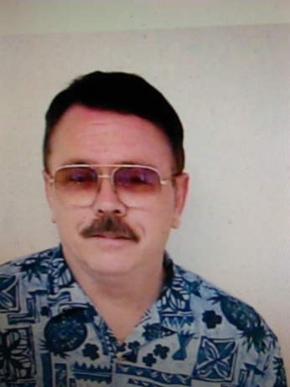
Good defense and thoughtless declarer play led to 3NT, down 4 (could have gone down at least 2 less).
Scoring: Matchpoints
Dealer: West
Vulnerability: North-South
North
♠ A 10 9 x
♥ A Q J
♦ 9 x x
♣ A 10 x
West East
♠ x ♠ K J 8 x x
♥ x x x ♥ K 9 x x x
♦ K J 8 x ♦ x x
♣ K J 9 7 5 ♣ 8
South
♠ Q x x
♥ 10x
♦ A Q 10 x
♣ Q x x x

The bidding at our table:
N E S W
pass
1NT 2♥* 3NT all pass

*Majors
Lead: low heart ☺

South just ignored East’s major suit takeout and he jumped to 3NT. North won the heart lead and led the diamond nine to West jack. A heart was returned, East’s king winning and another heart was led to North’s ace. Declarer led another diamond, and when Wei showed out, won his ace, led a spade to the ace and a club to the queen. When this lost to the king, a club was returned and declarer just gave up; won his ace and then led the club ten so he only took five tricks for down four – minus 400.
Declarer did not utilize the clues East’s major suit takeout gave him as to how he should play the hand.☹

Today’s Honoree
Anand Kumar Memorial
Stratiflighted Pairs
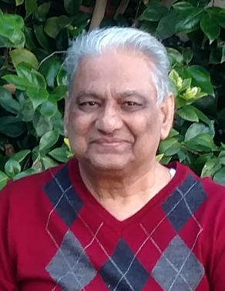
July 7, 1942 – August 23, 2016
Anand and his wife Kiran are well-known among the bridge players at Downey, Glendora and Riverside, as well as at the many Sectional and Regional tournaments around Southern California. He joined ACBL in 2013, but his passion for bridge started much earlier, while he was in college. His colleagues at work had a regular lunch-time game going everyday and his marathon weekend sessions were well-known.
Anand learned to be a survivor as he lost his father at the age of 10. Scholarships helped him achieve a brilliant academic career. Professionally he achieved success in IT at companies such as IBM, ARCO, and later, as an IT consultant.
Playing bridge was a welcome distraction for him from the many health problems he faced in his later years. The last game he played was on July 13 in Downey and he won. He died of complications from diabetes on August 23. He is survived by his wife, son, daughter and 3 grandchildren.
The family would like to thank the Directors of District 23 for giving us this opportunity to honor his memory.
Remember
When an irregularity occurs at the table, calmly summon a Director. Do not attempt to “fix” things by yourself. You are most likely to worsen the situation (for your side!) if you try to rectify the error without the Director’s help.

Answer to 299-er Quiz
Walter the Walrus counts 13 HCP, partner has 6-9. You could make a game try in clubs, but, how much help do you need there? One thing is certain: if you let the opponents bid spades again cheaply, you are going to be outbid. If partner doesn’t have too much wastage opposite your singletons, you should make a lot of tricks. Just bid 4♥. It might or might not make, but Faint Heart Ne’er Won Fair Matchpoints.
4♥ wins the auction, and partner puts down
♠ 875 ♥ 764 ♦ A1098 ♣ AJ2,
and your birthday has come early this year. Provided trumps are 3-2, 11 tricks will roll home. (The trump finesse loses, of course. Always does.) You should have play even if trumps are 4-1. And if they are 4-1, the opponents were going to take a fair number of tricks in a spade contract.

Bridge Quote-for-the-Day
“Never finesse against partner.” This sounds like an admirable precept, because except under extreme provocation one should not do anything much against partner, at least not openly. (Victor Mollo, from “Success at Bridge.”
Here are Mike Dunitz’s problems, and his preferred solutions:

1. Matchpoints 2. Matchpoints 3. IMPs
You
♠ K
♥ A43
♦ AK10543
♣ 1075

You
♠ Q72
♥ J842
♦ AQJ86
♣ 10

You
♠ 8
♥ AK5
♦ J9732
♣ A987

NV vs NV NV vs NV N/S Vul
Opponents
Pass
Throughout

You LHO Pard RHO Pard RHO You LHO You Pard
1♦ 2♣ X pass 1♣ 1NT X all pass 1♦ 1♠
? 2♦ 2♥
What do you lead? ?
Mike’s choice: 2♥ Mike’s choice: ♥8 Mike’s choice: 3♣

4. IMPs 5. BAM
You
♠ KQ10987
♥ AQ
♦ 9
♣ Q654

You
♠ 865
♥ KJ642
♦ AQJ6
♣ A

Both Vul N/S Vul
Opponents Pass Opponents Pass
Throughout Throughout

You Pard You Pard
1♥ 1NT 1♠ 2♦
2♦ 2♠ 2♠ 3♣
? ?
Mike’s choice: ♠3 Mike’s choice: 3NT

[Editor’s note: for those of us who are puzzled by the 2♠ bid in problem 4, it shows a hand too good to bid 3♦.]

NEW LIFE MASTER

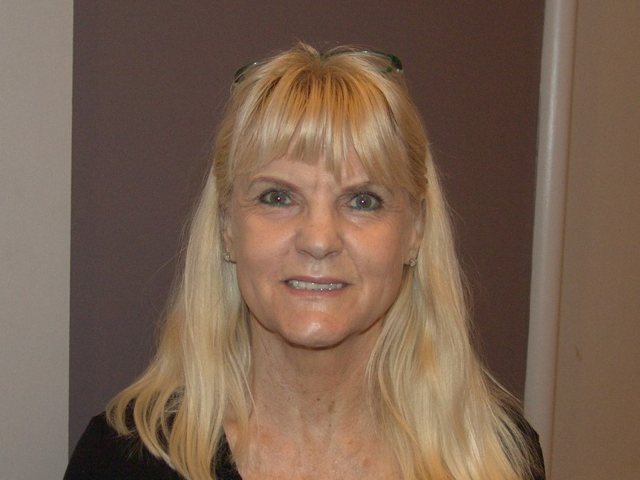
Cheeky Carlson

EVENT WINNERS

Friday Open Pairs
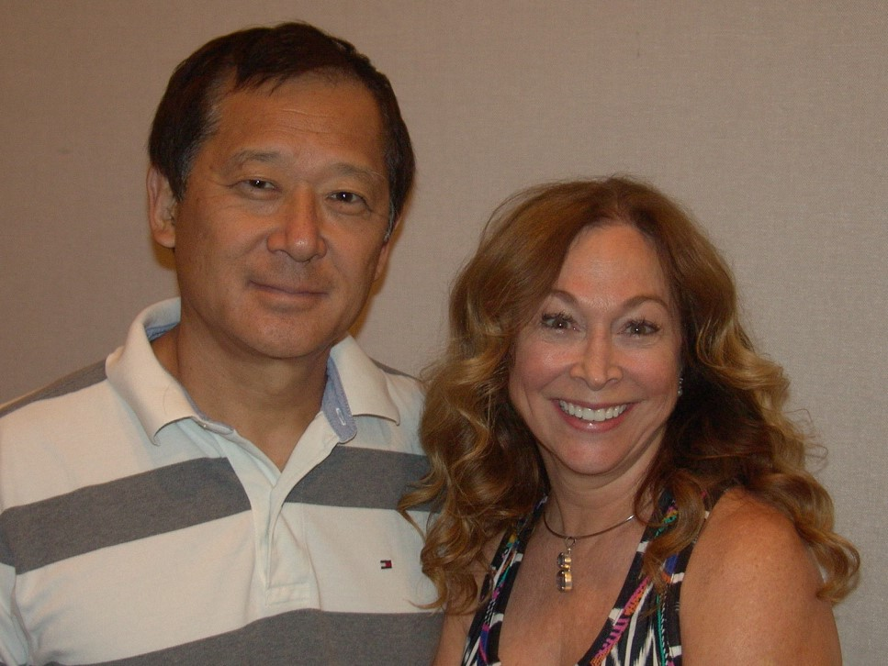
Mark Itabashi July Ratley
Thursday Open Pairs
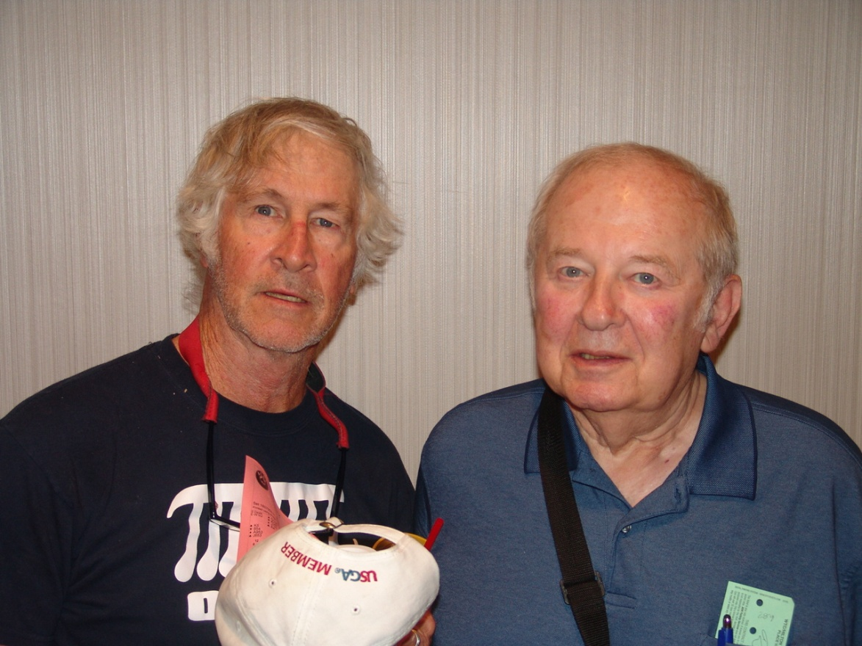
Bob Etter Joseph Kivel

Tuesday Betsy Ross KO – Bracket 2
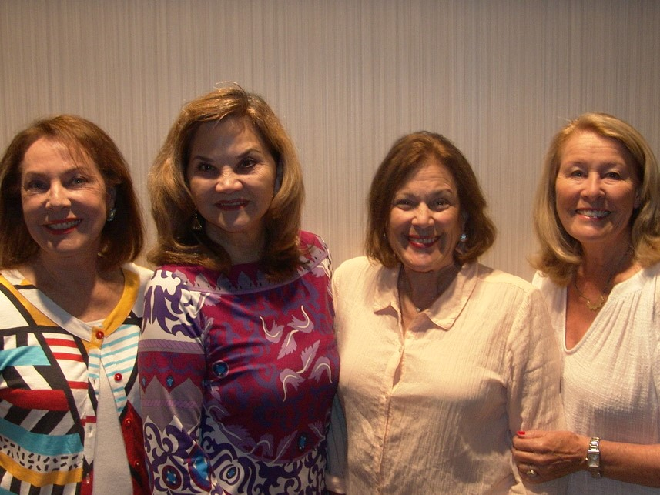
Barbara McKay Elizabeth Golamco Rita Levin Lillian Kirchoff
FRI GOLD RUSH PAIRS FIRST SESSION

NORTH-SOUTH SECTION G EAST-WEST
7 3 1 7 3 1
1 Mark Spiro, Encinitas 1 Aton Arbisser, Los
CA; Steve Reid, Carlsbad CA 64.32% Angeles CA; Jim Brunet,
2 1 Roberta Brown, Palos Santa Monica CA 56.07%
Verdes Es CA; Jack 2 Gerry Gastelum - Nancy
Stewart, Torrance CA 60.76% Raiche, Manhattan Beach CA 52.51%
3 2 Peter Koenig - Susan 3 1 Terry Hane, Redondo
Koenig, Tarzana CA 54.39% Beach CA; Lina Ashar,
4 Lou Zucker - Judy Torrance CA 52.42%
Zucker, Santa Monica CA 53.01% 4 Judith Lorber - Reva
Alban, Long Beach CA 51.08%
2 Beverly McLeod -
Bernard Seal, Northridge CA 50.96%

NORTH-SOUTH SECTION H EAST-WEST
7 3 1 7 3 1
1 G Ramanjaneya, Trabuco 1 Tanaaz Timblo, Vista
Canyon CA; Avinash CA; A. Luke Ratnayake,
Deshmukh, Irvine CA 62.19% Oceanside CA 57.92%
2 Martin Lipman, 2 Thomas Lill, Chino CA;
Huntington Bch CA; Larry Shannon, Yorba
Richard Schaeffer, Long 58.93% Linda CA 57.29%
3 Dianna Hoffman, Ladera 3 1 Karen Roper, Thousand
Ranch CA; Carol Hood, Oaks CA; Vera Iobbi,
San Juan Capo CA 51.70% Westlake Vlg CA 53.99%
4 Bettyanne Houts, Long 4 2 Gerald Ketz, Hermosa
Beach CA; Nancy Beach CA; Michael
Toussaint, Paramount CA 50.27% McGory, Rancho Palo Vds CA 52.99%
1 Chris Burton, Newport
Beach CA; Susan Skara,
Orange CA 47.42%

NORTH-SOUTH SECTION I EAST-WEST
7 3 1 7 3 1
1 John Bakovic, 1 1 1 Mark Rappaport - Larisa
Springfield VA; Richard Rappaport, Beverly Hills CA 62.45%
Bakovic, San Pedro CA 64.62% 2 2 2 Sandra Schlosser, Long
2 Willy Suriano, Portland Beach CA; Penny
OR; Carol Hanson, O'Toole, Westminster CA 59.42%
Redondo Beach CA 55.38% 3 3 Cindy Shoemaker - Jack
3 1 Julie Neilson - Shoemaker, Marana AZ 57.81%
Florence Houghton, 4 Joyce Field, Torrance
Laguna Woods CA 52.60% CA; Dawn Suart, El
4 Michael Abeles, Los Segundo CA 55.03%
Angeles CA; Marsha
Kerns, Marina Del Rey CA 49.64%
2 Michelle Katzman -
Marianne Seldman, San
Clemente CA 48.78%

FRI OPEN PAIRS FIRST SESSION

NORTH-SOUTH SECTION J EAST-WEST
A B C A B C
1 1 1 Jayendu Patel, Vista 1 Mark Itabashi, Murrieta
CA; Shailesh Gupta, CA; July Ratley, Redding CA 66.12%
Aliso Viejo CA 61.70% 2 Joshua Donn, Las Vegas
2 J. Jay Roll, Kelso WA; NV; Peter Gelfand,
Mac Busby, San Diego CA 61.34% Corralitos CA 57.24%
3 2 Dorn Bishop, San Diego 3 1 1 Phil Feldman, Los
CA; Rick Norton Jr, Angeles CA; James
Vista CA 60.07% Nicola, Whittier CA 55.83%
4 Luis Gamio-Klapic, 4 Steven Love, Laguna
Palos Verdes Pn CA; Niguel CA; Roger Bates,
Miguel Reygadas, 58.82% Las Vegas NV 55.43%
5 Subba Ravipudi, Downey 5 Ellen Anten, Encino CA;
CA; Yas Takeda, Paul Markarian,
Hacienda Hgts CA 58.70% Lancaster CA 54.07%
6 Robert Bass, Woodland 6 2 Joseph Viola III,
Hills CA; Steve Gross, Altadena CA; Gerard
Westlake Vlg CA 53.39% Geremia, La Verne CA 54.02%
7 3 Sherman Gao, Brea CA; 7 Judy Elbogen, Mission
Robert Micone, Tustin CA 52.33% Viejo CA; Gaye
2 Michael Klemens, Herrington, Redondo 52.94%
Tarzana CA; Dwight 3 2 Ted Gibbs, Rancho Palo
Hunt, Granada Hills CA 51.41% Vds CA; Mike Welsh,
Manhattan Beach CA 46.78%
4 3 Ted Teweles, Seal Beach
CA; John Petrie, Long
Beach CA 46.66%
4 Jerry Smith, Los
Angeles CA; David
Smith, Centennial CO 46.44%

NORTH-SOUTH SECTION K EAST-WEST
A B C A B C
1 1 Barbara Pinchuk, 1 Joseph Kivel, Newport
Woodland Hills CA; Coast CA; Bob Etter,
Freddie Straus, Encino CA 56.45% Elk Grove CA 62.67%
2 Walter Schafer Jr, 2 Marta Monheim, West
Fountain Valley CA; Hills CA; Andrew
William Chu, San Marino CA 55.54% Vinock, Woodland Hills CA 62.56%
3 2 Jim Johnsen, San Diego 3 Crispin Barrere,
CA; Christine Denny, Berkeley CA; Mark
Encinitas CA 55.15% Perlmutter, San Diego CA 58.48%
4 3 Hemant Bhatia, Foothill 4 1 1 Norman Pine - Stanford
Ranch CA; Brian Holzberg, Sherman Oaks CA 55.88%
Gilbert, Irvine CA 54.92% 5 2 Edward Schwartz,
5 Valentin Kovachev, Las Needham MA; Pat Larin,
Vegas NV; Margery Rancho Mirage CA 55.32%
Gould, Los Angeles CA 54.75% 6 Rick Roeder, La Mesa
6 4 Jackie Hess, Rancho CA; Michael Mikyska,
Palo Vds CA; Shirley Los Angeles CA 54.19%
Carroll, Newport Beach CA 53.96% 7/8 3/4 2/3 Marjorie O'Malley -
7 Iftikhar Baqai, Irvine Charles O'Malley III,
CA; Mitch Dunitz, San Diego CA 53.00%
Sherman Oaks CA 52.32% 7/8 3/4 2/3 Mark Sacks, Costa Mesa
1/2 Thomas Eby - Ewan Eby, CA; Harry Sacks,
Marina CA 51.07% Hacienda Hgts CA 53.00%
1/2 Noel Purkin - Tammy 5 Linda Gruber - Bob
Purkin, Encino CA 51.07% Gruber, Camarillo CA 49.94%
4 Maria Marshall,
Oceanside CA; Janice
Joerger, Rancho Santa Fe CA 48.64%

FRI MORN 299ER PAIRS ONLY SESSION

SECTION L
D E F
1 1 1 Brigitte Prince, Hermosa Beach CA; Petra Green, Rancho Palo Vds CA 57.64%
2 2 Tay Cherry - Robert Cherry, Fresno CA 55.56%
3 3 2 Robin Hill, Palos Verdes Es CA; Pamela Haskins, Rancho Palo Vds CA 54.86%

FRI AM SIDE GAME 4TH OF FIVE SESSIONS

NORTH-SOUTH SECTION M EAST-WEST
A B C A B C
1 1 1 Bill Brooks, Huntington 1 1 1 Albert Szeto - Robert
Bch CA; Thomas Felice, Chen, Los Angeles CA 65.87%
Anaheim CA 54.81% 2 2 2 James Jensen - Booth
2 2 2 David Johnson, Tarkington, Rancho Palo
Milledgeville GA; Vds CA 64.42%
Janice Carmean, 54.33% 3 Sara Carlson - William
3/4 3/4 3 Thomas Jones - Barbara Carlson Jr, Thousand
Jones, Canyon Country CA 54.17% Oaks CA 56.89%
3/4 3/4 Diane Sachs, Rossmoor 4 3 Calvin Waller, Rancho
CA; Renee Hoffman, Seal Palo Vds CA; Stanley
Beach CA 54.17% Greengard, Torrance CA 54.81%
5 5 Lise Cote, Palos Verdes 5 4 Roy Young II - Joseph
Es CA; Jo-Anne Waller, Thomas, Redondo Beach CA 54.65%
Rancho Palo Vds CA 53.53% 6 5 3 Moises Ganc Kolodner,
6 Fred Hamilton, Las Mexico Mexico; Dorothy
Vegas NV; Joe Lentz, Lloyd, Discovery Bay CA 51.28%
Madison WI 53.21%

FRIDAY MORN 0-99 PAIRS ONLY SESSION

NORTH-SOUTH SECTION N EAST-WEST
G H I G H I
1 1 Myrna Frankel, Beverly 1 1 Barbara Wallace -
Hills CA; Lynne Janice Fischer, Long
Rabineau, Los Angeles CA 56.50% Beach CA 64.50%
2 2 Gail Klein, San Gabriel 2 2 1 Malgorzata Koziol -
CA; Renee Hall, Las Laura Sterling, Las
Vegas NV 53.50% Vegas NV 52.50%
1 Elaine Bock - Toshie
Bergan, Rancho Palo Vds CA 48.50%

FRI GOLD RUSH PAIRS SECOND SESSION

NORTH-SOUTH SECTION G EAST-WEST
7 3 1 7 3 1
1 1 Terry Hane, Redondo 1 Lee Axelrod, Los
Beach CA; Lina Ashar, Angeles CA; Margot
Torrance CA 68.39% Hartman, Marina Del Rey CA 54.53%
2 Aton Arbisser, Los 2 Delene Hoff, Trabuco
Angeles CA; Jim Brunet, Canyon CA; Cynthia
Santa Monica CA 61.32% Gallaway, San Juan 52.46%
3 2 Beverly McLeod - 3 Michael Abeles, Los
Bernard Seal, Northridge CA 60.33% Angeles CA; Marsha
4 Roberta Brown, Palos Kerns, Marina Del Rey CA 48.60%
Verdes Es CA; Jack 4 1 Carol Herzlinger - Lois
Stewart, Torrance CA 60.05% Mullin, Long Beach CA 48.46%
2 Julie Neilson -
Florence Houghton,
Laguna Woods CA 46.74%

NORTH-SOUTH SECTION H EAST-WEST
7 3 1 7 3 1
1 Tanaaz Timblo, Vista 1 1 Elizabeth Silvius -
CA; A. Luke Ratnayake, Gary Silvius, San
Oceanside CA 58.41% Bernardino CA 56.45%
2 Martin Lipman, 2 Cheeky Carlson, La
Huntington Bch CA; Quinta CA; Judy Searle,
Richard Schaeffer, Long 55.34% Palm Springs CA 56.36%
3 Bruce Schelden, Playa 3 Lou Zucker - Judy
Del Rey CA; Victor Zucker, Santa Monica CA 53.99%
Tong, Houston TX 53.44% 4 Deborah Downs,
4 1 Nancy Peckham, Thousand Manhattan Beach CA;
Palms CA; Patricia Nancy Karnes, Hermosa 53.91%
Swanson, Palm Desert CA 51.43%
2 Gerald Ketz, Hermosa
Beach CA; Michael
McGory, Rancho Palo Vds CA 46.41%

NORTH-SOUTH SECTION I EAST-WEST
7 3 1 7 3 1
1 1 1 Mark Rappaport - Larisa 1 Thomas Lill, Chino CA;
Rappaport, Beverly Hills CA 59.38% Larry Shannon, Yorba
2 2 2 Anand Mhaskar, Linda CA 59.41%
Succasunna NJ; Madhav 2 1 Chris Burton, Newport
Gokhale, Bengaluru 54.53% Beach CA; Susan Skara,
3 3 Joyce Field, Torrance Orange CA 57.61%
CA; Dawn Suart, El 3 Karen Roper, Thousand
Segundo CA 53.99% Oaks CA; Vera Iobbi,
4 Peggy Shoup, Laguna Westlake Vlg CA 57.59%
Niguel CA; Savita Jain, 4 Nancy Shirley -
Irvine CA 53.42% Dorothea Williams,
Escondido CA 55.30%

FRI OPEN PAIRS SECOND SESSION

NORTH-SOUTH SECTION J EAST-WEST
A B C A B C
1 Joshua Donn, Las Vegas 1 Iftikhar Baqai, Irvine
NV; Peter Gelfand, CA; Mitch Dunitz,
Corralitos CA 64.18% Sherman Oaks CA 64.12%
2 1 1 Ted Gibbs, Rancho Palo 2 Walter Schafer Jr,
Vds CA; Mike Welsh, Fountain Valley CA;
Manhattan Beach CA 58.90% William Chu, San Marino CA 58.24%
3 2 2 Phil Feldman, Los 3 1 1 Mark Sacks, Costa Mesa
Angeles CA; James CA; Harry Sacks,
Nicola, Whittier CA 57.80% Hacienda Hgts CA 57.64%
4 Rai Osborne, Anaheim 4 2 2 Marel Bates, Winnetka
CA; Marjorie Michelin, CA; John Vacca,
Laguna Woods CA 57.64% Northridge CA 57.47%
5 Mark Itabashi, Murrieta 5 Craig Kavin, Newbury
CA; July Ratley, Redding CA 57.20% Park CA; John Grantham,
6 3 Sherman Gao, Brea CA; Bentonville AR 55.33%
Robert Micone, Tustin CA 56.04% 6 Crispin Barrere,
7 Steven Love, Laguna Berkeley CA; Mark
Niguel CA; Roger Bates, Perlmutter, San Diego CA 53.96%
Las Vegas NV 55.00% 7 3 3 Samuil St Ivanov, Las
4 Joseph Viola III, Vegas NV; Billy
Altadena CA; Gerard Trabaudo, Albuquerque NM 52.20%
Geremia, La Verne CA 54.01% 4 Maria Marshall,
3 Jerry Smith, Los Oceanside CA; Janice
Angeles CA; David Joerger, Rancho Santa Fe CA 49.18%
Smith, Centennial CO 53.68% 5 Hemant Bhatia, Foothill
4 Ted Teweles, Seal Beach CA Ranch CA; Brian
John Petrie, Long Beach CA 50.71% Gilbert, Irvine CA 47.53%
NORTH-SOUTH SECTION K EAST-WEST
A B C A B C
1 1 Barbara Pinchuk, 1 George Mittelman,
Woodland Hills CA; Thornhill ON; Ken
Freddie Straus, Encino CA 62.47% Bercuson, Las Vegas NV 61.26%
2 Valentin Kovachev, Las 2 Robert Bass, Woodland
Vegas NV; Margery Hills CA; Steve Gross,
Gould, Los Angeles CA 57.53% Westlake Vlg CA 58.52%
3 Gilbert Stinebaugh, Van 3 Bruce Ferguson, Palm
Nuys CA; Cliff Springs CA; Marilyn
Goodrich, Long Beach CA 56.70% Loesberg, Rancho Mirage CA 57.14%
4 Joseph Kivel, Newport 4 Cameron Doner, Surrey
Coast CA; Bob Etter, BC; Mary Dougherty,
Elk Grove CA 55.17% Santa Fe NM 54.18%
5 Marta Monheim, West 5 1 1 Ralph Beazley, Long
Hills CA; Andrew Beach CA; Thomas Gay,
Vinock, Woodland Hills CA 51.48% Apple Valley CA 53.24%
6/7 Rick Roeder, La Mesa 6 J. Jay Roll, Kelso WA;
CA; Michael Mikyska, Mac Busby, San Diego CA 52.75%
Los Angeles CA 49.78% 7 2 2 Michael Klemens,
6/7 John Jones, Santa Fe Tarzana CA; Dwight
Spgs CA; C. Valerie Hunt, Granada Hills CA 52.58%
Gamio, Palos Verdes Pn CA 49.78% 3 3 Jayendu Patel, Vista
2 Jackie Hess, Rancho CA; Shailesh Gupta,
Palo Vds CA; Shirley Aliso Viejo CA 52.25%
Carroll, Newport Beach CA 49.01%
3 1 Steven Rowe, Long Beach
CA; Frances Every,
Orange CA 46.98%
4 2 Michael Marcucci, San
Gabriel CA; Paula
Olivares, Valencia CA 46.87%
3 Paul Dubois, La Mesa
CA; Michael Moss,
Hawthorne CA 45.71%

FRI AFT SIDE GAME 5TH OF SIX SESSIONS

NORTH-SOUTH SECTION L EAST-WEST
A B C A B C
1 1 Rashmi Shah, Palos 1 Pradeep Jhawar -
Verdes Es CA; Eknath Vandana Jhawar, Layton UT 59.00%
Deo, Long Beach CA 64.41% 2 James Tanner, Highland
2 2 Betty Jackson, Seal CA; William Hamann,
Beach CA; Penny Riverside CA 57.46%
Barbieri, San Dimas CA 61.39% 3 1 1 George MacDonald, Agua
3 3 Jeanne Dea, Sierra Dulce CA; Ronald Oest,
Madre CA; Sandra Palmdale CA 57.35%
Rucker, San Gabriel CA 55.69% 4 2 2 Susan Miller, Hermosa
4 4 Laura Gastelum - Beach CA; Charles
Raymond Mack, Torrance CA 53.13% Strathman, Manhattan 57.11%
5 5 Ginny Curtis, Citrus 5 3 Calvin Waller, Rancho
Heights CA; Mary Ose, Palo Vds CA; Stanley
Sacramento CA 52.51% Greengard, Torrance CA 54.62%
1 Judy Brennan, Laguna 4 3 June Harwell, San
Beach CA; Thomas Marino CA; Ann Croupe,
Miller, San Clemente CA 50.40% Pasadena CA 53.13%
2 Ruth Fleisher, Encino
CA; Marilyn Gaims,
Reseda CA 47.82%

FRI EVE SIDE GAME 4TH OF FIVE SESSIONS

NORTH-SOUTH SECTION H EAST-WEST
A B C A B C
1 1 1 Peter Koenig - Susan 1 1 1 Andrea French - Ralph
Koenig, Tarzana CA 63.88% Moskowitz, Laguna Woods CA 60.63%
2 2 Sherman Gao, Brea CA; 2 2 2 Saul Priever, Van Nuys
Jim Liu, Saratoga CA 57.88% CA; Thomas Lill, Chino CA 59.63%
2 Samuil St Ivanov, Las
Vegas NV; Billy
Trabaudo, Albuquerque NM 48.38%

FRI MORN 299ER PAIRS
4.0 Tables
D E F
1.84 1 1 1 Brigitte Prince, Hermosa Beach CA; Petra Green, Rancho Palo Vds CA 57.64%
1.38 2 2 Tay Cherry - Robert Cherry, Fresno CA 55.56%
1.16 3 3 2 Robin Hill, Palos Verdes Es CA; Pamela Haskins, Rancho Palo Vds CA 54.86%
FRI AM SIDE GAME
15.0 Tables
A B C
4.74 1 1 1 Albert Szeto - Robert Chen, Los Angeles CA 65.87%
3.56 2 2 2 James Jensen - Booth Tarkington, Rancho Palo Vds CA 64.42%
2.67 3 Sara Carlson - William Carlson Jr, Thousand Oaks CA 56.89%
2.92 4/5 3/4 3 Bill Brooks, Huntington Bch CA; Thomas Felice, Anaheim CA 54.81%
2.15 4/5 3/4 Calvin Waller, Rancho Palo Vds CA; Stanley Greengard, Torrance CA 54.81%
1.38 6 5 Roy Young II - Joseph Thomas, Redondo Beach CA 54.65%
2.04 6 4 David Johnson, Milledgeville GA; Janice Carmean, Helendale CA 54.33%
1.24 5 Thomas Jones - Barbara Jones, Canyon Country CA 54.17%

FRIDAY MORN 0-99 PAIRS
5.0 Tables
G H I
1.75 1 1 Barbara Wallace - Janice Fischer, Long Beach CA 64.50%
1.31 2 2 Myrna Frankel, Beverly Hills CA; Lynne Rabineau, Los Angeles CA 56.50%
0.98 3 3 Gail Klein, San Gabriel CA; Renee Hall, Las Vegas NV 53.50%
1.21 4 4 1 Malgorzata Koziol - Laura Sterling, Las Vegas NV 52.50%
0.91 2 Sue Reese, Lomita CA; Wendy Meek, Rancho Palos V CA 50.00%

FRI GOLD RUSH PAIRS
32.0 Tables
7 3 1
9.65 1 1 1 Mark Rappaport - Larisa Rappaport, Beverly Hills CA 60.91%
7.24 2 2 Roberta Brown, Palos Verdes Es CA; Jack Stewart, Torrance CA 60.41%
5.43 3 3 Terry Hane, Redondo Beach CA; Lina Ashar, Torrance CA 60.40%
4.07 4 Aton Arbisser, Los Angeles CA; Jim Brunet, Santa Monica CA 58.70%
3.22 5 Thomas Lill, Chino CA; Larry Shannon, Yorba Linda CA 58.35%
3.06 6 Tanaaz Timblo, Vista CA; A. Luke Ratnayake, Oceanside CA 58.16%
2.41 7 Mark Spiro, Encinitas CA; Steve Reid, Carlsbad CA 57.94%
2.14 8 Martin Lipman, Huntington Bch CA; Richard Schaeffer, Long Beach CA 57.14%
1.93 9 G Ramanjaneya, Trabuco Canyon CA; Avinash Deshmukh, Irvine CA 57.08%
2.00 10 4 Karen Roper, Thousand Oaks CA; Vera Iobbi, Westlake Vlg CA 55.79%
1.61 11 5 Beverly McLeod - Bernard Seal, Northridge CA 55.64%
1.48 12 6 Joyce Field, Torrance CA; Dawn Suart, El Segundo CA 54.51%
1.61 13 John Bakovic, Springfield VA; Richard Bakovic, San Pedro CA 54.48%
1.29 14 Cheeky Carlson, La Quinta CA; Judy Searle, Palm Springs CA 54.42%
1.21 15 7 Peter Koenig - Susan Koenig, Tarzana CA 53.72%
1.33 16 Lou Zucker - Judy Zucker, Santa Monica CA 53.50%
1.71 2 Anand Mhaskar, Succasunna NJ; Madhav Gokhale, Bengaluru Karna
India 50.71%

FRI OPEN PAIRS
36.0 Tables / Based on 76 Tables
A B C
33.57 1 Mark Itabashi, Murrieta CA; July Ratley, Redding CA 61.66%
25.18 2 Joshua Donn, Las Vegas NV; Peter Gelfand, Corralitos CA 60.71%
18.88 3 1 Barbara Pinchuk, Woodland Hills CA; Freddie Straus, Encino CA 59.46%
14.16 4 Joseph Kivel, Newport Coast CA; Bob Etter, Elk Grove CA 58.92%
11.19 5 Iftikhar Baqai, Irvine CA; Mitch Dunitz, Sherman Oaks CA 58.22%
9.59 6 J. Jay Roll, Kelso WA; Mac Busby, San Diego CA 57.04%
8.39 7 Marta Monheim, West Hills CA; Andrew Vinock, Woodland Hills CA 57.02%
12.48 8 2 1 Jayendu Patel, Vista CA; Shailesh Gupta, Aliso Viejo CA 56.98%
6.71 9 Walter Schafer Jr, Fountain Valley CA; William Chu, San Marino CA 56.89%
9.36 10 3 2 Phil Feldman, Los Angeles CA; James Nicola, Whittier CA 56.81%
5.60 11 Crispin Barrere, Berkeley CA; Mark Perlmutter, San Diego CA 56.22%
5.16 12 Valentin Kovachev, Las Vegas NV; Margery Gould, Los Angeles CA 56.14%
4.80 13 Robert Bass, Woodland Hills CA; Steve Gross, Westlake Vlg CA 55.96%
4.48 14 Luis Gamio-Klapic, Palos Verdes Pn CA; Miguel Reygadas, Tlalpan
Mexico 55.37%
7.02 15 4 3 Mark Sacks, Costa Mesa CA; Harry Sacks, Hacienda Hgts CA 55.32%
3.95 16 Steven Love, Laguna Niguel CA; Roger Bates, Las Vegas NV 55.21%
3.73 17 Subba Ravipudi, Downey CA; Yas Takeda, Hacienda Hgts CA 54.74%
5.55 18 5 Sherman Gao, Brea CA; Robert Micone, Tustin CA 54.19%
4.75 6 Joseph Viola III, Altadena CA; Gerard Geremia, La Verne CA 54.01%
4.16 7 Dorn Bishop, San Diego CA; Rick Norton Jr, Vista CA 53.66%
4.43 8 4 Ted Gibbs, Rancho Palo Vds CA; Mike Welsh, Manhattan Beach CA 52.84%
3.50 9 5 Michael Klemens, Tarzana CA; Dwight Hunt, Granada Hills CA 52.00%
3.03 10 Jackie Hess, Rancho Palo Vds CA; Shirley Carroll, Newport Beach CA 51.49%
2.77 11 Edward Schwartz, Needham MA; Pat Larin, Rancho Mirage CA 51.34%
3.00 6 Marel Bates, Winnetka CA; John Vacca, Northridge CA 51.30%
2.73 7 Norman Pine - Stanford Holzberg, Sherman Oaks CA 50.55%
2.33 8 Jerry Smith, Los Angeles CA; David Smith, Centennial CO 50.06%

FRI AFT SIDE GAME
13.0 Tables
A B C
4.36 1 1 Rashmi Shah, Palos Verdes Es CA; Eknath Deo, Long Beach CA 64.41%
3.27 2 2 Betty Jackson, Seal Beach CA; Penny Barbieri, San Dimas CA 61.39%
2.68 3 Pradeep Jhawar - Vandana Jhawar, Layton UT 59.00%
1.88 4 James Tanner, Highland CA; William Hamann, Riverside CA 57.46%
2.80 5 3 1 George MacDonald, Agua Dulce CA; Ronald Oest, Palmdale CA 57.35%
2.10 6 4 2 Susan Miller, Hermosa Beach CA; Charles Strathman, Manhattan
Beach CA 57.11%
1.34 5 Jeanne Dea, Sierra Madre CA; Sandra Rucker, San Gabriel CA 55.69%
1.10 6 Calvin Waller, Rancho Palo Vds CA; Stanley Greengard, Torrance CA 54.62%
1.58 3 June Harwell, San Marino CA; Ann Croupe, Pasadena CA 53.13%
1.18 4 Ronald Morris - Don Elconin, Santa Barbara CA 52.00%

FRI AFT SWISS TEAMS
15 Tables
A B C
4.67 1 Rae Murbach - Jerry Murbach, Altadena CA; Eugene White Jr,
Playa Del Rey CA; Paul Gelb, Palm Springs CA 61.00
3.50 2 W Reynolds, South Pasadena CA; Lance Kerr, Sylmar CA; William
Hall, Thousand Oaks CA; David Pelka, Los Angeles CA 54.00
2.63 3 John Kissinger - Susan Kissinger, San Clemente CA; Becky Clough
- Roger Clough, Culver City CA 52.00
3.07 4/5 1/2 1/2 Jane Pace, Helendale CA; Genise Hasan, Santa Monica CA; Susan
Emminger, Upland CA; Kiran Kumar, Walnut CA 50.00
3.07 4/5 1/2 1/2 Phillip Calloway, Canoga Park CA; William Raines, Rancho Mirage
CA; Wayne Beagle, Woodland Hills CA; Jerold Rose, Calabasas CA 50.00
1.97 3 Mark Robertson - Richard Jacobson, Phoenix AZ; Gayle Quiros -
Judith Washor, Scottsdale AZ 45.00
1.48 4 Marion Tumen - Jodie Rachmil - Peggy Levin, Pacific Plsds CA;
Janet Cooper, Encino CA 44.00

FRI-SAT KO-1
12 Tables
Janet Wickersham, Sierra Madre CA Cameron Cotton, Chula Vista CA
Peter Szecsi, Pasadena CA vs Debbie Gailfus, Carlsbad CA
Joel Schiff, Calabasas CA Alan Gailfus, Carlsbad CA
Dominique Moore, Arcadia CA Jon Wright, San Diego CA

--------------------------------------------------

Eric Leong, Oakland CA Vinita Gupta, Woodside CA
Stephen Kennedy, Oakland CA vs Billy Miller, Las Vegas NV
Chris Compton, Dallas TX Weishu Wu, Irvine CA
Brian Glubok, New York NY Leo Bell, Carlsbad CA

--------------------------------------------------

FRI-SAT KO-2
14 Tables
Anthony Toto, Clovis CA Om Chokriwala, Sherman Oaks CA
Mike Moser, San Diego CA vs Nancie Barrier, Los Angeles CA
Maria Uhry, Encinitas CA Charles Kelley, Pacific Plsds CA
Brenda Glaze, Anchorage AK Jo Anne Kelley, Pacific Plsds CA

--------------------------------------------------

Scott Nason, Dallas TX R Turner, Los Angeles CA
Alexander Wiles vs Alyssa Kennedy, Marina Del Rey CA
Karen Byrd, Los Angeles CA Elaine Godin, Manhattan Beach CA
Nancy Heck, Los Angeles CA Lutrell Long, Rancho Palo Vds CA

--------------------------------------------------

FRI-SAT KO-3
14 Tables
Dawn Lee, Los Angeles CA Ronald Malkin, Northridge CA
Jill Thesman, Los Angeles CA vs Ronald Malkin, Northridge CA
Laura Waisler, Santa Monica CA Irving Klasky, Northridge CA
Jaclyn Hatfield, Santa Monica CA Gloria Malkin, Northridge CA
Merkie Rowan, Northridge CA

--------------------------------------------------

Cheri Bitar, Malibu CA Marlys Haraden, Anaheim CA
Jane Winston, Encino CA vs Raj Ramchandani, Rowland Heights CA
Lynn Edelson, Encino CA Clinton Gorsuch, Rowland Heights CA
Ravnesh Amar, Los Angeles CA Scott Gorsuch, Oakland CA

--------------------------------------------------

FRI EVE SIDE GAME
5.0 Tables
A B C
2.84 1 1 1 Peter Koenig - Susan Koenig, Tarzana CA 63.88%
2.13 2 2 2 Andrea French - Ralph Moskowitz, Laguna Woods CA 60.63%
1.60 3 3 3 Saul Priever, Van Nuys CA; Thomas Lill, Chino CA 59.63%
1.23 4 4 Sherman Gao, Brea CA; Jim Liu, Saratoga CA 57.88%

