Nottinghamshire Contract Bridge Association
Swiss Pairs

How to score a Swiss Pairs event with EBUScore version 1.2.5
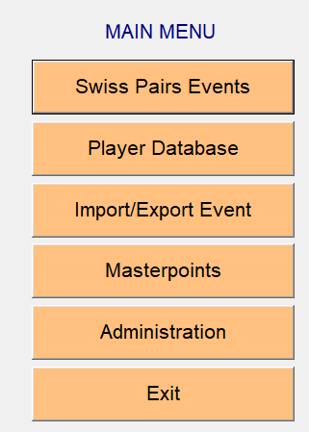
Click Swiss Pairs Event
Click Create New Event. (bottom left)
Enter Director, name of event details as required
BridgeWebs; enter details to enable web page upload.
Movement Details When you click the ‘Movement Details’ screen tab, the screen for entering the movement for the Swiss Pairs event appears as shown below.
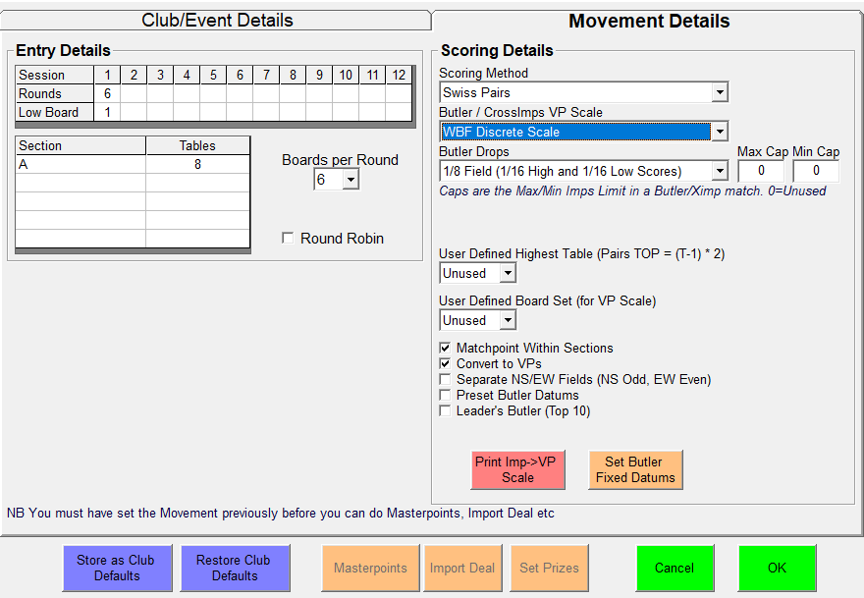
a. Under ‘Movement Details’: - (The above example is for 6 rounds of 6 boards. 8 Tables)
i. Enter the number of rounds to be played in the Session 1 column. For a simple event, there will only be one session. The ‘Low Board’ will usually be left as ‘1’.
ii. Enter ‘A’ in the first box of the Section column.
iii. Enter the number of tables in the first box of the Tables column.
b. Under ‘Scoring’: -
i. ‘Scoring Method’ set as Swiss Pairs
ii. ‘Butler Drops’ (not required) left as 1/8 Field
iii. ‘VP Scale’ left as WBF Discrete Sacale
iv. ‘No. Of Tables’ set as Unused
v. Click the ‘Matchpoint Within Sections’ to insert a tick
vi. Click the ‘Convert Imps/XImps to VPS’ to insert a tick

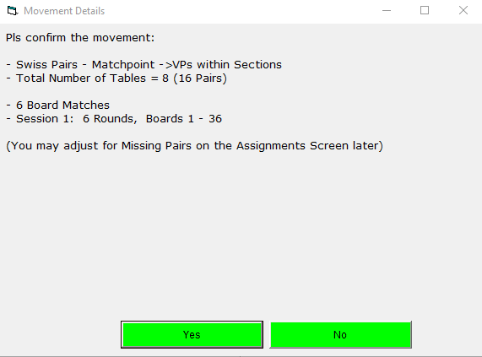
Check details and click Yes to proceed
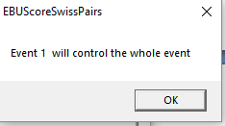

Click the “OK” button to return to the scoring menu list.
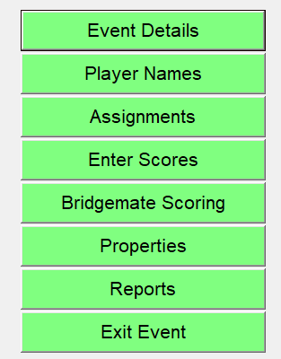
Click ‘Assignments’

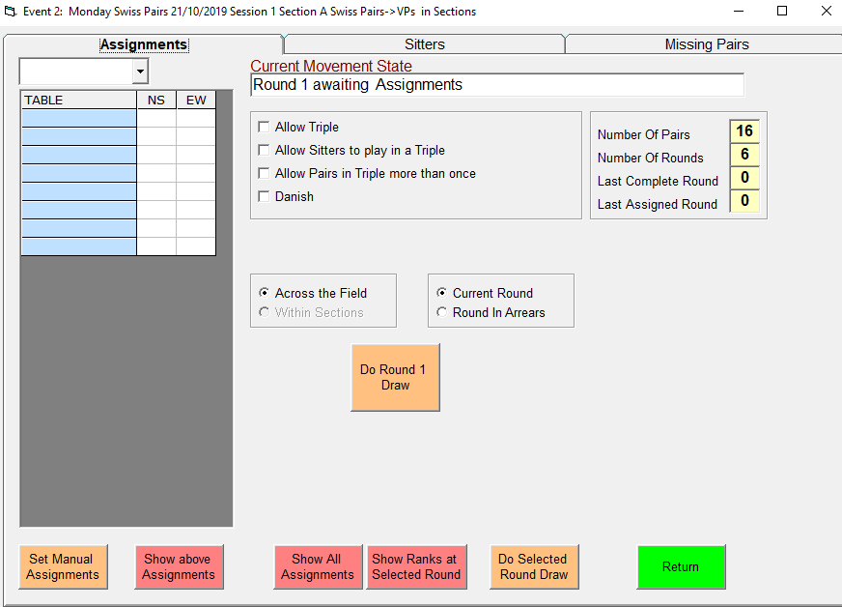
a: The ‘Sitters’ tab will only be used if incapacitated players need to be accommodated.
b: The ‘Missing Pairs’ tab will not be needed if arrangements for full tables are applying. At the top of the Assignments screen, the ‘Round’ box will be empty and ‘Current Movement State’ will read “Round 1 awaiting Assignments”. The ‘Number Of Pairs’ should be double the number of tables and ‘Number Of Rounds’ should match the entry made in the Movement Details section previously.
c: Insure that the ‘Across the Field’ and ‘Current Round’ button are checked
Ignore the Round Robin section
d: Click the ‘Do Round 1 Draw’ button. Confirming message appears

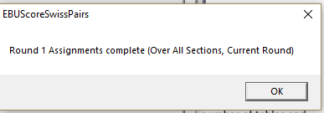

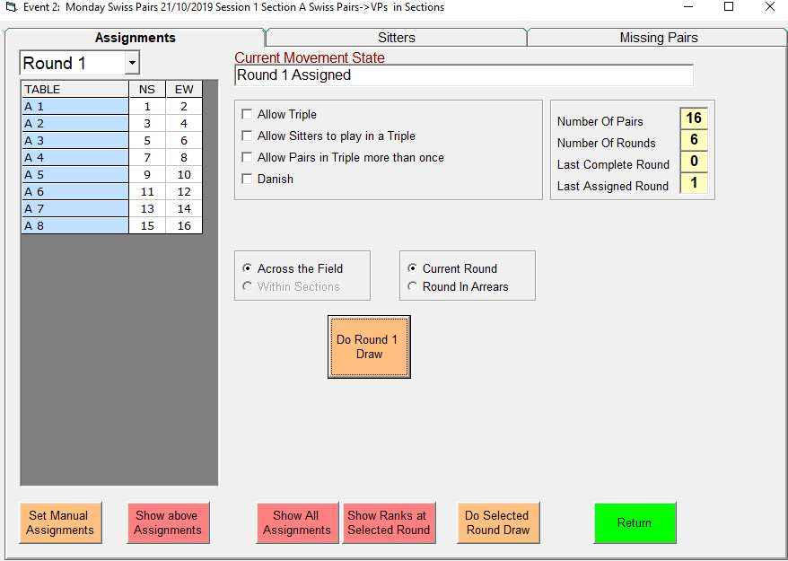
Round 1 positions will be populated as above.
Return
Bridgemate Scoring
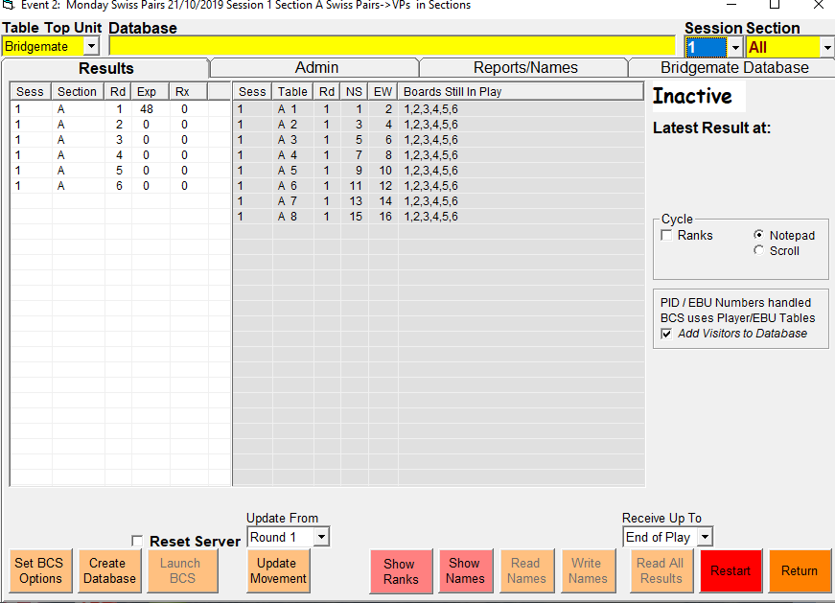

Click ‘BCS Options’ button and click ‘Restore EBU Swiss Pairs Defaults’
Round 1 is played: -
a. Boards may arrive at the table out of number sequence – check and accept ‘OK’
b. Board numbers, contracts, leads and results are entered as normal
c. East/West pairs agree and accept results d A percentage score is shown then press ‘OK’ button to go to next board
When all boards for the round have been played, a summary of the scores at the table will display. Press ‘OK’ and Bridgemate displays the message “End of Round – Waiting for New Movement. Announce
PLEASE DO NOT TOUCH BRIDGEMATE AND PAIRS SHOULD STAY AT THE TABLE UNTIL THE ASSIGNMENTS FOR THE NEXT ROUND HAVE BEEN MADE BY THE DIRECTOR.
Click ‘Return’ on the Bridgemate Scoring screen of EBUScore and select ‘Assignments’ from the Event Menu screen.
Make the assignments for Round 2 by clicking the ‘Do Round 2 Draw’ button on the Assignments screen.
16. Return to Bridgemate Scoring Screen
a. Check that the UPDATE MOVEMENT is set to the current round and click on it.
b. Tell players that the assignments have been sent to the Bridgemates and tell them to Press ‘OK’ ONCE on the Bridgemates to display the Round 2 assignments and to check it immediately, before the screen display times-out and disappears.
Screen display is: “End of Round 1 NS <position & table> EW <position & table>” Pressing ‘OK’ again displays the next round details. (The director should print an assignment list in case any Bridgemate assignment are missed.)
17. Assignment lists may be printed, if required, for checking and for posting around the playing area to assist players in moving to their correct positions for the next round. (See Appendix 1 at the end of this document).
18. Results sheets may be printed at any time by going to the Event Menu and selecting ‘Reports’. A suitable status report is produced by selecting: - a. ‘Ranks’ from Print Menu section b. ‘Ranks +Match Score’ and ‘Ranks + Matches Won/Drawn’ from Print Options section c. InSection = All d. Round = current round number or ‘All’ at the end e. Notepad in ‘Print to’ section
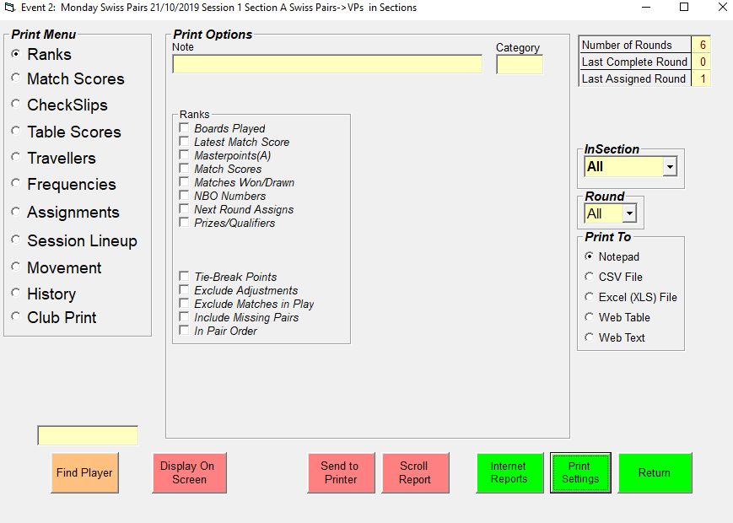

Once all the results are in return to the above.
Click Display On Screen will give results.
Click Internet Reports will enable upload to BridgeWebs and all to EBU as required.
Make sure correct Club Code and password are present.
