Derbyshire and Leicestershire
CBAs and EBU

Green Pointed
Swiss Weekend

26th and 27th

September 2015

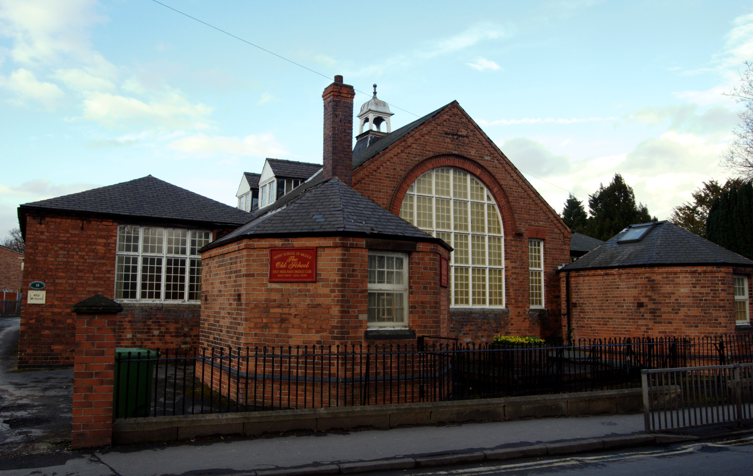
East Midlands Bridge Academy,

The Old School,

Chapel Street,

Spondon,

Derby DE21 7JR

Derbyshire and Leicestershire
CBAs and EBU
Green Pointed Swiss Weekend

Swiss Pairs – 1 pm Saturday Swiss Teams – 1 pm Sunday
7 x7 board Matches 7x7 Board Matches

1:00 pm Session 4x7 Boards 1:00 pm Session 1 4x7 Boards
4.30pm (approx) Tea – see below 5:00 pm (approx) Tea – see below
5:15 pm Session 2 3x7 Boards 5:45 pm Session 2 3x7 Boards
8:00 pm (approx) Results and 9:00 pm (approx) Results and
Presentation of Prizes Presentation of Prizes

Both Days: Green Point Awards and Prizes to EBU Scales
(1/4 point per match won or drawn plus ranking awards)

These will be directly credited and EBU numbers must be supplied with entry form

Free on site car parking (now extended)
4 ½ miles from J25 M1 Map available – Facilities for disabled.

Light refreshments from 12 noon.

Various salads, sandwiches and cakes available during the tea interval
order on the day.

Entry fees: Saturday Pairs – £45 per pair
Sunday Teams - £90 per team
(Juniors under 25 - half price)

All entries and enquiries to: Mr Ian Blake, 10 Whittlebury Drive, Littleover, Derby DE23 3BF
Tel: 01332 521648 email: igblake@aol.com

ENTRY FORM to
Mr Ian Blake, 10 Whittlebury Drive, Littleover, Derby DE23 3BF
or igblake@aol.com

Green Point Swiss Pairs – Saturday 26th September 2015

Contact name, number or email address ………………………………………

Player one name………………………….…EBU number………….

Player two name………………………..…... EBU number………….

Green Point Swiss Teams – Sunday 27th September 2015

Contact name, number or email address …………………………………………

Player one name………………………….…EBU number………….

Player two name………………………..…... EBU number………….

Player three name…………………..……….EBU number………....

Player four name………………………..…...EBU number…………..

Entry Fees:

Saturday – …. 2 players @ £45 per pair = £..........

Sunday – ……. 4 players @ £90 per team = £……...

Total Fee Enclosed = £…………

Please make cheques payable to DCBA

You are also welcome to transfer the monies to the following account.
Sort Code 20 25 85 Account No 60273716 Beneficiary: DCBA
Please make sure that you receive an acknowledgement of your payment

Entries, which must be prebooked, are limited by space. You are strongly advised to book
early, as places cannot be reserved.

Confirmation of entry can be sent by email or by enclosing a stamped addressed envelope.

