GHESTEM CARRIES A SEVERE HEALTH WARNING!!
This convention (Ghestem) allows one to show two specific suits with one overcall. A direct cue bid shows the top and bottom two suits, 2NT shows the two lowest suits and 3C shows the two highest suits. Simple eh? Well yes, as long as you and equally importantly your partner can remember it.
Helgemo and Helness, originally Norwegian but now representing Monaco are one of the world’s top three pairs, multi-champions and favourites for just about everything they enter. So, they are pretty good but they play Ghestem!
Look at the auction below. S opens 1S and W overcalls 3C. We know this shows the higher two remaining suits, i.e. hearts and diamonds and so does W, but when N asks about the bid he is informed it shows hearts and clubs! Disaster follows when E is happy to bid five clubs.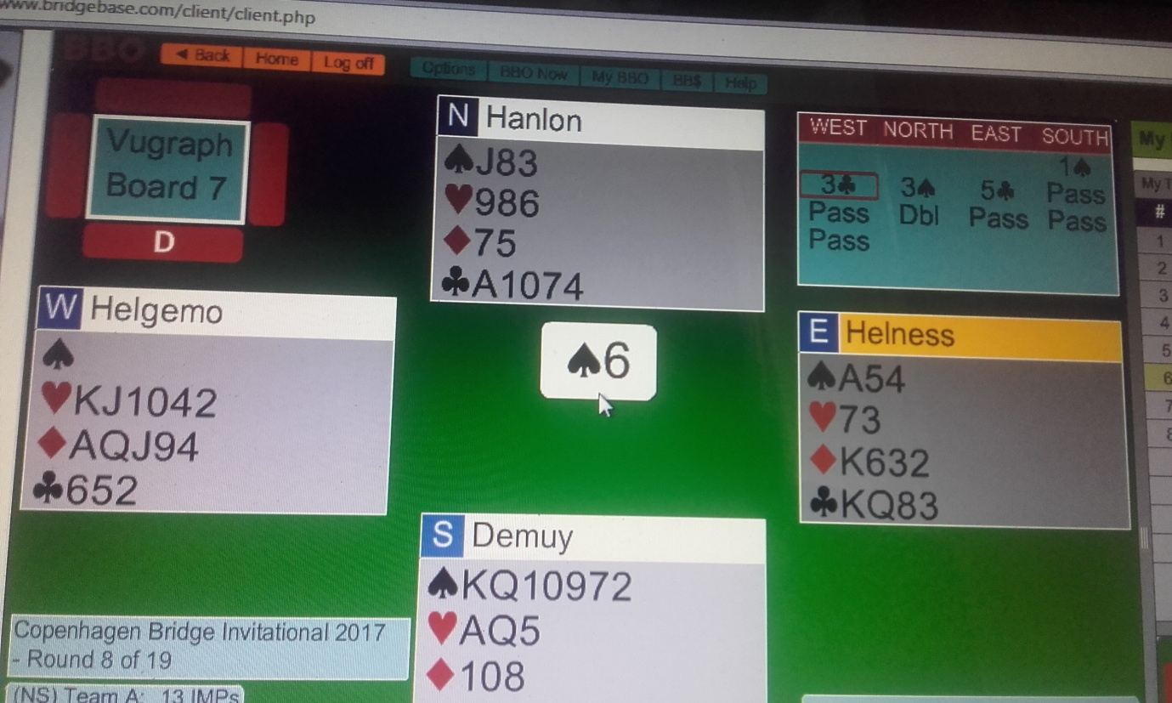
Obviously we can see a wheel has come off, but West can’t because he would be unaware of East’s explanation for they play with screens. He would have thought partner was flying a solo mission. If this can happen to H&H, can you be sure you won’t mess it up if you decide Ghestem is your favoured method?
After too many 3C cock-ups, Jon and I now play 3C as before over 1H/S, but as clubs over 1D. Therefore 1D – 3D has to show the majors. Life never seems to get simpler.
If you enjoy muddy waters by all means try Ghestem, but the simple and sensible among us will stick to Michaels.

