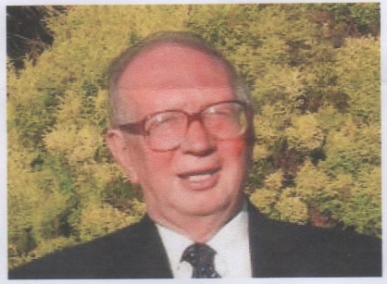
John Noel Bailey
John attained the rank of Premier Life Master within the EBU. He was Chairman of NEBA as well as a past Chairman of Newcastle B.C. He was a County Director, Directing at many NEBA events, both of Newcastle Congresses for many years, as well as Directing at the Club alternative weeks with the late Tom Smith.
John was always a gentleman at the table and always happy to advise less experienced players and Directors when asked. He will be missed by many not least by his partner Terry King who played with him at Newcastle.
Brenda Osborne, who has known John for many years, both at work and at Bridge shares some of her memories:-
Isi Mitrani remembers John playing at Newcastle Club when it was at Bentink Road, before my time. He said that was 60 years ago but it surely cannot be that long ago. I worked for British Paints in the 1970s as did John. His full name is John Noel but Jean always called him Noel, he was John to me and British Paints. We used to play bridge at lunch times in the canteen at Dunston and John had heard about us and asked if we would like to make up a team in the Business Houses League with him, Arthur Duell (his then partner 1970s) and others. He and Arthur then commandeered Sam Khadaroo and his then partner because we were having trouble putting up a team as John & Arthur were away a lot. That is how I met Sam, he and I played at Newcastle BC when it met in the University building at the end of Jesmond Road. We won first time out...he must have played well.
John and Arthur were a very successful partnership and went to lots of Congresses. I remember him winning numerous prizes at them. After Arthur’s sudden death John and I played together in the League. He and Sam taught me an awful lot about the game.
John was Managing Director at British Paints and worked his way up from the Chemistry Benches. That was no mean feat. I worked on the benches for about 7years in Dunston but John worked at Portland Road. When he came to Dunston he always came in for a chat, much to the annoyance of my colleagues and me as we had been on 2 days scrubs in preparation for his visits with Hoechst executives and latterly Berger who both took the company over in that order. They gave me stick every time he phoned me, always direct and not through his secretary. I will always remember him for that. He really didn’t need to do any of this but he did because friendshisp mattered to him.
Frank Springett and I were honoured to play with him and Jean in the teams at Peebles which was their last time there, Christmas 2016 but I believe they played there regularly until then.
Brenda Osborne.

