Exclusive Italian Bridge Holiday in association with Accolade Bridge Holidays

07th – 16th September 2018

£849.00 per person*

- Return transfers from Venice airport to Abano Terme
- Full board accommodation at the Hotel Salus
- Daily Bridge
- Hosted by Ian and Penny Bailey from Accolade Bridge

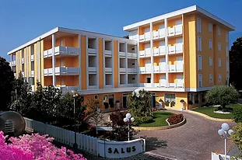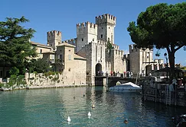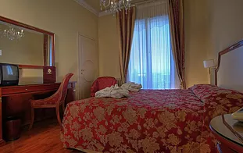

Hotel Salus
Centrally located in the charming spa resort of Abano Terme, the Hotel Salus is an outstanding hotel which typifies Italian style and hospitality.
It has a welcoming and elegant ambience with spacious and beautifully decorated rooms. The new indoor and outdoor swimming pools are kept at a year-round temperature of 38 degrees. The cuisine is excellent, so much so that it will be one of your abiding memories on your return.
Our holidays at the Hotel Salus are on a full-board arrangement.

Abano Terme, Padova
Abano Terme is the oldest spa in Europe. It is delightfully situated at the foot of the Euganean Hills and right in the centre of the Veneto Region. Abano Terme is ideally placed for those wishing to relax and explore the Padova region.
The pedestrian promenade of Abano Terme starts just 40 metres from your hotel. You can enjoy a relaxing walk among historical buildings such as the Hotel Orologio, through exclusive shops, cafes and ice cream parlours, surrounded by public flower beds, squares, fountains and parks.

For More Information please contact the Mercian Travel Team
T – 01562 883 796
E- tours@merciantravel.co.uk

*Price based on 2 adults sharing a twin/double room
Single rooms are available for a supplement of £12.00 per night
Flights aren’t included but can be arranged, contact Mercian Travel for flight details

