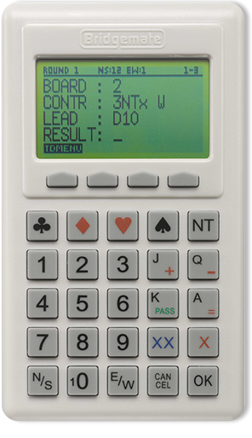

BRIDGEMATES at the Club on Thursday 1st October

Bridgemates.

Remember when we started playing bridge, we used to speak our bids? Then we used bidding boards and these were replaced by the bidding boxes that we are all familiar with now. Well, very few things stand still and the game of bridge is no exception. Many clubs have now replaced scoring slips and the manual input of scores by using Bridgemates, pocket-sized computers, with one placed on each table into which the results are typed at the time of playing - resulting in the final score being available as soon as the score from the last board is entered.

Many of you will, I am sure, have played with Bridgemates as several of the Leicestershire clubs now use them. The Committee has been looking at the feasibility of Loughborough Bridge Club acquiring Bridgemates, however, they do represent a sizable financial investment. So to give club members a taster of how they would work in our club, on 1st October, we are borrowing a set of Bridgemates and will be using them for the night’s bridge. Steve Wright, an LCBA Committee Member, has kindly offered to bring them along and oversee the evening.

So please come along and try them. The Committee would welcome any feedback from the evening.

