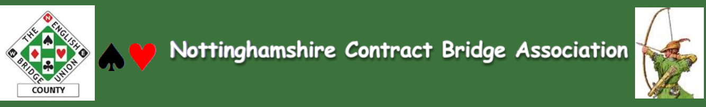
Newsletter September 2016 Issue 3

As Summer moves towards Autumn we find Team Captains thinking about their fixtures for the coming season. In this Newsletter you can find details/links to forthcoming competitions/events including AMENDED ‘teams of 8’ Rules. Jane Hall and Chris Clark (NCBA Committee) worked tirelessly to grapple with necessary changes, which covers convention cards, dealing machines, nominated players and ‘squads’. Please take a look.
Remember that there are various events and competitions in the yearly programme and there is something for everyone. It is true that not everyone likes raising the competitive stakes. A gentle game at a club or a social/charity drive suits many just fine. But others like to test their mettle! Its horses for courses! Have a think about joining in some of these events- once you’ve attended one you will find it is ‘NO FEAR BRIDGE’ and it’s a fun way to improve your game! Look at the calendar on the NCBA website.
We also focus in this issue on Training opportunities for Nottinghamshire Bridge Players. Many of us have been playing for many (too many to remember??) years and may not recall our first fumblings at the table. It can be traumatic but with experience and knowledge comes confidence and enjoyment. As part of the aims of NCBA are to promote Bridge across Nottinghamshire, we want to help raise standards and levels of enjoyment in the game through increasing knowledge and confidence via a range of development opportunities. Some of these are subsidised by your County Association and by EBU, and by local clubs too. Why not ask your club if they are subsidising these courses?
We have arranged them to be delivered locally at the excellent Nottingham Bridge Club (NBC) venue for your convenience and thank NBC for thus supporting these initiatives. So folks, do take up the offer to join in on these events- they need to be supported to justify our investment in putting them on for everyone’s benefit.
Remember if your club runs activities such as training events, or social/Charity drives etc let us know so we can publicise it for you. In particular there is a new initiative: we are creating a NOTTINGHAMSHIRE CLUBS PAGE on our NCBA website to help signpost people to Nottinghamshire clubs. This will be updated quarterly. Any club information you’d like sharing, whether lessons, social activities, celebrating great results, please just email them into the Editor by 31 October for the first posting.

Editor
Enjoy your bridge in 2016-17
~~~~

ALERT: DO YOU KNOW THIS MAN??
Is this Nottinghamshire’s most decorated competitor?
Find out on page 12
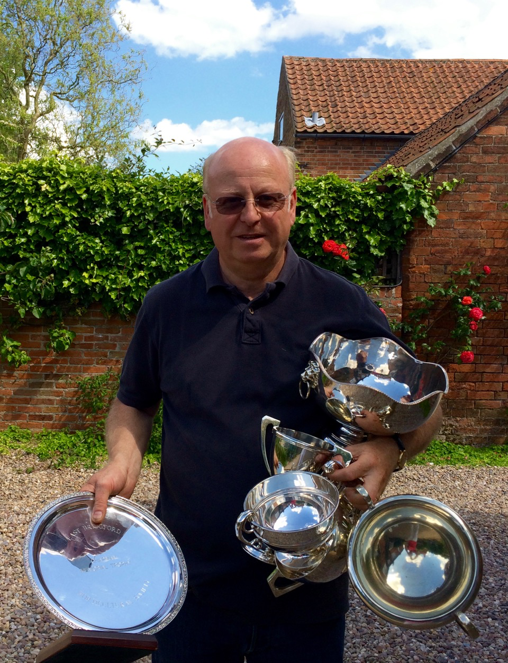
MASTER CLASS FOR ISSUE 3
Here is a hand for this issue by courtesy of the famous Willie Crook, one of Nottinghamshire’s premier players.
The bidding has gone like this and as West you are now on lead. Your hand is below. WHAT DO YOU LEAD? Willie’s answer is on pages 9/10 but don’t look until you have made your own decision!!

W N E S
P P 1C 2D
P 3C P 3S
P 4D P P
P (South’s 2D was described as an intermediate jump overcall)

WEST’S HAND…

J95
AJT53
Q9
965

Dlr: | West
Vul | None

~~~~~~~2016/7 COUNTY MATCHES~~~~~~~
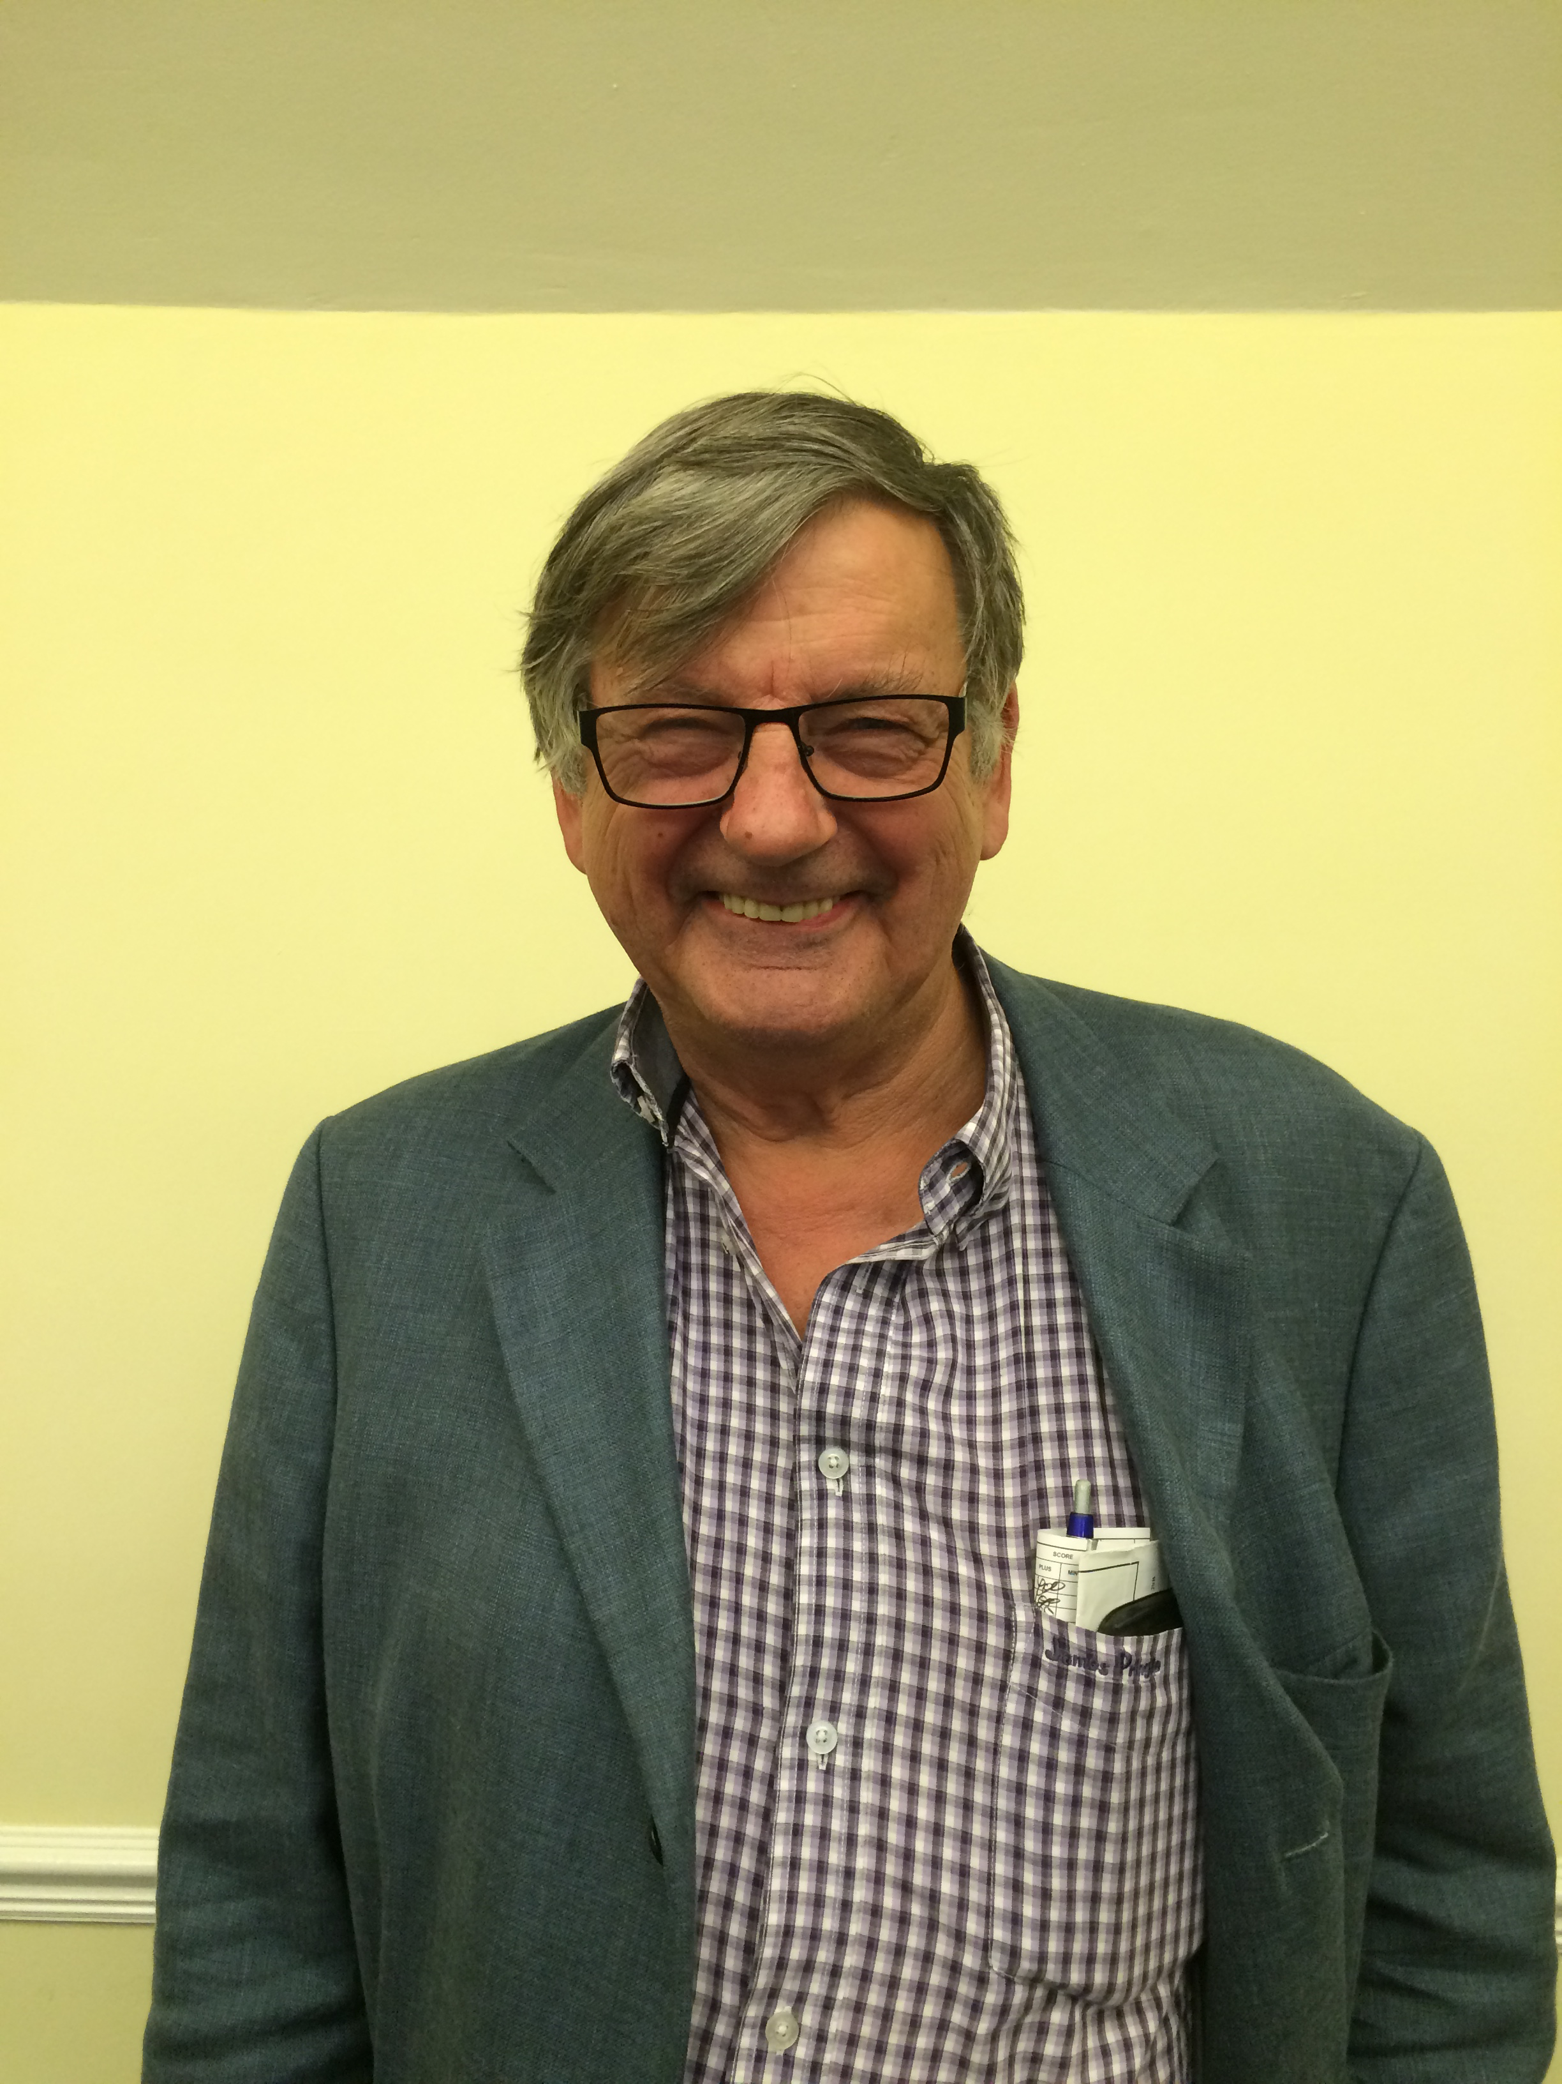

Keith Rodgers Needs YOU!

Keith Rodgers is Nottinghamshire County Team Captain. He is currently arranging teams for the County matches. There are 3 Divisions and Keith is aware that there may be some players who would like to be included but he does not have their details. Can anyone wishing to be considered email Keith with their contact details. Keith tries to get people a game where possible and the season goes on into 2017. Dates for these Sunday events are on the NCBA website, the first few are:
11 September Worcs. Home 10 October Oxford Away
13 November Derby Home 11 December Leics. Away

Summer Teams of Four
Summer 2016 marked a fresh approach to the Teams of Four League. In the attempt to attract more teams, it was felt that running the T04 and the T08 in separate seasons might reduce the time commitment for folk and entice more people to enter. At this point the T04 competition is coming towards completion and things are getting close. Current results can be found on the NCBA website. Its close and nearing the end of the competition. Exciting!!
Unfortunately some teams missed the start date; it was indeed a short deadline to announce the start of the new League and our apologies for that. BUT make a note for next summer- the DEADLINE TO ENTER THE 2017 SUMMER To4 is 1st May 2017
T04 are a great social way to enter into competitive Bridge- games can be played at any venue and time to suit - even in the afternoons and all standards are welcomed. If we get a few more teams entering we could run two Divisions.
For more information contact me, Keith, the T04 Convenor: keith.m.spencer@btinternet.com

NEWS ITEMS
The Winter pairs competition will start again on 14th September and run every second Wednesday of the month through the Winter ending in April. it will be at Nottingham bridge club starting at 7 pm. It will be a Butler imps competition which is like teams scoring. If are looking for a partner contact the county secretary Clare Batten at CPBatten@yahoo.com who will act as a contact point.

Nottingham University Bridge Club
We are attempting to resurrect this club and need old cards/equipment and volunteers to help. Contact Ant if you can help: anthony.pettengell@gmail.com

IMPORTANT NOTE FOR ALL CLUB SECRETARIES
Keep up to date with what is going on by regularly checking the NCBA calendar, which lists all the various competitions and events.

Mixed Pairs New date: 4 December. Previously this has been January. £9 per person
The Master Points Handbook has been revised

If you let the secretary, Clare know we can advertise your local/club event too, whether for charity or just social.

New Rules for NCBA Teams of Eight League - 2016

A new version of the Rules has been produced and has been distributed to all team captains within the League.

The main changes to the Rules were required because of the elimination of squads from the League. It was necessary to remove the concept of squads (groups of players from non-affiliated clubs) to comply with EBU legislation which requires that all teams competing in a County League must be playing on behalf of an EBU Affiliated Club. There have, therefore, been some changes and clarifications under the "Eligibility" section of the Rules to reflect these requirements.

Also under the "Eligibility" section of the Rules (item 9) there have been some clarifications to the Rules covering multiple teams from a single club and the usage of nominated players - often referred to as "starred" players.

Various clarifications have been added and grouped together under a "General" section at the beginning of the Rules (items 1 to 5).

An additional section has been incorporated at the end of the Rules entitled "Rules of Play" with two paragraphs (items 22 & 23) covering computer generated hands and the requirement for pairs to have convention cards.

No significant changes have been made to the section entitled "Matches and Results".

The Rules are available for viewing on the County's website:- http://www.bridgewebs.com/nottinghamshire
and are available for downloading if required.

Chris Clark
Secretary, NCBA Teams of Eight League

Key Events/dates to note
Look on the NCBA Calendar for forthcoming events in more detail

- Derby Green Point Event 3rd and 4th September

- We have been asked by Derbyshire to arrange a friendly County match to replace the defunct 3 Counties competition. This will be 27 November 2016 and is aimed at introducing more people to this sort of cross-county fixture. If you are interested in developing your potential for current or future County Teams, Keith Rodgers County Captain
- For the developing bridge player, a Wednesday afternoon drive is held at the Nottingham Bridge Club. You do not need to be an EBU or Club member, nor come as a pair. Just turn up! 14:00. Advice and support provided.

- Afternoon Bridge Drive. To raise money for the restoration and refurbishment of The Park Tennis Club pavilion. £5.00 per person at The Park Tennis club. Monday 26th September 2016. Bridge starts at 12.30pm prompt. Afternoon tea served at 2.30pm. Concludes approx. 4pm. If you would like to come please Contact: janet Jacques on 01159172178 or 07939876009 janet.jacques@ntlworld.com

- SOLD OUT Café Bridge Southwell. 11 October 2016. A fun social way to have great food, brilliant company and play daytime competitive Bridge in interesting and historic cafes and eateries. For past several years now this biannual event has been a sell out running in Nottingham and local towns, and is in aid of Beaumond House Hospice. 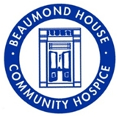 Look out for the April 2017 date in Nottingham City Centre- it sells out quick!! Further info and to log an interest in future dates, contact: nottinghamcafebridge@live.co.uk

Full details of these events are on are website.

TRAINING AND COACHING

Here is a list of developmental opportunities for this season.

EBU led Training for Directors.  3 formal comprehensive sessions with an assessment day leads to qualification with EBU as a Tournament Director (TD). Hosted in Nottingham Bridge Club. Dates:  Nov 19 Essentials  Dec 17 Book Rulings  Jan 14 Judgement rulings  Jan 28 Assessment  These Saturday sessions are stand alone- you can opt out of the assessment for example or complete them at a different venue if a particular date doesn’t suit you. Open to anyone including out of County players. Book via EBU website. | EBU led TD Refreshers.  A must day for T Directors (no assessment for this- just fun!) to refresh your knowledge and ask those pesky technical questions that you have always wrestled with. This is the first time such a session has been secured in our County and as it is so valuable to have competent and confident directors it is being generously subsidized by NBC, NCBA and EBU. Thank you all. Also open to non qualified TD’s who direct at clubs but don’t want/haven’t taken the EBU assessment. Date: 30 October 2016 Venue: Nottingham Bridge Club. Bookings and further details contact Toni at tonitsmith@tiscali.co.uk  Do NOT turn up without booking as places are limited. See agenda below.
STOP PRESS: A great opportunity for all bridge players (not just EBU registered players) to get a short crash course (no assessment) summarizing the basic bridge rules and etiquette.
As it is being generously subsidized by NCBA, NBC and EBU, this is a great investment to help further your enjoyment and understanding of this great game. In what other sport (sic) can you play and not make the effort to learn the Rules?? Come and get an insight into what your TD does. This course will benefit everyone- its not threatening but illuminating! (NB: this crash course is the start of the TD refreshers day referred to above)
~~~
This is an EBU delivered seminar. Date: 30 October. Venue: Nottingham Bridge Club. For more details or to book contact Toni at tonitsmith@tiscali.co.uk.

♥ ♣ ♦ ♠ ♥ ♦ ♣ ♠ ♥ ♣ ♦ ♠ ♥ ♣ ♦ ♠

CRASH COURSE AND TD REFRESHERS AGENDA
9.30 for 9.45 Welcome refreshments

9.45- 11.15 Session 1: Introduction to the Role of the TD and the key ‘Bridge Rules’ concepts FREE BUT MUST BE BOOKED IN ADVANCE DUE TO LIMIT ON NUMBERS (FIRE REGS). (TD’s must attend the full day).

11.15-11.30 Tea break (refreshments included: people may depart or remain for session 2)

11.45 – 1.30 Session 2: Review of the main Book Rulings (£5)

1.30- 2.00 lunch – not included (all non TD’s/directors depart)

2.00- 5.00 Session 3:TD’s/Directors remain for in depth review of the more complicated TD calls e.g. Judgments/hesitations etc £25 full day

TO BOOK CONTACT Toni: tonitsmith@tiscali.co.uk

WILLIE CROOK’S MASTER CLASS FOR ISSUE 3
HOW DID YOU FARE?

Graham Kirby found a scintillating defence in the semi-final of the Notts Teams Championship He reasoned that as they hadn’t bid 3NT and partner hadn’t doubled 3C for the lead then partner was suggesting an alternative so he led the H5 !!!! which went to the King and a heart to the Queen and Ace and the Jack cashed on which partner discarded the spade 4 - he now found the heart 3 and when dummy ruffed with the D5 his partner over ruffed with the Jack which promoted his Queen for one down. What’s this about leading away from an Ace? Never say Never in Bridge!!

The full hand:
North Q76
942
K65
AQ72
J95 T842
AJT53 K7
Q9 J7
965 KJT83
AK3
Q86
AT8432
4

SPOTLIGHT ON: EAST BRIDGFORD

Like many Clubs, East Bridgford BC prides itself on being a ‘friendly’ club. Nestling in the heart of this beautiful village, in the East of Nottinghamshire, EB Bridge Club attracts beginners as well as County players.
Secretary Lisa Toohey informed me that it was a typical ‘village club’, very jolly with a great Xmas party and regular pub visits after club night open to all! How often do you get that?
It has a varied membership of about 60, and probably has the record for the Nottinghamshire club with the most qualified TD’s!
East Bridgford are currently looking to expand their membership and are researching types of dealing machines and scoring software as a further attraction. With teams in the To4 and To8 Leagues for many years EB BC has lots to offer. BUT the best bit quips Lisa, ‘….is the tea break. We all stop for tea and very special biscuits- Waitrose, no less!’ .
EB BC has a sister unaffiliated club on a Monday. Look on the EB BC website for more details.
And who is this Man? The Chair of East Bridgford BC Steve Crawford, no less, showing off his winnings, sadly not in Bridge, but in Vegetable Growing!! One of the prestige band of Qualified TD’s in EB BC, Steve regularly directs and takes his Bridge marginally less seriously than his veggies! (I don’t think!!)
Editor

2016 NCBA Committee members and Officers (and their home club)
President Gordon Fullerton (Keyworth)
Chair John Auld (Nottingham)
Secretary Clare Batten (Nottingham &Keyworth )
Treasurer Ian Dovey (West Bridgford & Keyworth)
To4 convenor Keith Spencer (Woodborough)
T08 convenor Chris Clarke ( )
County Captain Keith Rodger (Nottingham)
Communications & Promotions Toni Smith (Woodborough & Nottingham)
Website Keith Spencer (Woodborough)
County TD Tim Anderson(West Bridgeford)
Other committee members: Anthony Pettengell (Phoenix & Nottingham & Woodborough) Jane Hall (Woodborough)

Any comments on this newsletter or related issues are welcome. Please contact Editor Toni or Secretary Clare or any NCBA Committee member.

Any articles or bridge information for inclusion in future Issues happily received. Editor: tonitsmith@tiscali.co,uk

