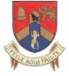 Bray Bridge Congress 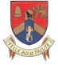
Friday 31st August to Sunday 2nd September 2018

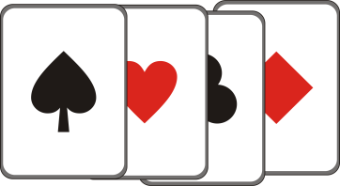

The Royal Hotel Bray
2 nights B&B+I dinner €149pps
First 20 bookings only!

Prize fund based on entries
Last year’s prize fund was €7,500

Friday 31st @ 19:30  Mixed Pairs  Gala Pairs  Novice Pairs  Inter B Pairs | Saturday 1st @13:00  Congress Pairs  Intermediate Pairs  Two Session events | Sunday 2nd @ 11:00  Congress Teams  Intermediate Teams  Two Session Events

Enter now to avoid disappointment
Limited to 68 tables - last year was a sell-out!
Pre-entry for all competitions through CBAI online booking system or to Anne Daly 0862596889 or to braybridgeclub@gmail.com

